U.S. Department of Commerce
Procedure for Harvesting TIGER and Cartographic Metadata Files to data.gov
A how to Guide
Matthew J McCready
8/3/2015

This guide describes the posting of TIGER and cartographic files

Contents
Introduction 2
Moving the files to the Metadata Server 3
Posting to Data.gov 4
Removing NGDA Tagging 12

Figure 1: The data.gov with the Census profile, feeds and settings 5
Figure 2: The Organizations button 5
Figure 3: The Admin Button 6
Figure 4: The Harvest Sources Screen 6
Figure 5: The Add Harvest Source Button 7
Figure 6: The Series Collection Screen 8
Figure 7: The Admin Button 8
Figure 8: The window that appears to confirm the rerun of the harvest 9
Figure 9: The dashboard page indicating how the last harvest performed. 10
Figure 10: The Error Report produced by data.gov 11
Figure 11: The download button in data.gov 12
Figure 12: The download WinZip window 12

Introduction
The following are directions for moving TIGER and cartographic ISO metadata files from the production server (prodmtdata003) on batch1 (batch1.geo.census.gov) to the metadata server web8 (web8.geo.census.gov). On web8, these files can be harvested by data.gov, which is designed to increase the public’s ability to find, download and use data produced by the federal government. It can accept data in the FGDC and ISO 19115 formats. Census, however, only publishes ISO metadata records to data.gov. Data.gov then uses the open source Comprehensive Knowledge Archive Network (CKAN) data management system to index and store the data.
To post these files on data.gov, a Series Information file or Parent File must be created for all county and state based files. These files allow large, homogeneous collections, like TIGER roads files, to not clutter the initial search results. These files indicate a group of similarly themed files and serves as the first level of search on data.gov. One parent file needs to be created and placed in a directory separate from the directory containing the theme’s files. Series Information files are not created for national level files.
To meet OMB and FGDC requirements, all of last year’s National Geospatial Data Asset (NGDA) tagged files must have the NGDA tags and the alternate title removed. These files must then be reposted.
All the scripts mentioned in the steps below can be found at /mtdata001/geo/gpms/PerlScripts on batch 1 under the dataDotGov. A brief description of each script is also shown below in Table 1.
Script Name | Brief Description
ISO_OnlySorter.px | Moves and sorts TIGER ISO metadata files by theme from a directory on prodmtdata003 to the directory from which the script is run.
MifISOSorter.px | Moves and sorts Cartographic ISO metadata files by theme from a directory on prodmtdata003 to the directory from which the script is run.
contentChange.px | Updates the URL in the /gmi:MI_Metadata/gmd:contentInfo/gmd:otherCitationDetail/gco:CharacterString element.
characterStringChange_ver1.px | Changes gco:characterString to gco:CharacterString.
titleChange_ver1.px | Inserts the title element for the contentInfo section.
rmNGDA_County_ver1.px | Removes the NGDA tags from the county based NGDA files
rmNGDA_State_ver1.px | Removes the NGDA tags from the state based NGDA files
Table 1: The Perl Scripts used in Harvesting ISO metadata files for data.gov

The following are the step by step instructions on how to move the files over to the metadata server, post them onto data.gov and remove the NGDA tags from last years TIGER files.

Moving the files to the Metadata Server
- If the files to be moved and sorted are ISO TIGER files:
  - Locate the directory on /prodmtdata003 on batch 1 where the metadata files are stored.
  - Run the ISO_OnlySorter.px Perl script by typing the following at the command line:
Perl ISO_OnlySorter.px –directory=directory name.
Ex: Perl ISO_OnlySorter.px –directory= prodmtdata003/geo/shpgen/tigerline/fe_2015

  - A directory will be created for each theme in the directory from which the Perl script is run.
  - All the files related to that theme will be moved into that directory.
  - Move the files over to a directory on the branch share drive.
- If the files to be moved are cartographic/MIF files:
  - Locate the directory on /mtdata001/geo/gpms/output/ISO on batch 1 where the metadata files are stored.
  - Run the MifISOSorter.px Perl script.
  - A directory will be created for each theme in the directory from which the Perl script is run.
  - All the files related to that theme will be moved into that directory.
- Create the directory on web8 (web8.geo.census.gov) in which the files will be stored
  - For TIGER/Line Files :Create a directory under /webapp/fgdc/metaFiles/existing/decennial/GEO/GPMB/TIGERline
  - For MIF/Cartographic Files: Create a directory under /webapp/fgdc/metaFiles/existing/decennial/GEO/CPMB/boundary
- Move the Series Information files over
  - Find the /prodmtdata001/geo/gpms/output/ISOParent directory
  - Copy the directory over to the branch share drive
- Ensure that the location of the URL for the Entity and Attribute (EA) file is correct
  - Find the /gmi:MI_Metadata/gmd:contentInfo/gmd:otherCitationDetail/gco:CharacterString element.
  - Make sure that URL points to the metadata server (http://meta.geo.census.gov/data)
  - If this element does not point to this URL, run the contentChange.px Perl script:
    - Move all the files to be converted to a folder under the folder containing the Perl Script.
    - This new folder should have the name of the theme since this folder name is going to be inserted into the path of the URL.
    - Type “perl contentChange.px -theme=themename” at the command line. Themename is the directory containing the files to be converted.
  - A new file with the same name will created with the updated URL.
  - This Perl script will be run for each theme that has the incorrect URL.
- Move the files over to the Metadata Server using WinSCP.
  - Copy the files over from Batch 1 to the share drive.
  - Copy the files from the share drive to the appropriate place on web8. This should be under the directory created in step 3.
  - Create a directory for the Series Information Files under the directory created in step 3.
  - Move all the Series Information Files created in step 2 over to the directory created in step 5c.
  - Make sure all the files on web8 have the correct permissions. The permissions should be set to “rwxr-xr-x”. If the files do not have the correct permissions, view the files in WinSCP. Right click on the files and select properties. Then set permissions by clicking on the entire box.

Posting to Data.gov
- Log onto data.gov
  - Click on the login icon in the lower portion of the page
  - Enter your email address and password in the screen that appears
  - An new page appears like the one shown in in the Figure 1 below:
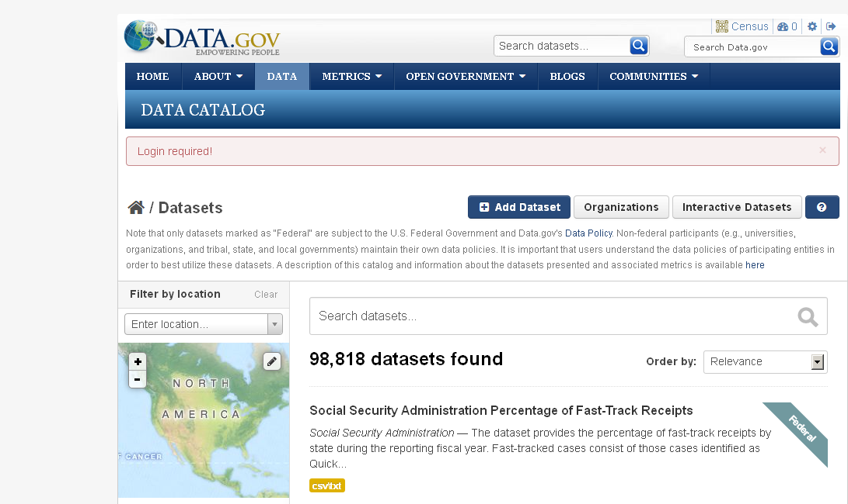
Figure 1: The data.gov with the Census profile, feeds and settings
  - This new page has icon representing the Census feed, feeds and settings in the upper right corner of the page. This indicates that you are logged in under the Census account.

- Find the Census Page on Data.gov
  - Click on the Data tab
  - Find the Census Harvest Page.
    - Graphically through the web page
      - Click on the organizations button on the upper right (shown below in Figure 2).

Figure 2: The Organizations button
      - Select Census from the list of organizations shown. You may have to click through the pages shown at the bottom of the first webpage.
    - Through the URL: http://catalog.data.gov/organization/census-gov.
    - If the harvest is for new files, proceed to step 3. If the harvest is to replace or update an already existing collection of Census files, proceed to step 4.
- Set up the Harvest for a new Series of Files
  - Make sure the files to be harvested have today’s date. If they do not, do the following:
    - In WinSCP, select the files to be updated
    - Right click on those files
    - In the window that appears, select “Custom Commands” and then “touch”
    - All the files now have today’s date.
  - Click on the blue Admin button in the upper right corner (shown below in Figure 3) of the Census harvest page.

Figure 3: The Admin Button
  - Click on the Harvest Sources tab as shown in Figure 3.

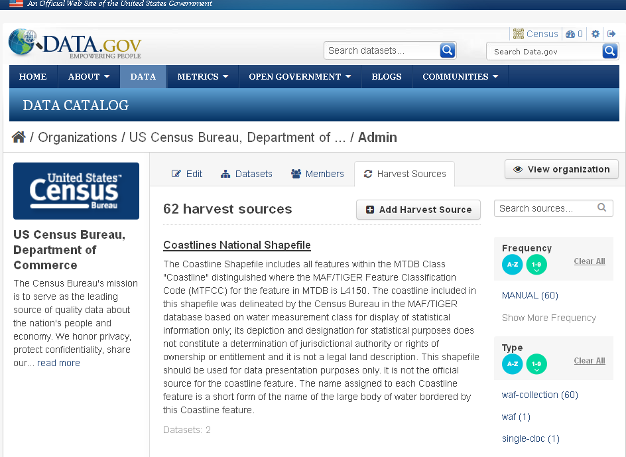
Figure 4: The Harvest Sources Screen

  - Click on the Add Harvest Source Button (shown below in Figure 5). Otherwise, skip to step e.
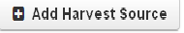
Figure 5: The Add Harvest Source Button
  - In the page that appears,
    - Enter the URL for the file containing the folder. This is the actual URL for the Census metadata website and should begin with http://meta.geo.census.gov/data/existing/decennial/GEO/.
    - Enter a title. This can be copied from the title element in the indentificationInformation section. Copy only the part after the last comma. This is the file’s theme.
    - Enter a description. This can be obtained from the last part of the abstract element in the indentificationInformation section. Skip the first part that of the abstract that explains what TIGER/Line files are.
    - For source type, select Web Accessible Folder (WAF) Homogeneous Collection for state and county files and Web Accessible Folder (WAF) for national files.
    - For update frequency, choose manual.
    - Enter the URL of the Series Collection File or Parent file for this theme.
    - For validation, select ISO 19115 Metadata (ISO 19139 XSD).
    - For data visibility, select “Public”.
    - Click the blue “Save” button on the bottom right of the page.
    - A screen similar to the one shown in Figure 5 appears
    - Skip to step 10.

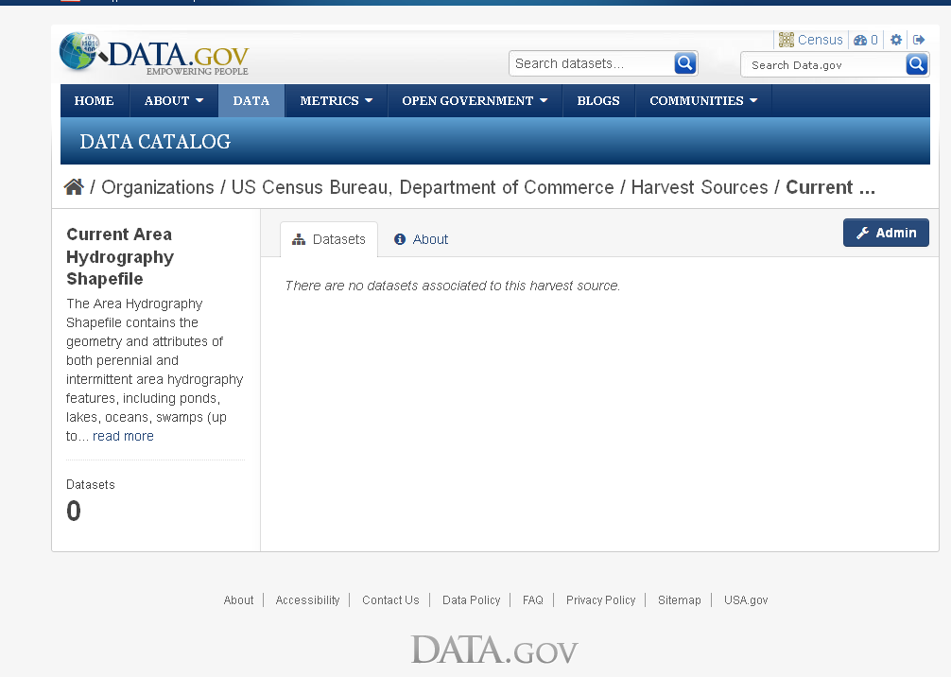
Figure 6: The Series Collection Screen
- If the files to be added to Data.gov already exist:
  - Make sure the metadata date has been updated.
  - Click on the Admin button shown in Figures 3 and 4.
  - Click on the Harvest Sources tab. A page similar to the one shown in Figure 3 appears.
  - Click on the collection that needs to be edited.
  - If the harvest source needs to be edited, click on the edit tab and make the needed changes.
- Start the harvest
  - Click on the blue Admin button (shown below in Figure 7) in the upper right corner of the Series Collection screen shown in Figure 6.
Figure 7: The Admin Button
  - Click on the Reharvest Button.
  - Press the Confirm button on the window that pops up (shown in Figure 8).
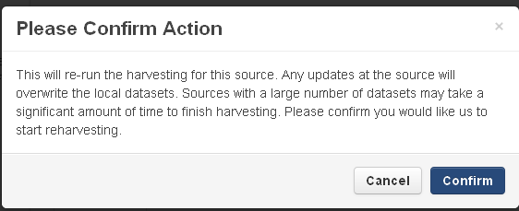
Figure 8: The window that appears to confirm the rerun of the harvest
  - Refresh the browser until the harvest is finished.
- When the harvest is finished, the following page shown in Figure 9 is produced under the dashboard tab. This page indicates how many files have errors in them, how many files were added to the collection, how many files were updated and how many files were deleted. It also gives the id of the harvest, when the harvest was created, the date the harvest was started and the date the harvest was finished.

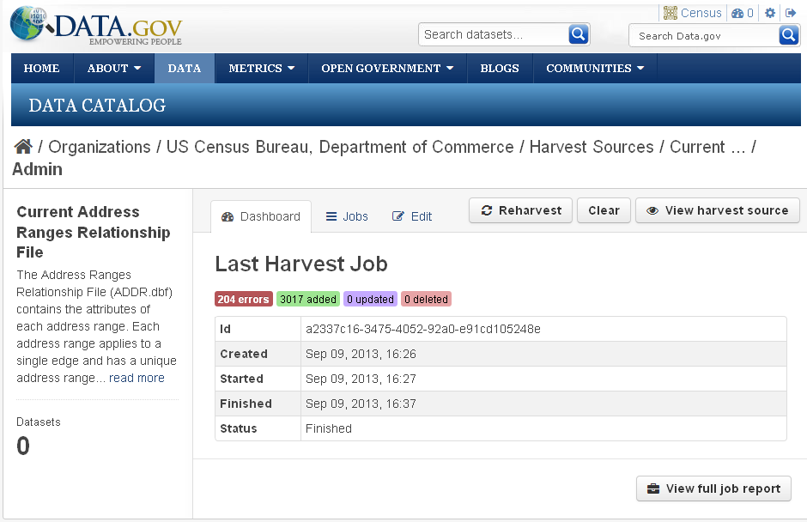
Figure 9: The dashboard page indicating how the last harvest performed.

- If there are errors, click on the “View full job report” button in the lower right corner of the page, as shown in Figure 9. An Error Report page similar to the one in Figure 10 appears. This page lists every file with errors in them, a brief description of the error and the line the error appears on. It should be noted that every theme that has Entity and Attribute Information will produce one error. This is due to the fact that ISO 19110 files are not supported in data.gov. These files are placed here so that they can be linked in the Content Info section of the ISO metadata file.
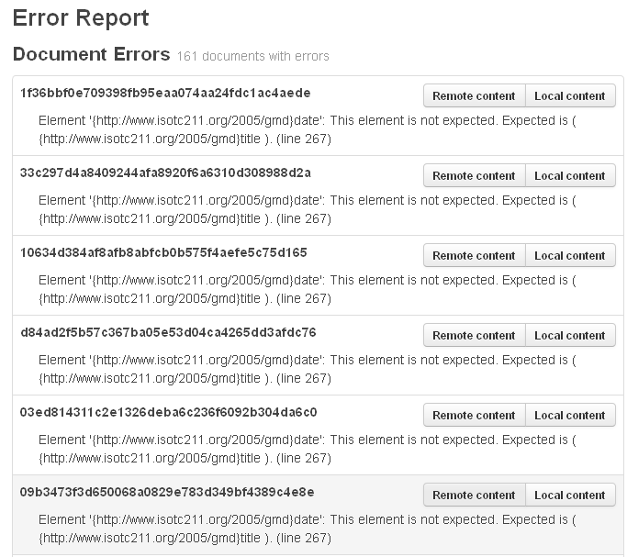

Figure 10: The Error Report produced by data.gov
- Click the remote content button to the right of each file to get its name. Copy the files with errors in them from web8 to the share drive and then to batch1.
- Correct the errors. The following Perl scripts may of assistance
  - characterStringChange_ver1.px: Changes gco:characterString to gco:CharacterString. To use this script, do the following:
    - Create a directory under the directory containing the script.
    - Place all the files that need to be updated in the directory mentioned in step i.
    - Run the script by typing “perl characterStringChange_ver1.px -theme= themename” at the command line. Themename is the directory containing the files to be updated.
- titleChange_ver1.px inserts the title element for the contentInfo section. To use this script, do the following
    - Create a directory under the directory containing the script.
- Place all the files that need to be updated in the directory mentioned in step i.
- Run the script by typing “perl titleChange_ver1.px -theme=themename” at the command line. Themename is the directory containing the files to be updated.
- Check to see if the link download link works
  - Click on the Download button, shown in Figure 11 below.

Figure 11: The download button in data.gov

  - The window, shown in figure 12, appears:

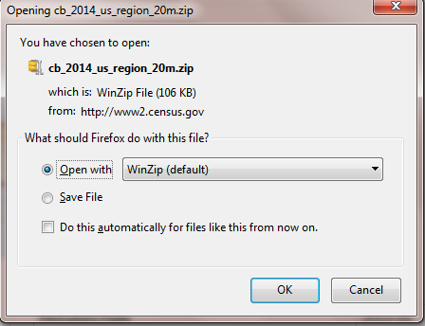
Figure 12: The download WinZip window

  - If the above window does not appear, the URL in the metadata is wrong. Fix it by doing the following:
    - Find the correct URL on the Census website
    - Replace the URL using oxygen for the following elements
      - /gmi:MI_Metadata/gmd:dataSetURI/gco:CharacterString
      - /gmi:MI_Metadata/gmd:distributionInfo/gmd:MD_Distribution/gmd:transferOptions/gmd:MD_DigitalTransferOptions/gmd:onLine/gmd:CI_OnlineResource/gmd:linkage/gmd:URL (this is the one used for the download link)
      - Repost to data.gov by using the steps in the “Posting to Data.gov” section

Removing NGDA Tagging
- Census has files with the following NGDA tags. Please see the table below for the names of the NGDA tagged files
  - Governmental Units (23 files)
  - Cultural Resources (1 file)
  - Transportation (3 files)
File Theme | NGDA Tag | Update Frequency
Census Traffic Analysis District (TAD) National | transportation | Every decade
Census Traffic Analysis Zone (TAZ) State-based Shapefile | transportation | Every decade
All Roads County-based Shapefile | transportation | annually
Area Landmark State-based | cultural | annually
Current American Indian/Alaska Native/Native Hawaiian Areas National (AIANNH) National Shapefile | Governmental Units | annually
Current Combined Statistical Area (CSA) National Shapefile | Governmental Units | annually
Current Unified School Districts State-based Shapefile | Governmental Units | annually
Census Block State-based Shapefile with Housing and Population Data | Governmental Units | Every decade
Census Voting District State-based (VTD) | Governmental Units | Every decade
Census Block State-based Shapefile | Governmental Units | annually
2014 Current Place State-based Shapefiles | Governmental Units | annually
Current Block Group State-based Shapefile | Governmental Units | annually
Current Census Tract State-based Shapefile | Governmental Units | annually
Current Combined New England City and Town Area (CNECTA) National Shapefile | Governmental Units | annually
Current Metropolitan Statistical Area/Micropolitan Statistical Area (CBSA) National Shapefile | Governmental Units | annually
Current American Indian/Alaska Native/Native Hawaiian Areas National (AIANNH) National Shapefile | Governmental Units | annually
Current Combined Statistical Area (CSA) National Shapefile | Governmental Units | annually
Current County Subdivision State-based Shapefile | Governmental Units | annually
Current Unified School Districts State-based Shapefile | Governmental Units | annually
Census Urban Growth Area (UGA) State-based Shapefile | Governmental Units | Every decade
Census Voting District State-based (VTD) | Governmental Units | Every decade
Census Block State-based Shapefile | Governmental Units | annually
Current Place State-based Shapefiles | Governmental Units | annually
Current Block Group State-based Shapefile | Governmental Units | annually
Current Census Tract State-based Shapefile | Governmental Units | annually
Current Combined New England City and Town Area (CNECTA) National Shapefile | Governmental Units | annually
Current Metropolitan Statistical Area/Micropolitan Statistical Area (CBSA) National Shapefile | Governmental Units | annually
Table 2: A list of Census NGDA datasets

- Run the Perl Script
  - For state and national files, run the rmNGDA_State_ver1.px Perl script
  - For county files rmNGDA_County_ver1.px Perl files
- Repost the files to data.gov by following the directions in the previous section.
- Ensure that the correct files are there by checking the geospatial platform.

