Effective Place-Based Policies
  - Using geospatial technology to integrate place into federal fiscal planning and policy implementation

In August 2009, the Directors of the Office of Management and Budget (OMB), the Domestic Policy Council, the Office of Urban Affairs, and the National Economic Council jointly issued preliminary guidance on developing effective place-based policies and instructed the heads of federal agencies to begin developing proposals in response to this guidance as part of the fiscal year 2011 budget process. The Administration has identified the use of place-based planning as a priority in its efforts to guide economic development, preserve sensitive natural resources, minimize government duplication or contradictory policies, and use technology for the benefit of the nation.

What does a place-based approach mean?
A place-based approach leverages the importance of location in planning, implementing, and analyzing government programs. This approach allows agencies to coordinate across “silos” of information, create linkages between organizations, track resources, and analyze and direct programs and policy within a location-based framework using Geographic Information Systems (GIS). The geographic display can then be readily used to effectively explain and communicate decisions using interactive maps.
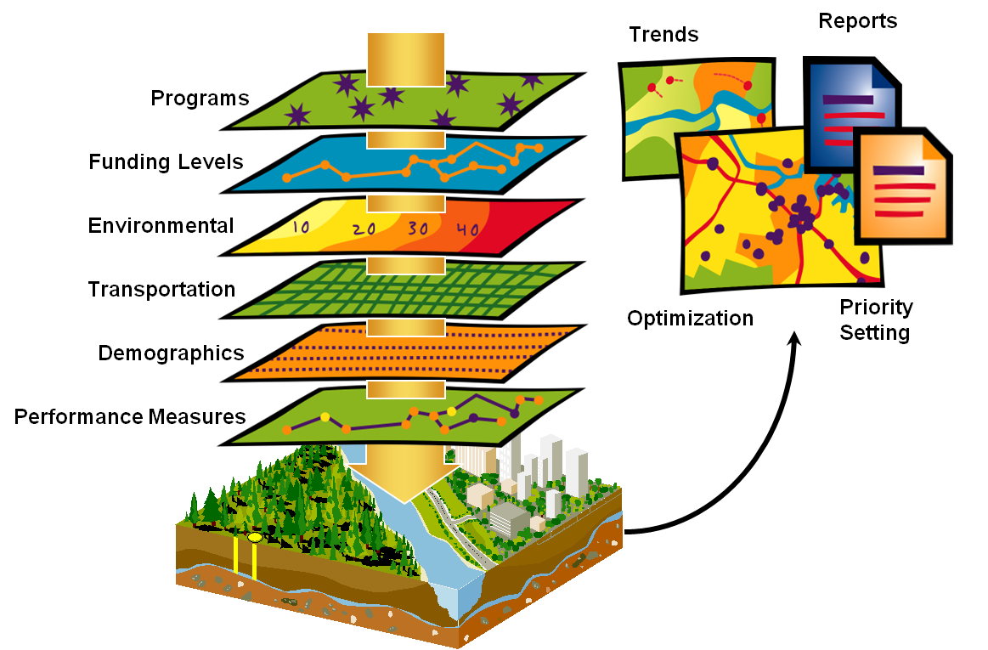
Currently, geospatial technologies are used in pockets of expertise across federal, state, and local government agencies, providing a technology framework to promote planning and collaboration across jurisdictional boundaries. The recent OMB memo opens the door to wider and more effective use of this technology to improve public policy results for the public.

How will geospatial tools benefit government policy makers?
Place-based approaches can leverage budgetary resources by organizing activity across programs, agencies, or levels of government in targeted geographic areas (urban, rural, coastal, etc.), thereby increasing program benefits through improved coordination. Focusing on given metropolitan areas, ecosystems, or regions can allow decision makers to create synergies among government programs that allow agencies to produce better results collectively than they could through an uncoordinated program-by-program approach.

Place-based planning offers decision-makers a new analytical lens. With the Administration’s launching of Data.gov, we now have an innovative means to access geospatial data as well as technology. Geospatial technology can combine various sources of information into integrated displays that allow interactive manipulation, queries, and rapid calculations. Decision-makers can see where agency funding is going and then compare that information to data on citizen needs, which enables them to more readily define appropriate performance indicators to evaluate the effectiveness of spending.

How can the Federal Geographic Data Committee support Place-based Policies?
The FGDC is a Federal interagency committee that promotes the coordinated development, use, sharing, and dissemination of geospatial data on a national basis. The FGDC has 32 member agencies, including the Executive Office of the President, Cabinet level and independent Federal agencies. The Secretary of the Interior chairs the FGDC and the Deputy Director for Management of OMB serves as Vice-Chair. Numerous stakeholder organizations participate in FGDC activities, representing the interests of state and local government, tribes, industry, and professional organizations.

In addition to its core member agencies and professional staff, the FGDC has additional resources and processes that are well-positioned to support the Administration’s place-based initiatives:

- The National Geospatial Advisory Committee (NGAC) includes top national experts in geospatial technology from the private sector, academia, and all levels of government. The NGAC could provide external advice on approaches for optimizing geospatial technology, across multiple sectors.

- The FGDC-managed Geospatial Line of Business initiative, which was established under the auspices of OMB, leverages geospatial expertise from across 26 federal agencies and can support the Administration’s place-based policies.

The FGDC, in coordination with OMB, could develop and implement a strategy to assist agencies with pursuing place-based initiatives, starting with the agency submittals accompanying the FY 2011 budget request to OMB. The strategy could include the following types of assistance for agencies:

- Assist agencies in defining the geographies of interest in the context of the OMB memo. It is important to precisely specify a common geographic frame of reference for place-based policy, particularly for interagency collaboration. For instance, the “Washington DC metropolitan area,” the “Great Lakes Region,” or “South Florida” may imply different geographies to different agencies, or even to different programs within the same agency. Being able to jointly visualize the boundaries of the geography of mutual interest improves coordination and focus, and therefore results. The FGDC could work with agencies to develop appropriate decision rules to specify geographies of interest, help identify information associated with those decision rules, and help apply those decision rules using available data. The outcome would be a consistent, clearly defined, and analytically defensible geography as the basis for place-based policy initiatives.

- Assist agencies in deciding how to use their existing agency databases to generate useful information that could be geo-enabled. Many programmatic databases can be linked to visual or map displays that would provide new ways of understanding complex interrelationships or trends. By working with agency officials, geospatial professionals can incorporate locational fields into selected databases. FGDC could assist agencies in identifying current data holdings that are either already geo-enabled, or that would produce added programmatic value were they to be cost-effectively geo-enabled. The principal outcome would be a well-understood portfolio of agency datasets that could inform analyses to support place-based policy initiatives. Another outcome would be a gap analysis identifying data that would be very useful to have, but is not presently available from internal agency sources.

- Help agencies secure externally available geospatial information that might be useful to include in the analysis. A wealth of geospatial data is available that can add richness, and community perspective, to agency program data. When program and spatial data are combined the power for wise decisions and effective communications is dramatically enhanced. Other federal agencies, state and local government agencies, and some private sector companies could be sources of such data. Much of this data is easy to access and can be secured at little or no cost to the government, often over the internet. Using Data.gov as a platform provides a holistic approach to accessing geospatial data and assets from the Geospatial One Stop portal, supported by the USGS and the FGDC, and is an OMB-sponsored tool for discovering useful data from federal and external sources. The outcome would be a list of datasets that, if secured, would be valuable in pursuing the placed-based policy initiative for the previously established geography.

- Help agencies utilize internally and externally available data and existing technology to frame and make policy choices on a geographic basis. Agencies can use geo-enabled data and GIS technology to analyze policy options and predict the results of policy and funding scenarios. The outcome would be a robust and yet easy to use suite of analytical tools that the agency could use well into the future to help effectively manage placed-based policies.

- Assist agencies and OMB by documenting place-based success stories and sharing them across the federal enterprise and the broader geospatial community. By documenting the process and benefits of a place-based approach, we would produce a series of models that could be easily replicated across government.

Next Steps – FGDC Virtual National Forum on Place-Based Policies
The FGDC Executive Committee is organizing a series of virtual forums to bring together diverse public sector constituents, beneficiaries, and stakeholders to explore implementation of "place-based policy planning and programming" innovations and best practices. The first forum is tentatively planned for December 9, 2009. The purpose of the forums is to utilize principles of social networking and technology tools to:
- Conduct a series of four forums: first, with federal government geospatial program executives; second, with state, local, and tribal representatives; third, with the general public communities of interest and academic constituencies; and fourth, with industry, nonprofits and other stakeholders.
- Engage in discussion about utilizing geospatial technology to enable place-based policies which address economic competiveness, environmental sustainability, community health access and security.
- Build awareness of and create access to existing federal government geospatial assets.
- Obtain broad-based input into a National geospatial policy defining the value of "place-based" government product and services.
- Develop a sustainable space for future interactions concerning the effectiveness of place-based policies and the ongoing maturity of government geospatial solutions.
- Reach out to partners and stakeholders in the geospatial community to engage their active participation in place-based initiatives.

Contact
- Ivan B. DeLoatch, Executive Director, FGDC (ideloatch@fgdc.gov, 703-648-5752)
- Karen Siderelis, Acting Chair, FGDC (karen_siderelis@ios.doi.gov, 202-208-6318)

