U.S. Department of Commerce
U.S. Census Bureau Procedure for Using and Creating Parent Files
Matthew J McCready
7/2/2013

Contents
Introduction 2
How Parent files are used in geo.data.gov 2
Linking the individual metadata file to the parent file 5
Creating the Parent or Series Information File 6
Creating the XSLT needed to create the Parent File 6
Appendix A 10

Introduction

In the new versions of geo.data.gov and data.gov, there are records called parent files or series information files, which serve as an identifier for a homogeneous collection of individual metadata records. For example, the “TIGER/Line Shapefile, 2012, Series Information File for the Current Elementary School Districts” parent file serves as an identifier for a collection of 24 Current Elementary School District TIGER\Line shapefiles. These parent files exist to simplify searches on geo.data.gov by returning only the relevant parent files for the search term. Previously, the user was overwhelmed with every individual file that was related to the search term. Where a user could get thousands of hits for a search term, the user now only gets one hit per collection. An example of a parent file is shown in Appendix A.

How Parent files are used in geo.data.gov
An example of how Parent files are used in geo.data.gov is shown in Figures 1 thru 3. When a user does a search for “TIGER Elementary School Districts”, the web page similar to the one shown in Figure 1 is returned. This web page contains links to all the Parent files that are related to the search term “TIGER Elementary School Districts”. Each one of these links represents a collection of files that are related to the search tem. The source of each collection is represented through the use of banners to the right of the file that indicate whether the file comes from a federal, state, local, tribal or university source. A navigation panel on the left of the webpage allows the user to further refine the search by choosing the location, the dataset type, the tags, formats, groups, organizations, organization types and community categories the user desires.
When the user clicks on one of the links shown in Figure 1, the web page shown in Figure 2 is returned. This is the page for the actual parent file and contains a description of the Parent file and links to download the individual files within the collection. When the user clicks on the “Search datasets within this collection” button, the webpage shown in Figure 3 is returned. As Figure 3 shows, this webpage contains a link to all 24 Elementary School Districts TIGER\Line files.
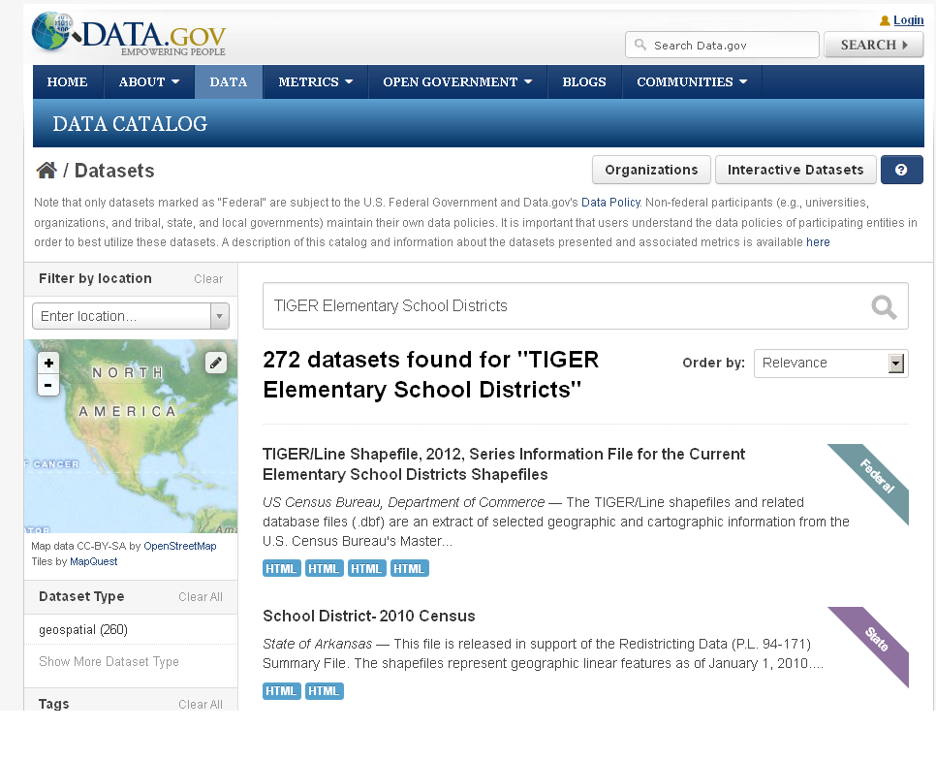
Figure 1: The screen that is returned to a user after a search is done for “TIGER Elementary School Districts”
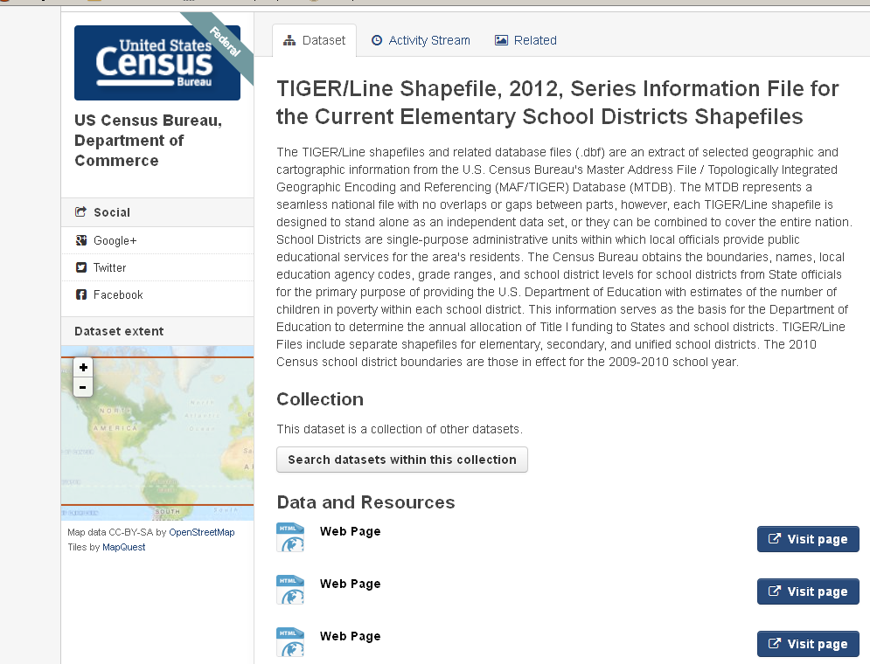
Figure 2: The page returned to the user after “Series Information File for the Current Elementary School Districts Shapefiles” is clicked.

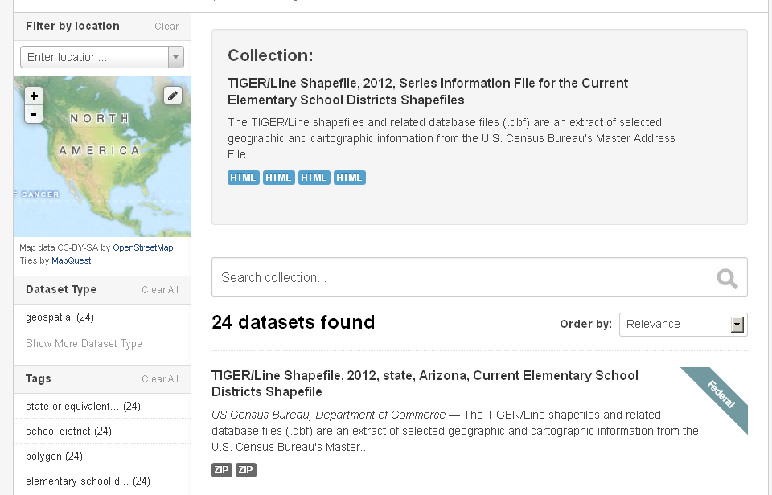
Figure 3: The page returned to the user after the “Search datasets within this collection” button is clicked.

Linking the individual metadata file to the parent file
An individual file that is part of a collection of files is linked to the parent file through the parentIdentifier element, which is the first element after the root element in ISO metadata files. An example of this is shown in Figure 4. In this example, the value for this element indicates that this file is linked to the “TIGER/Line Shapefile, 2012, Series Information for the Current Elementary School Districts” series information file.
<gmd:parentIdentifier xmlns:gmd="http://www.isotc211.org/2005/gmd">
<gco:CharacterString xmlns:gco="http://www.isotc211.org/2005/gco">TIGER/Line Shapefile, 2012, Series Information for the Current Elementary School Districts Shapefile</gco:CharacterString>
</gmd:parentIdentifier>

Figure 4: An example of a parentIdentifier element

Creating the Parent or Series Information File
To create these series information or parent files, Census has created a stylesheet that transforms an individual theme file into a parent or Series Information File. To automate production of these parent files, a PERL script has been created that calls this stylesheet. This PERL script will create a series information file for every theme file in this directory, so only one example of each theme should be in this directory. Examples of Census themes are place, address ranges, roads and counties. The procedure for creating a parent file is shown in Figure 7.
Within Census, a parent file is created even for themes that are national in scope and have only one file for that theme. This is done so that these files will be displayed in the initial page, shown in Figure 1, when a user does a search related to one of the national themes. Examples of national themes are rails and American Indian areas..

Creating the XSLT needed to create the Parent File
When creating the style sheet to transform an individual theme file into a parent file, differences between the newly created parent file and the individual theme file the parent file is being created from must be accounted for. The main difference between the individual theme file and the parent file is the value of the title element. This value has to be changed to indicate the new title of the parent file. Census did this this inserting “Series Information File for the” between the year and the theme. In the creation of the new title for the parent file, the level of geography (nation, state, or county) and the state or county name are discarded. An example of a title for a series Information file is shown in Figure 5.
<gmd:title>
<gco:CharacterString xmlns:gco="http://www.isotc211.org/2005/gco">TIGER/Line Shapefile, 2012, Series Information File for the Current Elementary School Districts Shapefiles</gco:CharacterString>
</gmd:title>

Figure 5: An example of a title for a parent or series information file.
To reflect the national extent of Census parent files, most of the keywords relating to place have been stripped out of the parent file. The only place names left are “U.S” and “State or Equivalent Entity” for state based themes or “County or Equivalent Entity” for county based themes. The geographic extent, represented by the “gmd:geographicElement” element in ISO metadata, in the Identification Information section have been changed so that the latitude and longitude reflects the entire nation, instead of an individual state or county. The changes made to the geographic extent are shown in Figure 6.

<gmd:geographicElement>
<gmd:EX_GeographicBoundingBox id="boundingGeographicBoundingBox">
<gmd:westBoundLongitude>
<gco:Decimal xmlns:gco="http://www.isotc211.org/2005/gco">-179.231086</gco:Decimal>
</gmd:westBoundLongitude>
<gmd:eastBoundLongitude>
<gco:Decimal xmlns:gco="http://www.isotc211.org/2005/gco">179.859681</gco:Decimal>
</gmd:eastBoundLongitude>
<gmd:southBoundLatitude>
<gco:Decimal xmlns:gco="http://www.isotc211.org/2005/gco">-14.601813</gco:Decimal>
</gmd:southBoundLatitude>
<gmd:northBoundLatitude>
<gco:Decimal xmlns:gco="http://www.isotc211.org/2005/gco">71.441059</gco:Decimal>
</gmd:northBoundLatitude>
</gmd:EX_GeographicBoundingBox>
</gmd:geographicElement>

Figure 6: The modification made to the gmd:geographicElement
The entity and attribute information section is also dropped from the series information file, as this file only serves as notice that a series of files on that user provided search term exists. For the actual entity and attribute information, the user should see the individual theme file.
One last difference between a parent file and an individual theme file that is part of a collection is that the parent file contains no parentIdentifier element. This is due to the fact that the parent file is not part of a series or collection but instead signifies that a collection of files exist.
Other than the differences stated above, all the other values were mapped as is from the individual theme file to the parent file. The above procedure for creating a style sheet to transform an individual theme file into a parent file is shown in Figure 8.
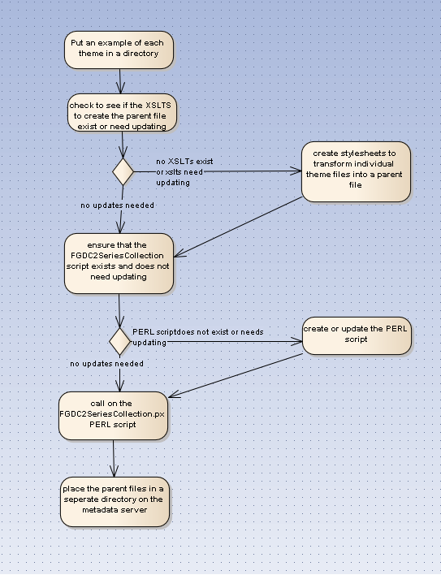
Figure 7: Steps needed to create a Parent File

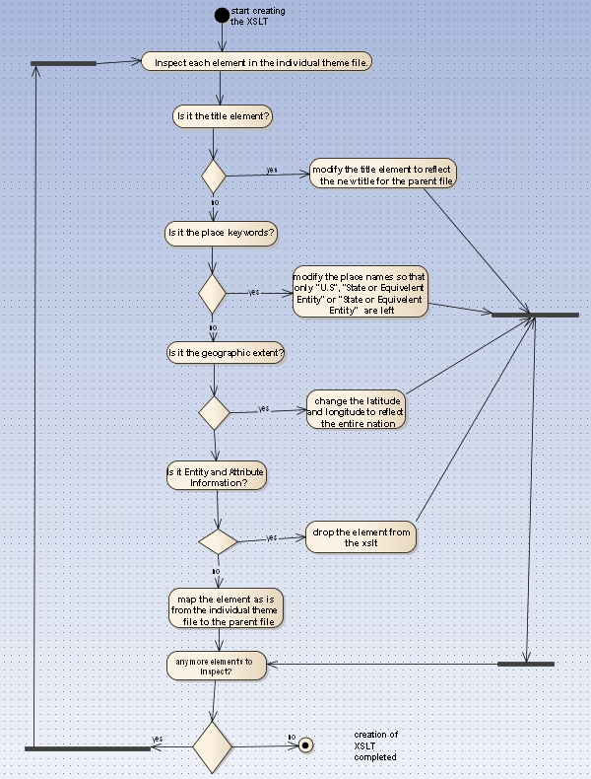
Figure 8: Steps in the creation of a style sheet to transform an individual file into a theme file.

Appendix A

<?xml version="1.0" encoding="UTF-8"?>
<gmi:MI_Metadata xmlns:gmi="http://www.isotc211.org/2005/gmi">
<gmd:hierarchyLevel xmlns:gmd="http://www.isotc211.org/2005/gmd">
<gmd:MD_ScopeCode
codeList="http://www.isotc211.org/2005/resources/Codelist/gmxCodelists.xml#MD_ScopeCode"
codeListValue="dataset "> dataset </gmd:MD_ScopeCode>
</gmd:hierarchyLevel>
<gmd:contact xmlns:gmd="http://www.isotc211.org/2005/gmd"
xmlns:xlink="http://www.w3.org/1999/xlink"
xlink:href="https://www.ngdc.noaa.gov/docucomp/c5ceb003-1ed6-4126-8a16-bc08ce8fc267"
xlink:name="U.S. Department of Commerce, U.S. Census Bureau, Geography Division, Geographic Products Branch"/>
<gmd:dateStamp xmlns:gmd="http://www.isotc211.org/2005/gmd">
<gco:Date xmlns:gco="http://www.isotc211.org/2005/gco">2012-06-15</gco:Date>
</gmd:dateStamp>
<gmd:metadataStandardName xmlns:gmd="http://www.isotc211.org/2005/gmd">
<gco:CharacterString xmlns:gco="http://www.isotc211.org/2005/gco">ISO 19115 Geographic
Information - Metadata </gco:CharacterString>
</gmd:metadataStandardName>
<gmd:metadataStandardVersion xmlns:gmd="http://www.isotc211.org/2005/gmd">
<gco:CharacterString xmlns:gco="http://www.isotc211.org/2005/gco">2009-02-15
</gco:CharacterString>
</gmd:metadataStandardVersion>
<gmd:dataSetURI xmlns:gmd="http://www.isotc211.org/2005/gmd">
<gco:CharacterString xmlns:gco="http://www.isotc211.org/2005/gco" >http://www2.census.gov/geo/tiger/TIGER2012/ELSDhttp://tigerweb.geo.census.gov/tigerwebmain/TIGERweb_main.html</gco:CharacterString>
</gmd:dataSetURI>
<!-- This is the ptvctinf/sdtsterm/sdtstype from section 3 of the FGDC Standard (Spatial Data Organization) -->
<gmd:spatialRepresentationInfo xmlns:gmd="http://www.isotc211.org/2005/gmd">
<gmd:MD_VectorSpatialRepresentation>
<gmd:geometricObjects>
<gmd:MD_GeometricObjects>
<gmd:geometricObjectType>
<gmd:MD_GeometricObjectTypeCode
codeList="http://www.isotc211.org/2005/resources/Codelist/gmxCodelists.xml#MD_GeometricObjectTypeCode"
codeListValue="complex" codeSpace="001"> complex
</gmd:MD_GeometricObjectTypeCode>
</gmd:geometricObjectType>
<gmd:geometricObjectCount>
<gco:Integer xmlns:gco="http://www.isotc211.org/2005/gco">104</gco:Integer>
</gmd:geometricObjectCount>
</gmd:MD_GeometricObjects>
</gmd:geometricObjects>
</gmd:MD_VectorSpatialRepresentation>
</gmd:spatialRepresentationInfo>
<!--This is the indirect spatial reference of section 3 -->
<gmd:referenceSystemInfo xmlns:gmd="http://www.isotc211.org/2005/gmd">
<gmd:MD_ReferenceSystem>
<gmd:referenceSystemIdentifier>
<gmd:RS_Identifier>
<gmd:code xmlns:gco="http://www.isotc211.org/2005/gco" gco:nilReason="unknown"/>
<gmd:codeSpace>
<gco:CharacterString xmlns:gco="http://www.isotc211.org/2005/gco">Federal
Information Processing Series (FIPS), ANSI, and feature
names.</gco:CharacterString>
</gmd:codeSpace>
</gmd:RS_Identifier>
</gmd:referenceSystemIdentifier>
</gmd:MD_ReferenceSystem>
</gmd:referenceSystemInfo>
<!-- This part represents Section 1 of the FGDC Metadata Standard -->
<gmd:identificationInfo xmlns:gmd="http://www.isotc211.org/2005/gmd">
<gmd:MD_DataIdentification>
<gmd:citation>
<gmd:CI_Citation>
<gmd:title>
<gco:CharacterString xmlns:gco="http://www.isotc211.org/2005/gco">TIGER/Line
Shapefile, 2012, Series Information File for the Current Elementary
School Districts Shapefiles</gco:CharacterString>
</gmd:title>
<gmd:date>
<gmd:CI_Date>
<!-- This is the publication date -->
<gmd:date>
<gco:Date xmlns:gco="http://www.isotc211.org/2005/gco" >2012</gco:Date>
</gmd:date>
<gmd:dateType>
<gmd:CI_DateTypeCode
codeList="./resources/codeList.xml#CI_DateTypeCode"
codeListValue="publication" codeSpace="002"> publication
</gmd:CI_DateTypeCode>
</gmd:dateType>
</gmd:CI_Date>
</gmd:date>
<gmd:edition>
<gco:CharacterString xmlns:gco="http://www.isotc211.org/2005/gco" >2012</gco:CharacterString>
</gmd:edition>
<gmd:citedResponsibleParty xmlns:xlink="http://www.w3.org/1999/xlink"
xlink:href="https://www.ngdc.noaa.gov/docucomp/cf2b3bf2-5dd9-4fed-a495-1ddfb9a41de2"
xlink:name="originator - U.S. Department of Commerce, U.S. Census Bureau, Geography Division"/>
<gmd:presentationForm>
<gmd:CI_PresentationFormCode
codeList="http://www.isotc211.org/2005/resources/Codelist/gmxCodelists.xml#CI_PresentationFormCode"
codeListValue="mapDigital" codeSpace="005"> mapDigital
</gmd:CI_PresentationFormCode>
</gmd:presentationForm>
</gmd:CI_Citation>
</gmd:citation>
<gmd:abstract>
<gco:CharacterString xmlns:gco="http://www.isotc211.org/2005/gco">The TIGER/Line
shapefiles and related database files (.dbf) are an extract of selected
geographic and cartographic information from the U.S. Census Bureau's Master
Address File / Topologically Integrated Geographic Encoding and Referencing
(MAF/TIGER) Database (MTDB). The MTDB represents a seamless national file with
no overlaps or gaps between parts, however, each TIGER/Line shapefile is
designed to stand alone as an independent data set, or they can be combined to
cover the entire nation. School Districts are single-purpose administrative
units within which local officials provide public educational services for the
area's residents. The Census Bureau obtains the boundaries, names, local
education agency codes, grade ranges, and school district levels for school
districts from State officials for the primary purpose of providing the U.S.
Department of Education with estimates of the number of children in poverty
within each school district. This information serves as the basis for the
Department of Education to determine the annual allocation of Title I funding to
States and school districts. TIGER/Line Files include separate shapefiles for
elementary, secondary, and unified school districts. The 2010 Census school
district boundaries are those in effect for the 2009-2010 school
year.</gco:CharacterString>
</gmd:abstract>
<gmd:purpose>
<gco:CharacterString xmlns:gco="http://www.isotc211.org/2005/gco">In order for
others to use the information in the Census MAF/TIGER database in a geographic
information system (GIS) or for other geographic applications, the Census Bureau
releases to the public extracts of the database in the form of TIGER/Line
Shapefiles.</gco:CharacterString>
</gmd:purpose>
<gmd:status>
<gmd:MD_ProgressCode
codeList="http://www.isotc211.org/2005/resources/Codelist/gmxCodelists.xml#MD_ProgressCode"
codeListValue="completed" codeSpace="001 "> completed </gmd:MD_ProgressCode>
</gmd:status>
<gmd:contact xmlns:xlink="http://www.w3.org/1999/xlink"
xlink:href="https://www.ngdc.noaa.gov/docucomp/c5ceb003-1ed6-4126-8a16-bc08ce8fc267"
xlink:name="U.S. Department of Commerce, U.S. Census Bureau, Geography Division, Geographic Products Branch"/>
<gmd:resourceMaintenance>
<gmd:MD_MaintenanceInformation>
<gmd:maintenanceAndUpdateFrequency>
<gmd:MD_MaintenanceFrequencyCode
codeList="http://www.tc211.org/ISO19139/resources/codeList.xml#MD_MaintenanceFrequencyCode"
codeListValue="notPlanned" codeSpace="011"> notPlanned </gmd:MD_MaintenanceFrequencyCode>
</gmd:maintenanceAndUpdateFrequency>
</gmd:MD_MaintenanceInformation>
</gmd:resourceMaintenance>
<gmd:descriptiveKeywords>
<gmd:MD_Keywords>
<gmd:keyword>
<gco:CharacterString xmlns:gco="http://www.isotc211.org/2005/gco">State or equivalent entity</gco:CharacterString>
</gmd:keyword>
<gmd:keyword>
<gco:CharacterString xmlns:gco="http://www.isotc211.org/2005/gco" >Polygon</gco:CharacterString>
</gmd:keyword>
<gmd:keyword>
<gco:CharacterString xmlns:gco="http://www.isotc211.org/2005/gco">School District</gco:CharacterString>
</gmd:keyword>
<gmd:keyword>
<gco:CharacterString xmlns:gco="http://www.isotc211.org/2005/gco">Elementary School District</gco:CharacterString>
</gmd:keyword>
<gmd:keyword>
<gco:CharacterString xmlns:gco="http://www.isotc211.org/2005/gco" >Boundaries</gco:CharacterString>
</gmd:keyword>
<gmd:type>
<gmd:MD_KeywordTypeCode
codeList="http://www.isotc211.org/2005/resources/Codelist/gmxCodelists.xml#MD_KeywordTypeCode"
codeListValue="theme" codeSpace="005"> theme </gmd:MD_KeywordTypeCode>
</gmd:type>
<gmd:thesaurusName>
<gmd:CI_Citation>
<gmd:title>
<gco:CharacterString xmlns:gco="http://www.isotc211.org/2005/gco" >None</gco:CharacterString>
</gmd:title>
<gmd:date xmlns:gco="http://www.isotc211.org/2005/gco"
gco:nilReason="unknown"/>
</gmd:CI_Citation>
</gmd:thesaurusName>
</gmd:MD_Keywords>
</gmd:descriptiveKeywords>
<gmd:descriptiveKeywords>
<gmd:MD_Keywords>
<gmd:keyword>
<gco:CharacterString xmlns:gco="http://www.isotc211.org/2005/gco"> U.S. </gco:CharacterString>
</gmd:keyword>
<gmd:keyword>
<gco:CharacterString xmlns:gco="http://www.isotc211.org/2005/gco"> State or Equivalent Entity </gco:CharacterString>
</gmd:keyword>
<gmd:type>
<gmd:MD_KeywordTypeCode
codeList="http://www.isotc211.org/2005/resources/Codelist/gmxCodelists.xml#MD_KeywordTypeCode"
codeListValue="place" codeSpace="002"> place </gmd:MD_KeywordTypeCode>
</gmd:type>
<gmd:thesaurusName>
<gmd:CI_Citation>
<gmd:title>
<gco:CharacterString xmlns:gco="http://www.isotc211.org/2005/gco"
>ANSI INCITS 38:2009 (Formerly FIPS 5-2), ANSI INCITS 31:2009
(Formerly FIPS 6-4),ANSI INCITS 454:2009 (Formerly FIPS 8-6),
ANSI INCITS 455:2009(Formerly FIPS 9-1), ANSI INCITS 446:2008
(Geographic Names Information System (GNIS))
</gco:CharacterString>
</gmd:title>
<gmd:date xmlns:gco="http://www.isotc211.org/2005/gco"
gco:nilReason="unknown"/>
</gmd:CI_Citation>
</gmd:thesaurusName>
</gmd:MD_Keywords>
</gmd:descriptiveKeywords>
<gmd:resourceConstraints>
<gmd:MD_LegalConstraints>
<gmd:accessConstraints>
<gmd:MD_RestrictionCode
codeList="http://www.isotc211.org/2005/resources/Codelist/gmxCodelists.xml#MD_RestrictionCode"
codeListValue="otherRestrictions" codeSpace="008 "> otherRestrictions </gmd:MD_RestrictionCode>
</gmd:accessConstraints>
<gmd:useConstraints>
<gmd:MD_RestrictionCode
codeList="http://www.isotc211.org/2005/resources/Codelist/gmxCodelists.xml#MD_RestrictionCode"
codeListValue="otherRestrictions" codeSpace="008 "/>
</gmd:useConstraints>
<gmd:otherConstraints>
<gco:CharacterString xmlns:gco="http://www.isotc211.org/2005/gco">Aceess Constraints: None</gco:CharacterString>
</gmd:otherConstraints>
<gmd:otherConstraints>
<gco:CharacterString xmlns:gco="http://www.isotc211.org/2005/gco">Use
Constraints: The TIGER/Line Shapefile products are not copyrighted
however TIGER/Line and Census TIGER are registered trademarks of the
U.S. Census Bureau. These products are free to use in a product or
publication, however acknowledgement must be given to the U.S. Census
Bureau as the source. The boundary information in the TIGER/Line
Shapefiles are for statistical data collection and tabulation purposes
only; their depiction and designation for statistical purposes does not
constitute a determination of jurisdictional authority or rights of
ownership or entitlement and they are not legal land
descriptions. Coordinates in the TIGER/Line shapefiles have six implied
decimal places, but the positional accuracy of these coordinates is not
as great as the six decimal places suggest.</gco:CharacterString>
</gmd:otherConstraints>
<gmd:otherConstraints>
<gco:CharacterString xmlns:gco="http://www.isotc211.org/2005/gco"
>Distribution Liability: No warranty, expressed or implied is made with
regard to the accuracy of these data, and no liability is assumed by the
U.S. Government in general or the U.S. Census Bureau in specific as to
the spatial or attribute accuracy of the data. The act of distribution
shall not constitute any such warranty and no responsibility is assumed
by the U.S. government in the use of these files. The boundary
information in the TIGER/Line Shapefiles is for statistical data
collection and tabulation purposes only; their depiction and designation
for statistical purposes do not constitute a determination of
jurisdictional authority or rights of ownership or entitlement and they
are not legal land descriptions.</gco:CharacterString>
</gmd:otherConstraints>
</gmd:MD_LegalConstraints>
</gmd:resourceConstraints>
<!-- This is from the Direct Spatial Reference from Chapter 3 -->
<gmd:spatialRepresentationType>
<gmd:MD_SpatialRepresentationTypeCode
codeList="http://www.isotc211.org/2005/resources/Codelist/gmxCodelists.xml#MD_SpatialRepresentationTypeCode"
codeListValue="vector" codeSpace="001"/>
</gmd:spatialRepresentationType>
<gmd:language>
<gco:CharacterString xmlns:gco="http://www.isotc211.org/2005/gco"
>eng</gco:CharacterString>
</gmd:language>
<gmd:topicCategory>
<gmd:MD_TopicCategoryCode>boundaries</gmd:MD_TopicCategoryCode>
</gmd:topicCategory>
<gmd:environmentDescription>
<gco:CharacterString xmlns:gco="http://www.isotc211.org/2005/gco">Technical
Prerequisites: The TIGER/Line shapefiles contain geographic data only and do not
include display mapping software or statistical data. For information on how to
use the TIGER/Line shapefile data with specific software package users shall
contact the company that produced the software.</gco:CharacterString>
</gmd:environmentDescription>
<gmd:extent>
<gmd:EX_Extent id="boundingExtent">
<gmd:geographicElement>
<gmd:EX_GeographicBoundingBox id="boundingGeographicBoundingBox">
<gmd:westBoundLongitude>
<gco:Decimal xmlns:gco="http://www.isotc211.org/2005/gco" >-179.231086</gco:Decimal>
</gmd:westBoundLongitude>
<gmd:eastBoundLongitude>
<gco:Decimal xmlns:gco="http://www.isotc211.org/2005/gco" >179.859681</gco:Decimal>
</gmd:eastBoundLongitude>
<gmd:southBoundLatitude>
<gco:Decimal xmlns:gco="http://www.isotc211.org/2005/gco" >-14.601813</gco:Decimal>
</gmd:southBoundLatitude>
<gmd:northBoundLatitude>
<gco:Decimal xmlns:gco=http://www.isotc211.org/2005/gco>71.441059</gco:Decimal>
</gmd:northBoundLatitude>
</gmd:EX_GeographicBoundingBox>
</gmd:geographicElement>
<gmd:temporalElement>
<gmd:EX_TemporalExtent>
<gmd:extent>
<gml:TimePeriod xmlns:gml="http://www.opengis.net/gml/3.2"
gml:id="boundingTemporalExtent1">
<gml:description>Publication Date</gml:description>
<gml:beginPosition>2011-08</gml:beginPosition>
<gml:endPosition>2012-06</gml:endPosition>
</gml:TimePeriod>
</gmd:extent>
</gmd:EX_TemporalExtent>
</gmd:temporalElement>
</gmd:EX_Extent>
</gmd:extent>
</gmd:MD_DataIdentification>
</gmd:identificationInfo>
<gmd:contentInfo xmlns:gmd="http://www.isotc211.org/2005/gmd">
<gmd:MD_FeatureCatalogueDescription>
<gmd:includedWithDataset>
<gco:Boolean xmlns:gco="http://www.isotc211.org/2005/gco">false</gco:Boolean>
</gmd:includedWithDataset>
<gmd:featureCatalogueCitation>
<gmd:CI_Citation>
<gmd:date>
<gmd:CI_Date>
<gmd:date>
<gco:Date xmlns:gco="http://www.isotc211.org/2005/gco" >2012-06-15</gco:Date>
</gmd:date>
<gmd:dateType>
<gmd:CI_DateTypeCode
codeList="./resources/codeList.xml#CI_DateTypeCode"
codeListValue="publication " codeSpace="002"/>
</gmd:dateType>
</gmd:CI_Date>
</gmd:date>
<gmd:citedResponsibleParty xmlns:xlink="http://www.w3.org/1999/xlink"
xlink:href="https://www.ngdc.noaa.gov/docucomp/186104a8-278b-412d-9b61-d4d488142f3c "
xlink:title="pointofContact - U.S. Department of Commerce, U.S. Census Bureau, Geography Division"/>
<gmd:otherCitationDetails>
<gco:CharacterString xmlns:gco="http://www.isotc211.org/2005/gco"> URL: Please Insert URL </gco:CharacterString>
</gmd:otherCitationDetails>
</gmd:CI_Citation>
</gmd:featureCatalogueCitation>
</gmd:MD_FeatureCatalogueDescription>
</gmd:contentInfo>
<gmd:distributionInfo xmlns:gmd="http://www.isotc211.org/2005/gmd">
<gmd:MD_Distribution>
<gmd:distributionFormat>
<gmd:MD_Format>
<gmd:name>
<gco:CharacterString xmlns:gco="http://www.isotc211.org/2005/gco">TGRSHP (compressed)</gco:CharacterString>
</gmd:name>
<gmd:version xmlns:gco="http://www.isotc211.org/2005/gco"
gco:nilReason="unknown"/>
<gmd:fileDecompressionTechnique>
<gco:CharacterString xmlns:gco="http://www.isotc211.org/2005/gco">PK-ZIP, version 1.93 A or higher</gco:CharacterString>
</gmd:fileDecompressionTechnique>
</gmd:MD_Format>
</gmd:distributionFormat>
<gmd:distributor>
<gmd:MD_Distributor>
<gmd:distributorContact xmlns:xlink="http://www.w3.org/1999/xlink"
xlink:href="https://www.ngdc.noaa.gov/docucomp/f48e4893-a57f-4f2b-ad5d-0cca1b34ec62"
xlink:name="distributor - U.S. Department of Commerce, U.S. Census Bureau, Geography Division, Geographic Products Branch"/>
<gmd:distributionOrderProcess>
<gmd:MD_StandardOrderProcess>
<gmd:fees>
<gco:CharacterString xmlns:gco="http://www.isotc211.org/2005/gco" >The online copy of the TIGER/Line files may be accessed without charge.</gco:CharacterString>
</gmd:fees>
<gmd:orderingInstructions>
<gco:CharacterString xmlns:gco="http://www.isotc211.org/2005/gco">To
obtain more information about ordering TIGER/Line shapefiles
visit http://www.census.gov/geo/www/tiger </gco:CharacterString>
</gmd:orderingInstructions>
</gmd:MD_StandardOrderProcess>
</gmd:distributionOrderProcess>
</gmd:MD_Distributor>
</gmd:distributor>
<gmd:transferOptions>
<gmd:MD_DigitalTransferOptions>
<gmd:onLine>
<gmd:CI_OnlineResource>
<gmd:linkage>
<gmd:URL>http://www2.census.gov/geo/tiger/TIGER2012/ELSD</gmd:URL>
</gmd:linkage>
</gmd:CI_OnlineResource>
</gmd:onLine>
</gmd:MD_DigitalTransferOptions>
</gmd:transferOptions>
<gmd:transferOptions>
<gmd:MD_DigitalTransferOptions>
<gmd:offLine>
<gmd:MD_Medium>
<gmd:name/>
</gmd:MD_Medium>
</gmd:offLine>
</gmd:MD_DigitalTransferOptions>
</gmd:transferOptions>
</gmd:MD_Distribution>
</gmd:distributionInfo>
<gmd:metadataMaintenance xmlns:gmd="http://www.isotc211.org/2005/gmd">
<gmd:MD_MaintenanceInformation>
<gmd:maintenanceAndUpdateFrequency>
<gmd:MD_MaintenanceFrequencyCode
codeList="http://www.tc211.org/ISO19139/resources/codeList.xml#MD_MaintenanceFrequencyCode"
codeListValue="notPlanned" codeSpace="011"> notPlanned
</gmd:MD_MaintenanceFrequencyCode>
</gmd:maintenanceAndUpdateFrequency>
<gmd:maintenanceNote>
<gco:CharacterString xmlns:gco="http://www.isotc211.org/2005/gco">This metadata was
automatically generated from the FGDC Content Standards for Digital Geospatial
Metadata standard version FGDC-STD-001-1998 using the June 2011 version of the
csdgm2iso19115-2_master.xslt stylesheet, which is based on NOAA's FGDC CSDGM to
ISO 19115-2 transform. The Spatial Reference Information is not currently mapped
over to ISO but will be mapped in future versions. </gco:CharacterString>
</gmd:maintenanceNote>
<gmd:contact>
<gmd:citedResponsibleParty xmlns:xlink="http://www.w3.org/1999/xlink"
xlink:href="https://www.ngdc.noaa.gov/docucomp/cf2b3bf2-5dd9-4fed-a495-1ddfb9a41de2"
xlink:name="originator - U.S. Department of Commerce, U.S. Census Bureau, Geography Division"
/>
</gmd:contact>
</gmd:MD_MaintenanceInformation>
</gmd:metadataMaintenance>
</gmi:MI_Metadata>

