U.S. Department of Commerce
U.S Profile Diagrams, Mapping Tables, Class Syntax Tables and Instances for the U.S. Profile to ISO 19160-1
6/27/2013 Version
Sean Uhl, Matthew McCready
6/28/2013

This is the latest version of the U.S Profile

B.11 US FGDC Profile

B.11.1 Introduction
The US FGDC profile conforms to the core, lifecycle, and provenance classes.
The US FGDC profile represents addresses specified by FGDC-STD-016-2011: FGDC United States Thoroughfare, Landmark, and Postal Address Data Standard.

B.11.2 US FGDC Profile Diagrams
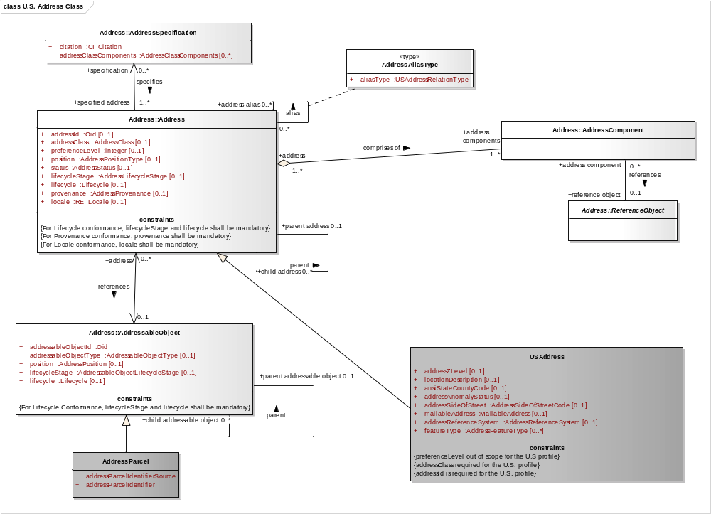
Figure B.11.1 US FGDC Profile: Address Class
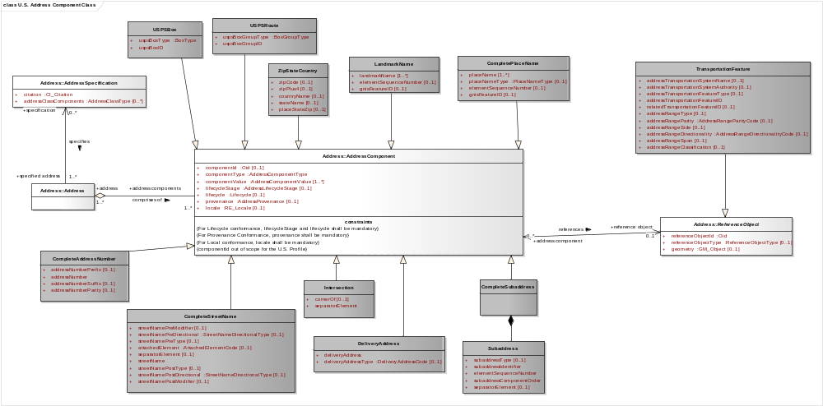
Figure B.11.2 US FGDC Profile: Component Class
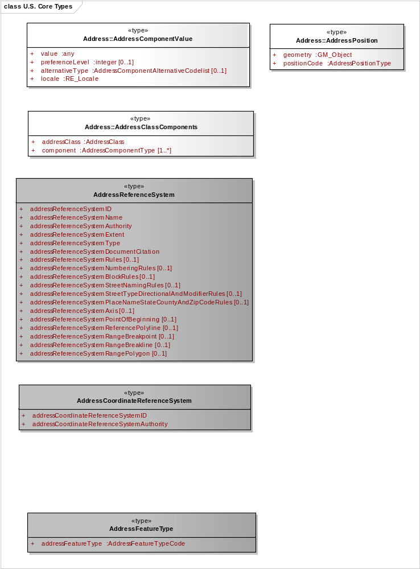
Figure B.11.3 US FGDC Profile: Types
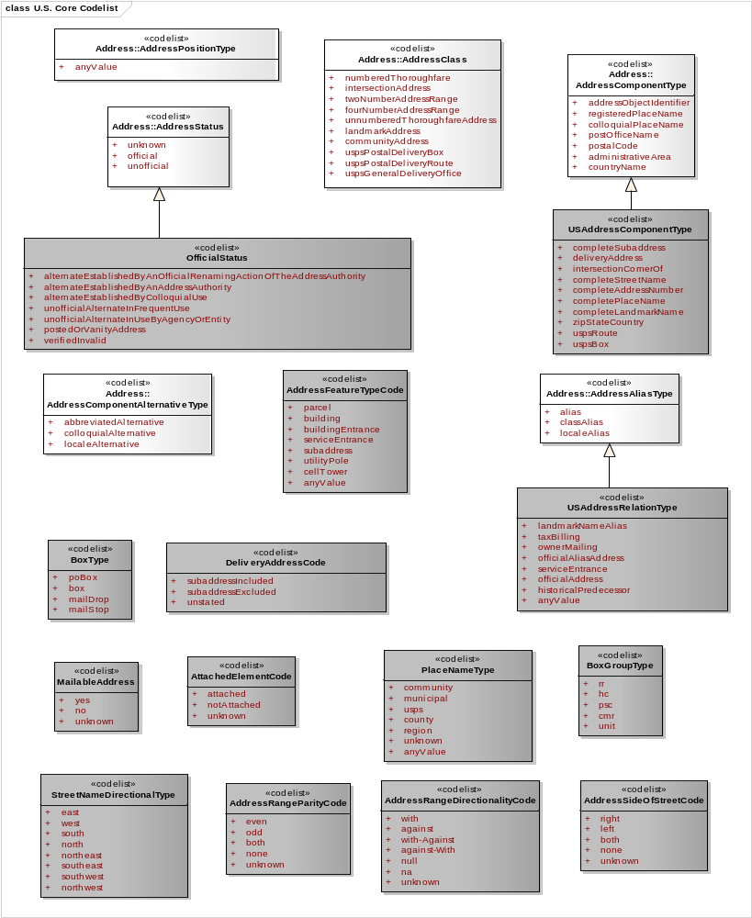
Figure B.11.4 US FGDC Profile: Core Codelists
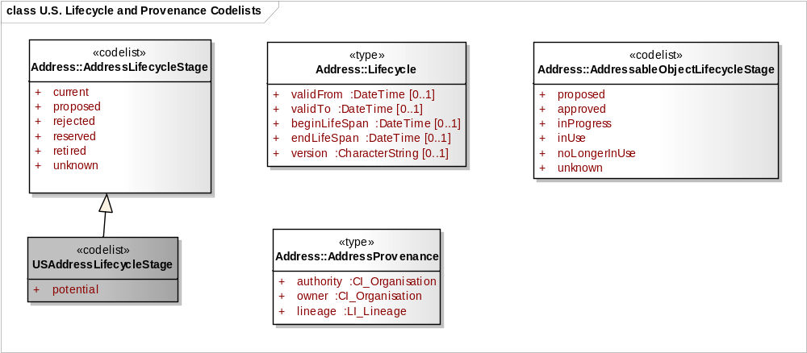
Figure B.11.5 US FGDC Profile: Lifecycle Class and Provenance Class Codelists

B.11.3 US FGDC Mapping Tables
Table B.11.1 Address mapping from US Profile of ISO 19160-1 to US Address Standard
US Profile of ISO 19160-1 Attribute: | Class | US Address Standard Attribute | Data Type | Mapping description
addressID | Address | AddressID | characterString | Map OID to US FGDC AddressID_type
addressClassCode | Address | AddressClassification | characterString | Map from AddressClassCodelist to AddressClassification.
preferenceLevel | Address | no equivalent attribute
aliasType | Address | AddressRelationType | characterString | Map data from AddressAliasType to AddressRelationType.
status | Address | OfficialStatus | characterString | Map data from AddressStatus to OfficialStatus.
position
geometry | Address | AddressXCoordinate, AddressYCoordinate | Real
geometry | Address | AddressLongitude, AddressLatitude | Real
geometry | Address | USNationalGridCoordinate | characterString | Described in FGDC-STD-011-2001.
geometry | Address | AddressElevation
geometry | Address | AddressCoordinateReferenceSystem | characterString | Combine Address CRS Authority and ID.
geometry | Address | AddressCoordinateReferenceSystemAuthority | characterString
geometry | Address | AddressCoordinateReferenceSystemID | Integer
positionCode | Address | AddressFeatureType | characterString | Map data from AddressPositionCodeType to AddressFeatureType
lifecycle.stage | Address | AddressLifecycleStatus | characterString | Map data
lifecycle.version | Address | no equivalent attribute
lifecycle.beginLifeSpan | Address | no equivalent attribute | Date (YYYYMMDD) | Map data
lifecycle.endLifeSpan | Address | no equivalent attribute | Date (YYYYMMDD) | Map data
lifecycle.validFrom | Address | AddressStartDate
lifecycle.validTo | Address | AddressEndDate
provenance.authority | Address | AddressAuthority | characterString | Map data
provenance.owner | Address | no equivalent attribute
provenance.LI_Lineage | Address | AddressDirectSource | Text
locale.name | Address | no equivalent attribute
locale.language | Address | no equivalent attribute
locale.country | Address | CountryName | characterString | Map data
locale.characterEncoding | Address | no equivalent attribute
locale.citation | Address | no equivalent attribute
parent address relationship | Address | no equivalent attribute
address alias relationship | Address | RelatedAddressID | characterString | Map addressID of alias address to RelatedAddressID.
addressFeatureType | Address | AddressFeatureType | characterString | Transfer data
addressAnomolyStatus | Address | AddressAnomolyStatus |  | Transfer data
addressSideofStreet | Address | AddressSideofStreet |  | Transfer data
addressZLevel | Address | AddressZLevel |  | Transfer data
locationDescription | Address | LocationDescription |  | Transfer data
mailableAddress | Address | MailableAddress |  | Transfer data
dataSetID | Address | DataSetID |  | Transfer data
addressReferenceSystemID | Address | AddressReferenceSystemID |  | Transfer data
addressReferenceSystemAuthority | Address | AddressReferenceSystemAuthority |  | Transfer data

Table B.11.2 Component mapping from US Profile of ISO 19160-1 to US Address Standard
US Profile of ISO 19160-1 Attribute: | Class | US Address Standard Attribute | Data Type | Mapping description
componentId | Component | no equivalent attribute
componentType | Component | Element Name |  | See mapping of specific components in this table. See Table B.11.11 for component types and their associated address classes.
componentValue | Component |  |  | Different attributes depending on the component types. See mapping of specific components in this table.
lifecycle.stage | Component | no equivalent attribute
lifecycle.version | Component | no equivalent attribute
lifecycle.beginLifeSpan | Component | no equivalent attribute
lifecycle.endLifeSpan | Component | no equivalent attribute
lifecycle.validFrom | Component | no equivalent attribute
lifecycle.validTo | Component | no equivalent attribute
provenance.authority | Component | no equivalent attribute
provenance.owner | Component | no equivalent attribute
provenance.LI_Lineage | Component | no equivalent attribute
locale.name | Component | no equivalent attribute
locale.language | Component | no equivalent attribute
locale.country | Component | no equivalent attribute
locale.characterEncoding | Component | no equivalent attribute
locale.citation | Component | no equivalent attribute
reference ReferenceObject | Component | AddressTransportationFeatureId | characterString | Key for relating feature component to transportation ReferenceObject
addressObjectIdentifier | Component | no equivalent attribute
completeAddressNumber | Component | CompleteAddressNumber | Complex data type (see profile) | Transfer data.
completeStreetName | Component | CompleteStreetName | characterString | Transfer data.
completePlaceName | Component | CompletePlaceName | Complex data type (see profile) | CompletePlaceName is comprised of PlaceName, PlaceNameType, ElementSequenceNumber, and GnisFeatureId. Transfer data.
completePlaceName.placeName | Component | PlaceName | characterString | Part of CompletePlaceName. Transfer data.
completePlaceName.placeNameType | Component | PlaceNameType | characterString | Part of CompletePlaceName. This attribute indicates if place is postal, administrative, etc. Transfer data.
completePlaceName.gnisFeatureID | Component | GnisFeatureID | characterString | Transfer data
zipStateCountry.zipCode | Component | ZipCode | characterString | Transfer data
zipStateCountry.zipPlus4 |  | ZipPlus4 | characterString | Transfer data
zipStateCountry.countryName | Component | CountryName | characterString | Transfer data
zipStateCountry.stateName | Component | StateName | characterString | Transfer data
zipStateCountry.placeStateZip | Component | PlaceStateZip | Complex data type | PlaceStateZip is comprised of ZipCode, ZipPlus4, StateName, and optionally, CountryName. Transfer data.
landmarkName | Component | LandmarkName | characterString | Transfer data
completeSubaddress | Component | CompleteSubaddress | Complex data type (see profile) | Transfer data
intersection | Component | Intersection | characterString | Transfer data
deliveryAddress | Component | DeliveryAddress | characterString | Transfer data
uspsBox | Component | USPSBox | characterString | Transfer data
uspsRoute | Component | USPSRoute | characterString | Transfer data

Table B.11.3 Addressable Object mapping from US Profile of ISO 19160-1 to US Address Standard
US Profile of ISO 19160-1 Attribute: | Class | US Address Standard Attribute | Data Type | Mapping description
addressableObjectID | AddressableObject | ParcelIdentifier | characterString | Limited to parcelIdentifier. Transfer data.
type | AddressableObject | AddressFeatureType | characterString | Limited to 'parcel'. Set AddressFeatureType to ‘parcel’.
position | AddressableObject | no equivalent attribute
lifecycle.stage | AddressableObject | no equivalent attribute
lifecycle.version | AddressableObject | no equivalent attribute
lifecycle.beginLifeSpan | AddressableObject | no equivalent attribute
lifecycle.endLifeSpan | AddressableObject | no equivalent attribute
lifecycle.validFrom | AddressableObject | no equivalent attribute
lifecycle.validTo | AddressableObject | no equivalent attribute

Table B.11.4 Specification mapping from US Profile of ISO 19160-1 to US Address Standard
US Profile of ISO 19160-1 Attribute: | Class | US Address Standard Attribute | Data Type | Mapping description
citation | Specification |  | CL_Citation
addressClasses | Specification | no equivalent attribute |  | Address Classification Matrix provides mandatory, conditional, optional, and forbidden elements for each address class.

Table B.11.5 Reference Object (Transportation Feature) mapping from US Profile of ISO 19160-1 to US Address Standard
US Profile of ISO 19160-1 Attribute: | Class | US Address Standard Attribute | Data Type | Mapping description
referenceObjectID | Reference Object | AddressTransportationSystemFeatureID | characterString | Transfer data
geometry | Reference Object | geometry | GM_Object | Transfer data
addressTransportationSystemName | Reference Object | AddressTransportationSystemName |  | Transfer data
addressTransportationSystemAuthority | Reference Object | AddressTransportationSystemAuthority |  | Transfer data
addressTransportationSystemFeatureType | Reference Object | AddressTransportationSystemFeatureType |  | Transfer data
relatedTransportationSystemName | Reference Object | RelatedTransportationSystemName |  | Transfer data
addressRangeType | Reference Object | AddressRangeType |  | Transfer data
addressRangeParity | Reference Object | AddressRangeParity |  | Transfer data
addressRangeDirectionality | Reference Object | AddressRangeDirectionality |  | Transfer data
addressRangeSpan | Reference Object | AddressRangeSpan |  | Transfer data

Table B.11.6 Address mapping from US Address Standard to US Profile of ISO 19160-1
US Profile of ISO 19160-1 Attribute: | Class | US Address Standard Attribute | Data Type | Mapping description
addressID | Address | AddressID | characterString | Map US FGDC AddressID to OID
addressClassCode | Address | AddressClassification | characterString | Map from AddressClassification to AddressClassCodelist .
preferenceLevel | Address | no equivalent attribute
aliasType | Address | AddressRelationType | characterString | Map data from AddressRelationType to AddressAliasType.
status | Address | OfficialStatus | characterString | Map data from OfficialStatus to AddressStatus.
position
geometry | Address | AddressXCoordinate, AddressYCoordinate | Real
geometry | Address | AddressLongitude, AddressLatitude | Real
geometry | Address | USNationalGridCoordinate | characterString | Described in FGDC-STD-011-2001.
geometry | Address | AddressElevation
geometry | Address | AddressCoordinateReferenceSystem | characterString | Combine Address CRS Authority and ID.
geometry | Address | AddressCoordinateReferenceSystemAuthority | characterString
geometry | Address | AddressCoordinateReferenceSystemID | Integer
positionCode | Address | AddressFeatureType no equivalent attribute | characterString | Conditional: If AddressFeatureType is a position, map data from AddressFeatureType to AddressPositionCodeType. Else, do not map to AddressPositionCodeType.
addressFeatureType | Address | AddressFeatureType | characterString | Transfer data
lifecycle.stage | Address | AddressLifecycleStatus | characterString | Map data
lifecycle.version | Address | no equivalent attribute
lifecycle.beginLifeSpan | Address | no equivalent attribute | Date (YYYYMMDD) | Map data
lifecycle.endLifeSpan | Address | no equivalent attribute | Date (YYYYMMDD) | Map data
lifecycle.validFrom | Address | AddressStartDate
lifecycle.validTo | Address | AddressEndDate
provenance.authority | Address | AddressAuthority | characterString | Map data
provenance.owner | Address | no equivalent attribute
provenance.LI_Lineage | Address | AddressDirectSource | Text
locale.name | Address | no equivalent attribute
locale.language | Address | no equivalent attribute
locale.country | Address | CountryName | characterString | Map data
locale.characterEncoding | Address | no equivalent attribute
locale.citation | Address | no equivalent attribute
parent address relationship | Address | no equivalent attribute
address alias relationship | Address | RelatedAddressID | characterString | Provide RelatedAddressID when present.
addressAnomolyStatus | Address | AddressAnomolyStatus |  | Transfer data
addressSideofStreet | Address | AddressSideofStreet |  | Transfer data
addressZLevel | Address | AddressZLevel |  | Transfer data
locationDescription | Address | LocationDescription |  | Transfer data
mailableAddress | Address | MailableAddress |  | Transfer data
dataSetID | Address | DataSetID |  | Transfer data
addressReferenceSystemID | Address | AddressReferenceSystemID |  | Transfer data
addressReferenceSystemAuthority | Address | AddressReferenceSystemAuthority |  | Transfer data

Table B.11.7 Component mapping from US Profile of ISO 19160-1 to US Address Standard
US Profile of ISO 19160-1 Attribute: | Class | US Address Standard Attribute | Data Type | Mapping description
componentId | Component | no equivalent attribute
componentType | Component | Element Name |  | See mapping of specific components in this table. See Table B.11.11 for component types and their associated address classes.
componentValue | Component |  |  | Different attributes depending on the component types. See mapping of specific components in this table.
lifecycle.stage | Component | no equivalent attribute
lifecycle.version | Component | no equivalent attribute
lifecycle.beginLifeSpan | Component | no equivalent attribute
lifecycle.endLifeSpan | Component | no equivalent attribute
lifecycle.validFrom | Component | no equivalent attribute
lifecycle.validTo | Component | no equivalent attribute
provenance.authority | Component | no equivalent attribute
provenance.owner | Component | no equivalent attribute
provenance.LI_Lineage | Component | no equivalent attribute
locale.name | Component | no equivalent attribute
locale.language | Component | no equivalent attribute
locale.country | Component | no equivalent attribute
locale.characterEncoding | Component | no equivalent attribute
locale.citation | Component | no equivalent attribute
reference ReferenceObject | Component | AddressTransportationFeatureId | characterString | Key for relating feature component to transportation ReferenceObject
addressObjectIdentifier | Component | no equivalent attribute
completeAddressNumber | Component | CompleteAddressNumber | Complex data type (see profile) | Transfer data
completeStreetName | Component | CompleteStreetName | characterString | Transfer data
completePlaceName | Component | CompletePlaceName | Complex data type (see profile) | CompletePlaceName is comprised of PlaceName, PlaceNameType, ElementSequenceNumber, and GnisFeatureId. Transfer data.
completePlaceName.placeName | Component | PlaceName | characterString | Part of CompletePlaceName. Transfer data.
completePlaceName.placeNameType | Component | PlaceNameType | characterString | Part of CompletePlaceName. This attribute indicates if place is postal, administrative, etc. Transfer data.
completePlaceName.gnisFeatureID | Component | GnisFeatureID | characterString | Transfer data
zipStateCountry.zipCode | Component | ZipCode | characterString | Transfer data
zipStateCountry.zipPlus4 |  | ZipPlus4 | characterString | Transfer data
zipStateCountry.countryName | Component | CountryName | characterString | Transfer data
zipStateCountry.stateName | Component | StateName | characterString | Transfer data
zipStateCountry.placeStateZip | Component | PlaceStateZip | Complex data type | PlaceStateZip is comprised of ZipCode, ZipPlus4, StateName, and optionally, CountryName. Transfer data.
landmarkName | Component | LandmarkName | characterString | Transfer data
completeSubaddress | Component | CompleteSubaddress | Complex data type (see profile) | Transfer data
intersection | Component | Intersection | characterString | Transfer data
deliveryAddress | Component | DeliveryAddress | characterString | Transfer data
uspsBox | Component | USPSBox | characterString | Transfer data
uspsRoute | Component | USPSRoute | characterString | Transfer data

Table B.11.8 Addressable Object mapping from US Address Standard to US Profile of ISO 19160-1
US Profile of ISO 19160-1 Attribute: | Class | US Address Standard Attribute | Data Type | Mapping description
addressableObjectID | AddressableObject | parcelIdentifier | characterString | Limited to parcelIdentifier. Transfer data.
addressableObjectType | AddressableObject | AddressFeatureType | characterString | Limited to 'parcel'. Set addressableObjectType to ‘parcel’.
position | AddressableObject | no equivalent attribute
lifecycle.stage | AddressableObject | no equivalent attribute
lifecycle.version | AddressableObject | no equivalent attribute
lifecycle.beginLifeSpan | AddressableObject | no equivalent attribute
lifecycle.endLifeSpan | AddressableObject | no equivalent attribute
lifecycle.validFrom | AddressableObject | no equivalent attribute
lifecycle.validTo | AddressableObject | no equivalent attribute

Table B.11.9 Specification mapping from US Address Standard to US Profile of ISO 19160-1
US Profile of ISO 19160-1 Attribute: | Class | US Address Standard Attribute | Data Type | Mapping description
citation | Specification |  | CL_Citation | Transfer data
addressClasses | Specification | no equivalent attribute

Table B.11.10 Reference Object (Transportation Feature) mapping from US Address Standard to US Profile of ISO 19160-1
US Profile of ISO 19160-1 Attribute: | Class | US Address Standard Attribute | Data Type | Mapping description
referenceObjectID | Reference Object | AddressTransportationSystemFeatureID | characterString | Transfer data
geometry | Reference Object | geometry | GM_Object | Transfer data
addressTransportationSystemName | Reference Object | AddressTransportationSystemName |  | Transfer data
addressTransportationSystemAuthority | Reference Object | AddressTransportationSystemAuthority |  | Transfer data
addressTransportationSystemFeatureType | Reference Object | AddressTransportationSystemFeatureType |  | Transfer data
relatedTransportationSystemName | Reference Object | RelatedTransportationSystemName |  | Transfer data
addressRangeType | Reference Object | AddressRangeType |  | Transfer data
addressRangeParity | Reference Object | AddressRangeParity |  | Transfer data
addressRangeDirectionality | Reference Object | AddressRangeDirectionality |  | Transfer data
addressRangeSpan | Reference Object | AddressRangeSpan |  | Transfer data

B.11.4 US FGDC Address Classification Tables
Table B.11.11 US Address Standard- Classification Matrix
Element | ISO 19160-1 Element | US Address Class
Element | ISO 19160-1 Element | Numbered Thoroughfare | Unnumberered Thoroughfare | Landmark | Community | USPS Postal Delivery Route | General | Intersection | USPS Postal Delivery Box |  | USPS Postal Delivery Office | Two Number Range | Four Number Range
GeneralAddress | DeliveryAddress | F | F | F | F | F | M | F | F |  | F | F | F
USPSBox | USPSBox | F | F | F | F | F | F | F | M |  | F | F | F
USPSGeneralDeliveryPoint | USPSRoute | F | F | F | F | F | C | F | F |  | M | F | F
USPSAddress | USPSRoute | F | F | F | F | M | F | F | F |  | F | F | F
DeliveryAddress | DeliveryAddress | F | F | F | F | F | C | F | F |  | F | F | F
CompleteLandmarkName | CompleteLandmarkName | O | O | M | C | F | F | O | F |  | F | O | O
CompletePlaceName | CompletePlaceName | O | O | F | C | F | F | O | F |  | F | O | O
CompleteAddressNumber | CompleteAddressNumber | M | F | F | M | F | F | F | F |  | F | M | M
SeparatorElement | Intersection | F | F | F | F | F | F | M | F |  | F | M | F
CornerOf | Intersection | F | F | F | F | F | F | O | F |  | F | F | F
CompleteStreetName | CompleteStreetName | M | M | F | F | F | F | M | F |  | F | M | M
CompleteSubAddress | CompleteSubAddress | O | O | O | O | O | C | F | F |  | F | F | F
CompletePlaceName | CompletePlaceName | C | C | C | C | C | C | C | C |  | C | C | C
StateName | ZipStateCountry | C | C | C | C | C | C | C | C |  | C | C | C
ZipCode | ZipStateCountry | C | C | C | C | C | C | C | C |  | C | C | C
ZipPlus4 | ZipStateCountry | C | C | C | C | C | C | C | C |  | C | C | C
CountryName | ZipStateCountry | C | C | C | C | C | C | C | C |  | C | C | C
PlaceStateZip | ZipStateCountry | C | C | C | C | C | C | C | C |  | C | C | C
AddressID | AddressID | M | M | M | M | M | M | M | M |  | M | M | M
ansiStateCountyCode | USAddress | O | O | O | O | O | O | O | O |  | O | O | O
AddressAuthority |  | O | O | O | O | O | O | O | O |  | O | O | O
RelatedAddressID |  | O | O | O | O | O | O | O | O |  | O | O | O
AddressXCoordinate |  | O | O | O | O | O | O | O | O |  | O | O | O
AddressYCoordinate |  | O | O | O | O | O | O | O | O |  | O | O | O
AddressLatitude |  | O | O | O | O | O | O | O | O |  | O | O | O
AddressLongitude |  | O | O | O | O | O | O | O | O |  | O | O | O
USNationalGridCoordinate |  | O | O | O | O | O | O | O | O |  | O | O | O
AddressElevation |  | O | O | O | O | O | O | O | O |  | O | O | O
AddressCoordinateReferenceSystem | USAddress | O | O | O | O | O | O | O | O |  | O | O | O
AddressParcelIdentifierSource | AddressParcel | O | O | O | O | O | O | O | O |  | O | O | O
AddressParcelIdentifier | AddressParcel | O | O | O | O | O | O | O | O |  | O | O | O
AddressTransportationSystemName | TransportationFeature | O | O | O | O | O | O | O | O |  | O | O | O
AddressTransportationSystemAuthority | TransportationFeature | O | O | O | O | O | O | O | O |  | O | O | O
AddressTransportationFeatureType | TransportationFeature | O | O | O | O | O | O | O | O |  | O | O | O
AddressTransportationFeatureID | TransportationFeature | O | O | O | O | O | O | O | O |  | O | O | O
relatedTransportationFeatureID | TransportationFeature | O | O | O | O | O | O | O | O |  | O | O | O
AddressRangeType | TransportationFeature | O | O | O | O | O | O | O | O |  | O | O | O
AddressRangeParity | TransportationFeature | O | O | O | O | O | O | O | O |  | O | O | O
AddressRangeSide | TransportationFeature | O | O | O | O | O | O | O | O |  | O | O | O
AddressRangeDirectionality | TransportationFeature | O | O | O | O | O | O | O | O |  | O | O | O
AddressRangeSpan | TransportationFeature | O | O | O | O | O | O | O | O |  | O | O | O
addressRangeClassification | TransportationFeature | O | O | O | O | O | O | O | O |  | O | O | O
AddressClassification |  | O | O | O | O | O | O | O | O |  | O | O | O
AddressFeatureType |  | O | O | O | O | O | O | O | O |  | O | O | O
AddressLifecycleStatus |  | O | O | O | O | O | O | O | O |  | O | O | O
OfficialStatus |  | O | O | O | O | O | O | O | O |  | O | O | O
AddressAnomalyStatus | USAddress | O | O | O | O | O | O | O | O |  | O | O | O
AddressSideOfStreet | USAddress | O | O | O | O | O | O | O | O |  | O | O | O
AddressZLevel | USAddress | O | O | O | O | O | O | O | O |  | O | O | O
LocationDescription | USAddress | O | O | O | O | O | O | O | O |  | O | O | O
MailableAddress | USAddress | O | O | O | O | O | O | O | O |  | O | O | O
AddressStartDate |  | O | O | O | O | O | O | O | O |  | O | O | O
AddressEndDate |  | O | O | O | O | O | O | O | O |  | O | O | O
DataSetID |  | O | O | O | O | O | O | O | O |  | O | O | O
AddressReferenceSystem | USAddress | O | O | O | O | O | O | O | O |  | O | O | O
AddressReferenceSystemId |  | O | O | O | O | O | O | O | O |  | O | O | O
AddressReferenceSystemAuthority |  | O | O | O | O | O | O | O | O |  | O | O | O
AddressDirectSource |  | O | O | O | O | O | O | O | O |  | O | O | O
 |  |  |  |  |  |  |  |  |  | Key
 |  |  |  |  |  |  |  |  |  | F: Forbidden
 |  |  |  |  |  |  |  |  |  | M: Mandatory
 |  |  |  |  |  |  |  |  |  | C: Conditional
 |  |  |  |  |  |  |  |  |  | O: Optional
 |  |  |  |  |  |  |  |  |  | Can not be mapped to ISO Profile elements

Table B.11.12 US Address Standard- Address Classes Syntax Table

Numbered Thoroughfare Address
Syntax: { Complete Landmark Name or Complete Place Name } + { Complete Address Number * } + { Complete Street Name * } + { Complete Subaddress } + { Complete Place Name * } + { State Name * } + { Zip Code } + { Zip Plus 4 } + { Country Name }

Intersection Address

Syntax: { Complete Landmark Name or Complete Place Name } + { Corner Of } + { Complete Street Name * { Separator Element * } } (2..n) + { Complete Place Name *} + { State Name *} + { Zip Code } + { Zip Plus 4 } + { Country Name }

Two Number Address Range

Syntax: { Complete Landmark Name or Complete Place Name } + { Complete Address Number (low) *} + { Separator Element *} + { Complete Address Number (high)*} +{ Complete Street Name * } + { Complete Place Name * } + { State Name * } + { Zip Code } + { Zip Plus 4 } + { Country Name }

Four Number Address Range

Syntax: { Complete Landmark Name or Complete Place Name } + { Complete Address Number *(left low) } + { Complete Address Number *(left high) } + { Complete Address Number * (right low) } + { Complete Address Number * (right high) }+{ Complete Street Name * } + { Complete Place Name * } + { State Name * } + { Zip Code } + { Zip Plus 4 } + { Country Name }

Unnumbered Thoroughfare Address

Syntax: { Complete Landmark Name or Complete Place Name } + { Complete Street Name * } + { Complete Subaddress } + { Complete Place Name * } + { State Name * } + { Zip Code } + { Zip Plus 4 } + { Country Name }

Landmark Address

Syntax: { Complete Landmark Name * } (1..n) + { Complete Subaddress } + { Complete Place Name * } + { State Name * } + { Zip Code } + { Zip Plus 4 } + { Country Name }

Community Address

Syntax: { Complete Address Number * } + { Complete Landmark Name or Complete Place Name * } + { Complete Subaddress } + { Complete Place Name * } + { State Name * } + { Zip Code } + { Zip Plus 4 } + { Country Name }

USPSPostal Delivery Box

Syntax: { Usps Box* } + { Complete Subaddress } + { Complete Place Name * } + { State Name * } + { Zip Code } + { Zip Plus 4 } + { Country Name }

Usps Box Format: Usps Box = "PO Box"* + { USPSBox ID * }

USPSPostal Delivery Route
Syntax: { Usps Address * } + { Complete Place Name * } + { State Name * } + { Zip Code } + { Zip Plus 4 } + { Country Name }
Type 1: Rural Route (RR) or Highway Contract Route (HC):
Usps Address = "RR" or "HC" + { USPSBox Group ID * } + "BOX" + { USPSBox ID * } + { Private Mail Box }
Type 2: Overseas Military or Diplomatic Delivery:
Usps Address = "PSC" or "CMR" or "UNIT" + { USPSBox Group ID * } + "BOX" + { USPSBox ID * }
NOTE 1: In this type, the Complete Place Name must be "APO" or "FPO" or "DPO"
NOTE 2: In this type, the State Name must be "AE" or "AP" or "AA"

USPSGeneral Delivery Office
Syntax: { USPSGeneral Delivery Point * } + { Complete Place Name * } + { State Name * } + { Zip Code } + { Zip Plus 4 } + { Country Name }
Type 1: General Delivery:
USPSGeneralDeliveryPoint = "GENERAL DELIVERY" *
Type 2: Overseas Military Address:
USPSGeneralDeliveryPoint = [A ship's name]
NOTE 1: In this type, the Complete Place Name must be "APO" or "FPO" or "DPO"
NOTE 2: In this type, the State Name must be "AE" or "AP" or "AA"

General Address Class
Syntax:
Type 1: The complete address as a single unparsed string of text.
Type 2: The complete address with place, state and zip code parsed out to a single field
{ Delivery Address *} + { Place State ZIP *}
Type 3: The complete address with place, state and zip code parsed out to separate fields
{ Delivery Address * } + { Complete Place Name * } + { State Name * } + { Zip Code } + { Zip Plus 4 } + { Country Name }

B.11.5 US FGDC Profile Instance Diagrams
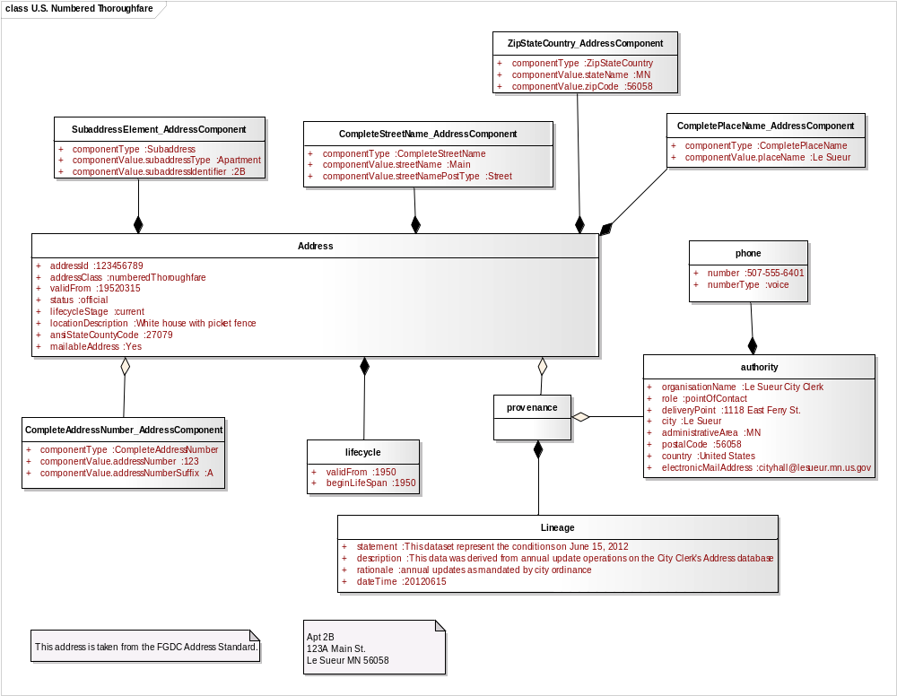
Figure B.11.6 US FGDC Profile Instance: US Numbered Thoroughfare Address
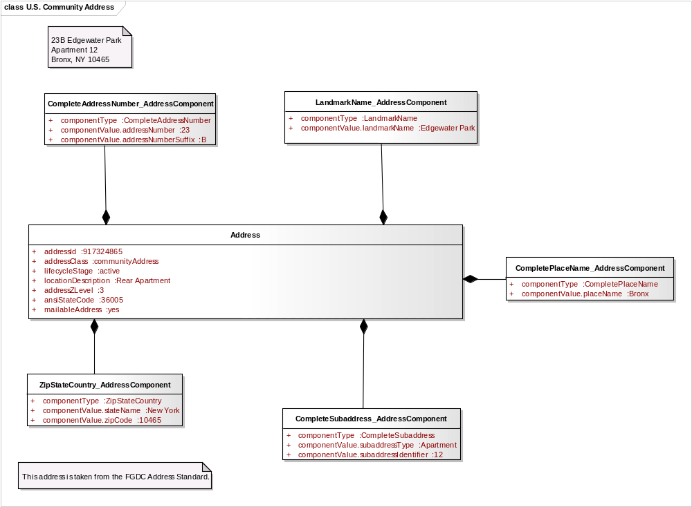
Figure B.11.7 US FGDC Profile Instance: US Community Address
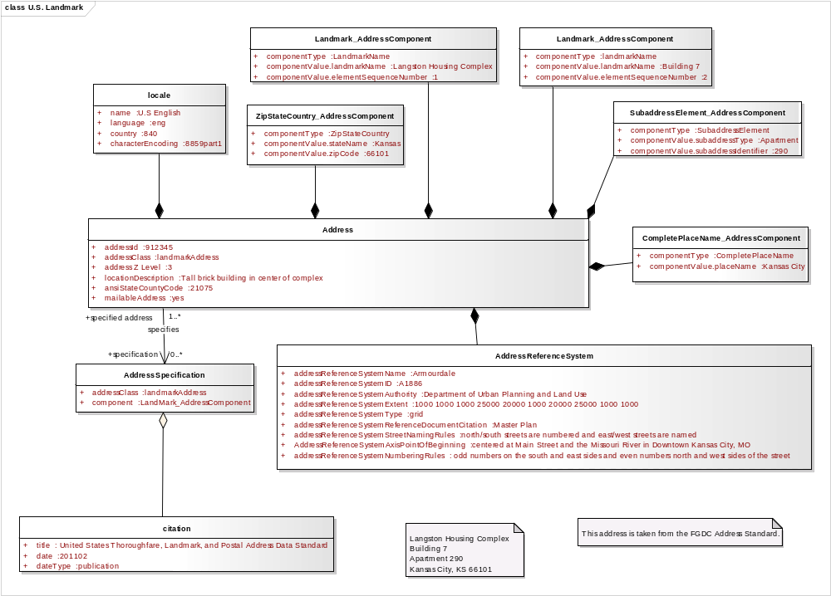
Figure B.11.8 US FGDC Profile Instance: US Landmark Address
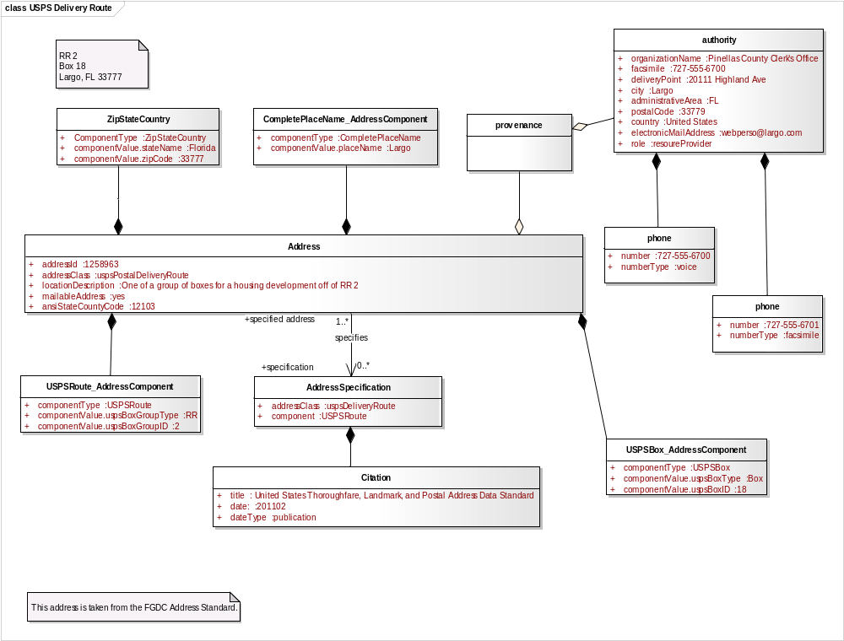
Figure B.11.9 US FGDC Profile Instance: USPS Delivery Route Address
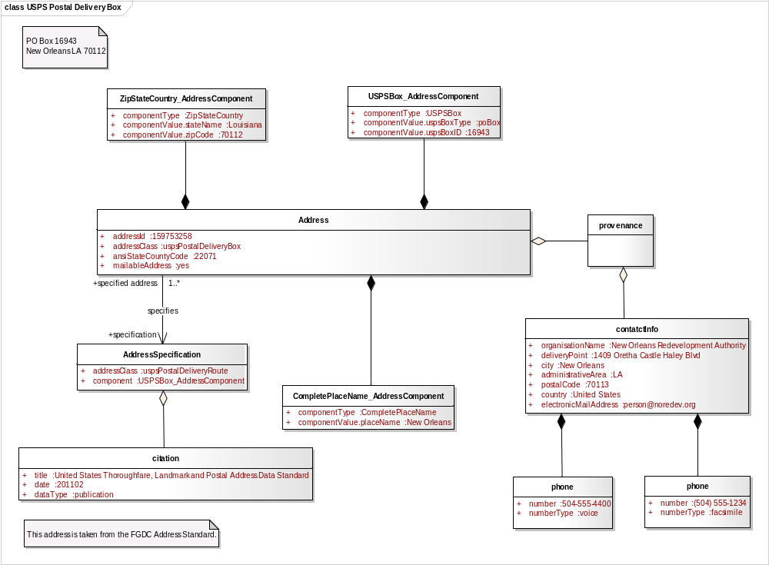
Figure B.11.10 US FGDC Profile Instance: USPS Postal Delivery Box
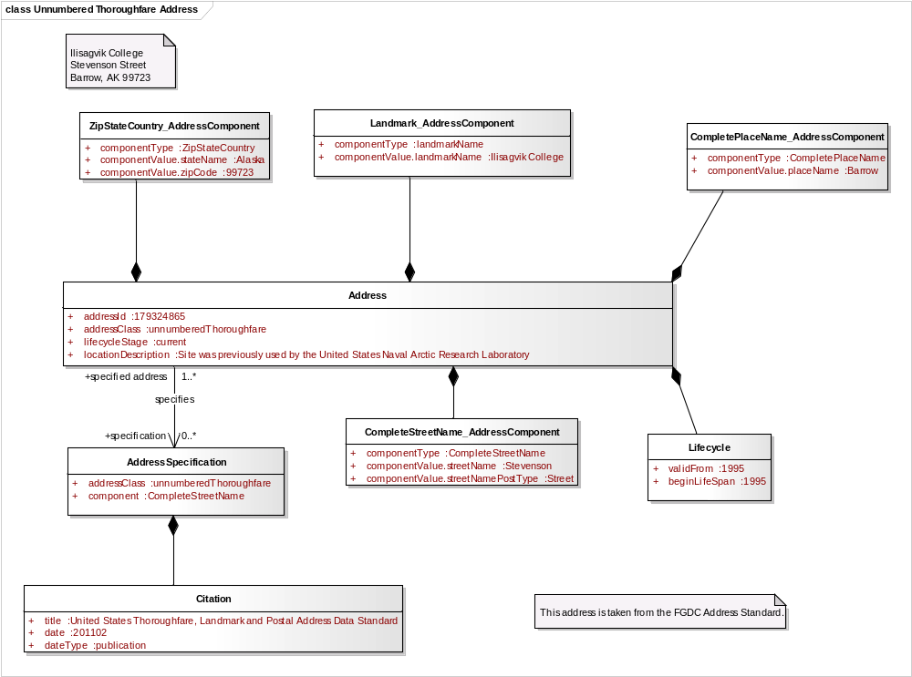
Figure B.11.11 US FGDC Profile Instance: US Unnumbered Thoroughfare Address
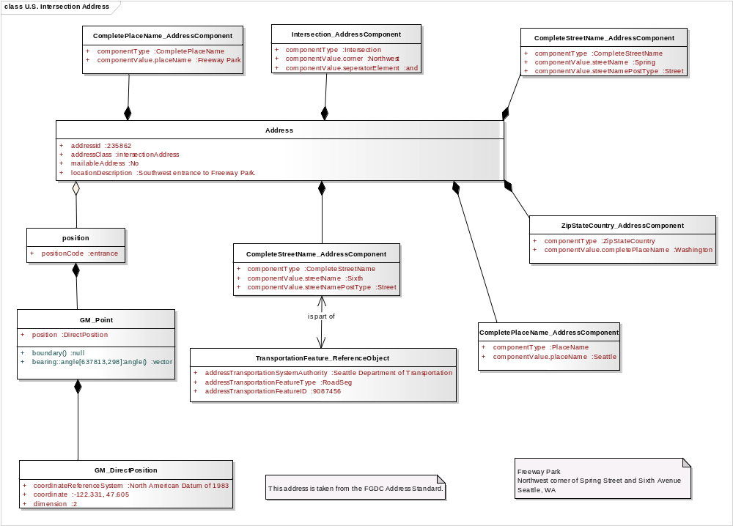
Figure B.11.12 US FGDC Profile Instance: US Intersection Address

