B.11 US FGDC profile

B.11.1 Introduction
The US FGDC profile conforms to the core, lifecycle, and provenance classes.
The US FGDC profile represents addresses specified by FGDC-STD-016-2011: FGDC United States Thoroughfare, Landmark, and Postal Address Data Standard.

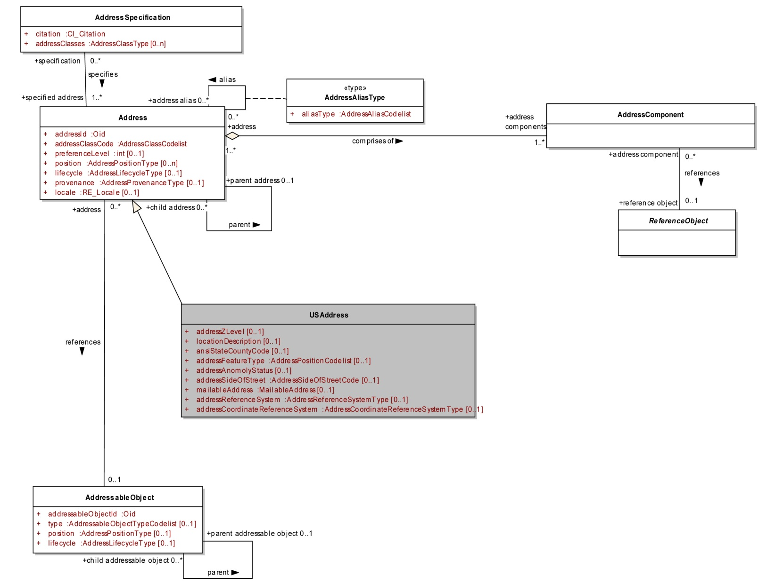
B.11.2 Diagrams
Figure B.11.1 US FGDC Profile: Address Class

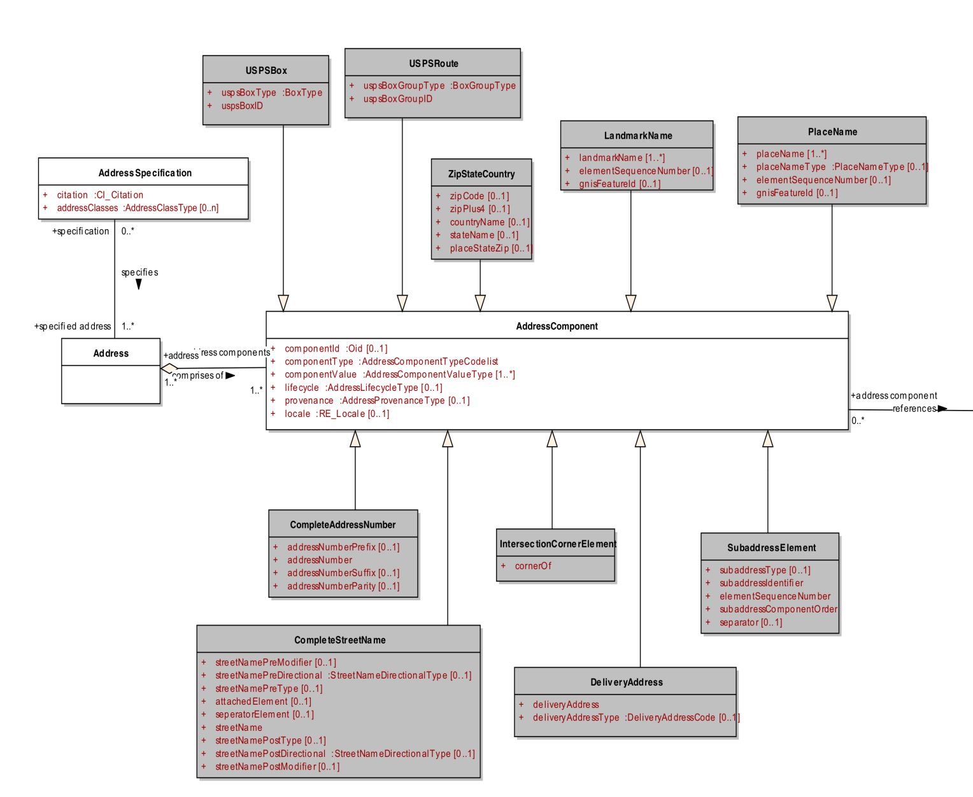
Figure B.11.2A US FGDC Profile: Component Class

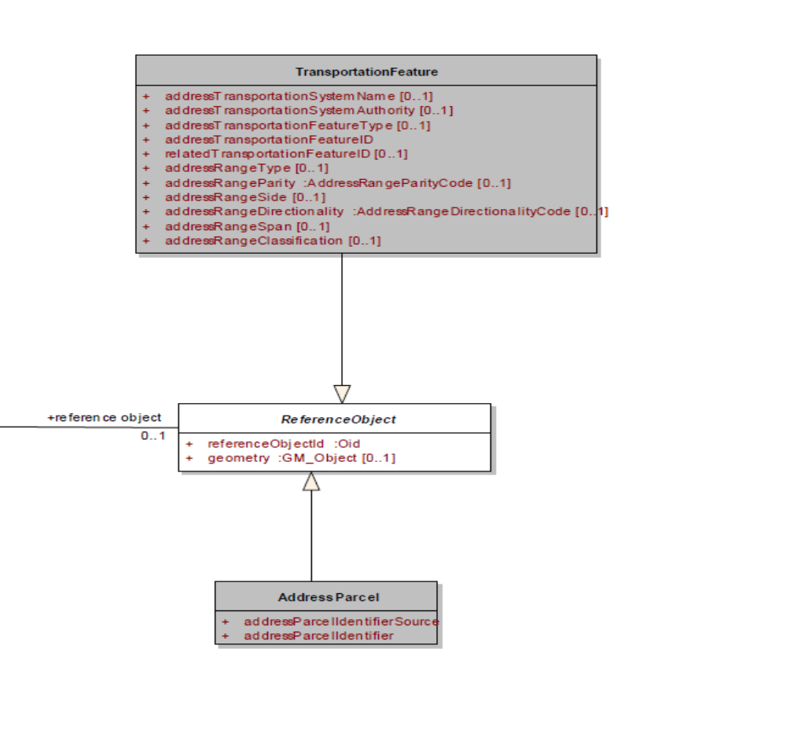
Figure B.11.2B US FGDC Profile: Component Class
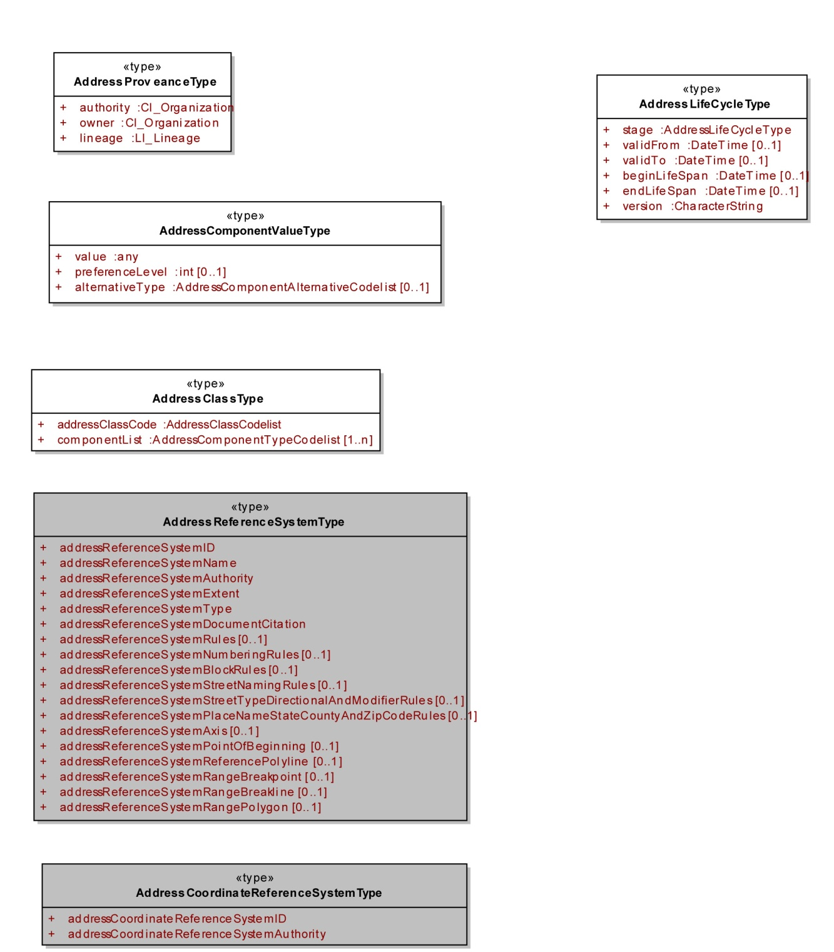
Figure B.11.3 US FGDC Profile: Types

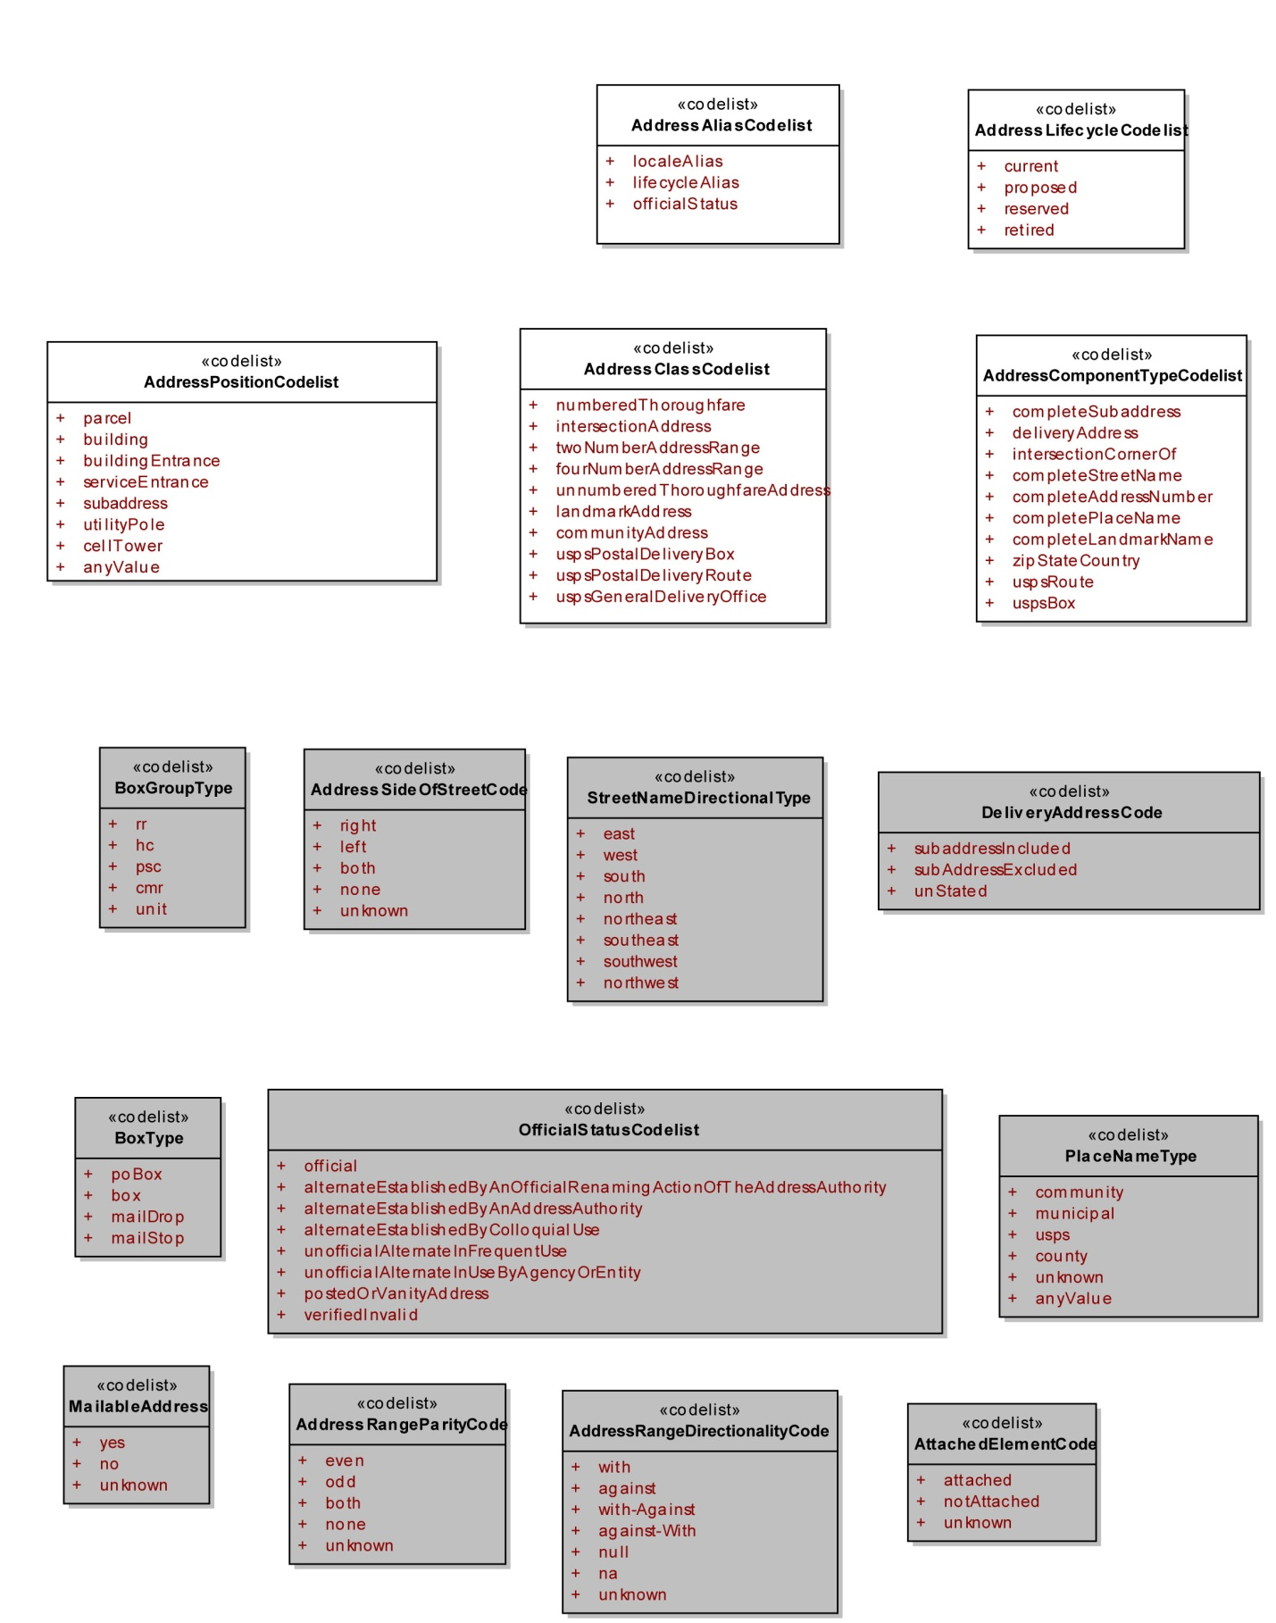
Figure B.11.4 US FGDC Profile: Codelists

B.11.3 US FGDC Mapping Tables
Table B.11.1 Address mapping from US Profile of ISO 19160-1 to US Address Standard
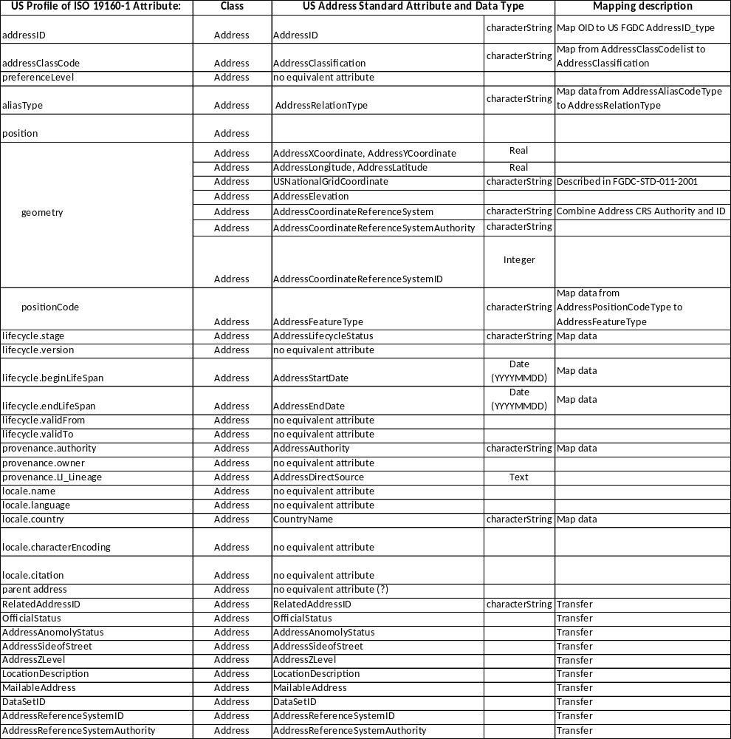

Table B.11.2 Component mapping from US Profile of ISO 19160-1 to US Address Standard
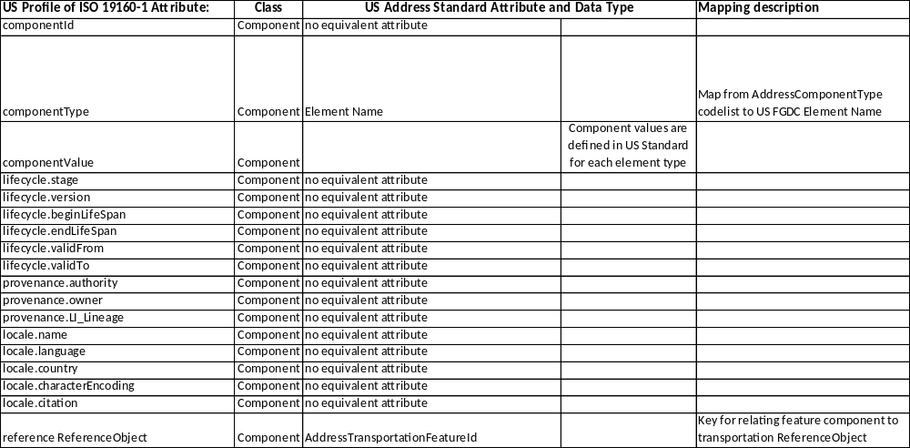
Table B.11.3 Addressable Object mapping from US Profile of ISO 19160-1 to US Address Standard
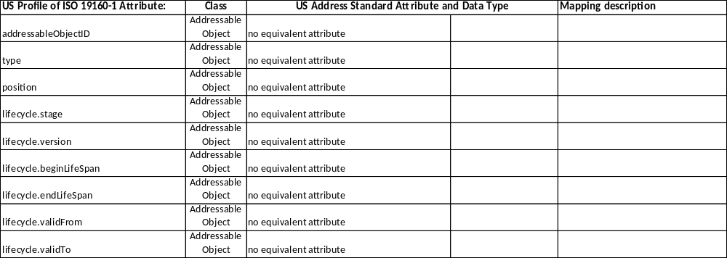
Table B.11.4 Specification mapping from US Profile of ISO 19160-1 to US Address Standard

Table B.11.5 Reference Object (Transportation Feature) mapping from US Profile of ISO 19160-1 to US Address Standard – under development
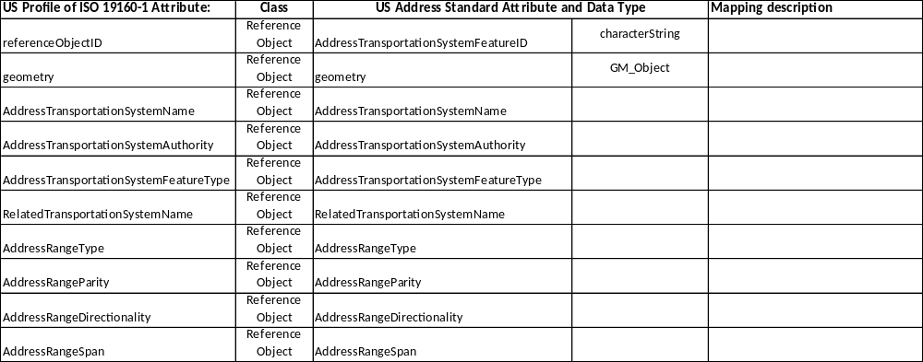
Table B.11.6 Reference Object (Cadastral) mapping from US Profile of ISO 19160-1 to US Address Standard – under development

*Mappings from US Address Standard to US Profile need to be developed.
**US instance data needs to be developed.

