U.S. Department of Commerce
U.S. Profile Diagrams, Mapping Tables, Class Syntax Tables and Instances for the U.S Profile to ISO 19160-1
7/15/2013 Version
By Sean Uhl, Matthew McCready
7/15/2013

[Type the abstract of the document here. The abstract is typically a short summary of the contents of the document. Type the abstract of the document here. The abstract is typically a short summary of the contents of the document.]

B.11 US FGDC Profile

B.11.1 Introduction
The US FGDC profile conforms to the core, lifecycle, and provenance classes.
The US FGDC profile represents addresses specified by FGDC-STD-016-2011: FGDC United States Thoroughfare, Landmark, and Postal Address Data Standard.

B.11.2 US FGDC Profile Diagrams
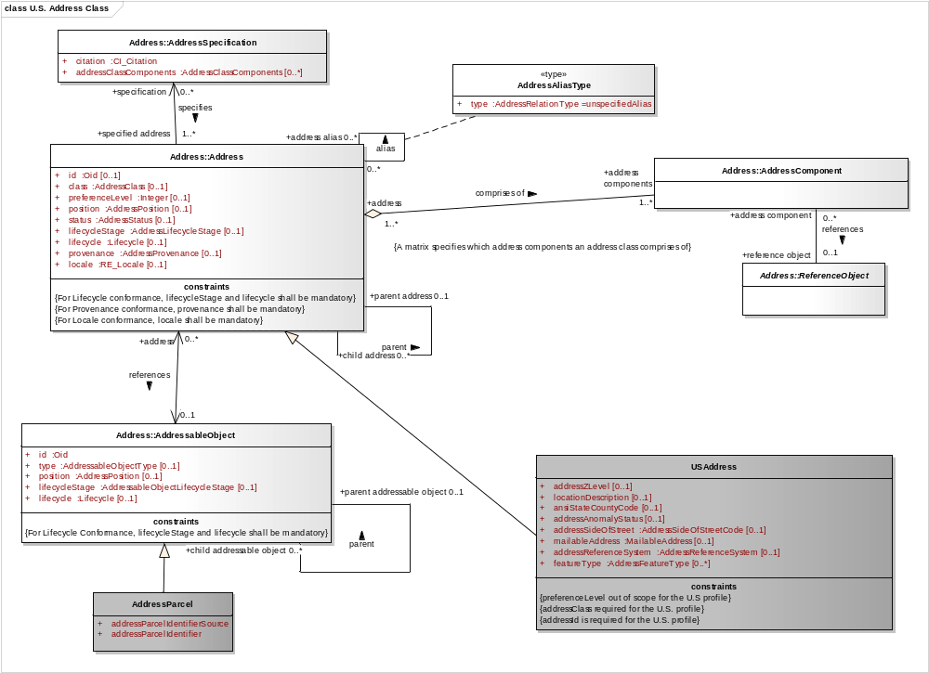
Figure B.11.1 US FGDC Profile: Address Class
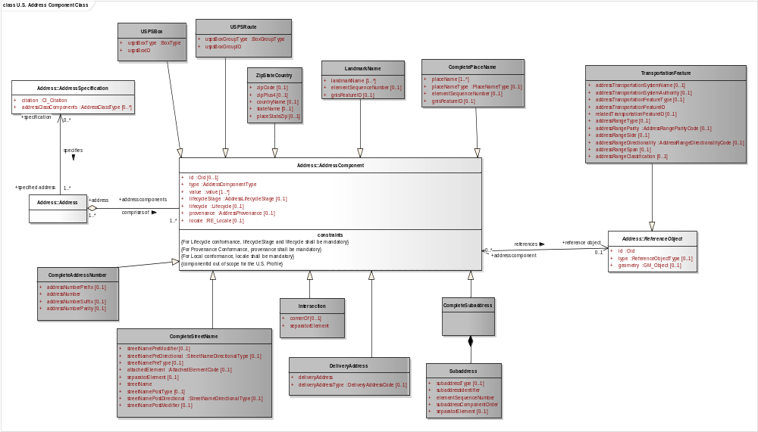
Figure B.11.2 US FGDC Profile: Component Class
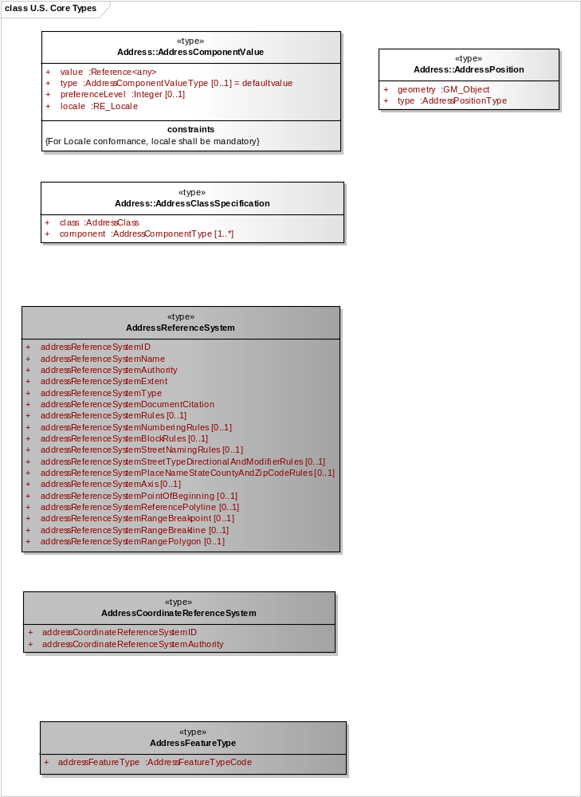
Figure B.11.3 US FGDC Profile: Types
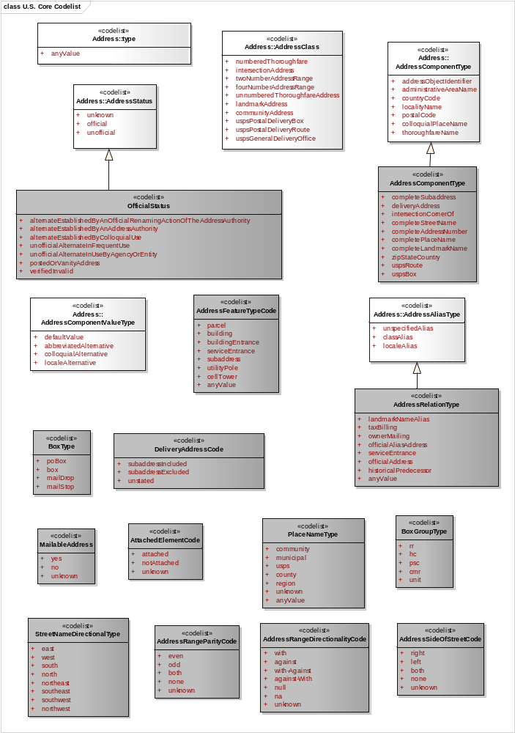
Figure B.11.4 US FGDC Profile: Core Codelists
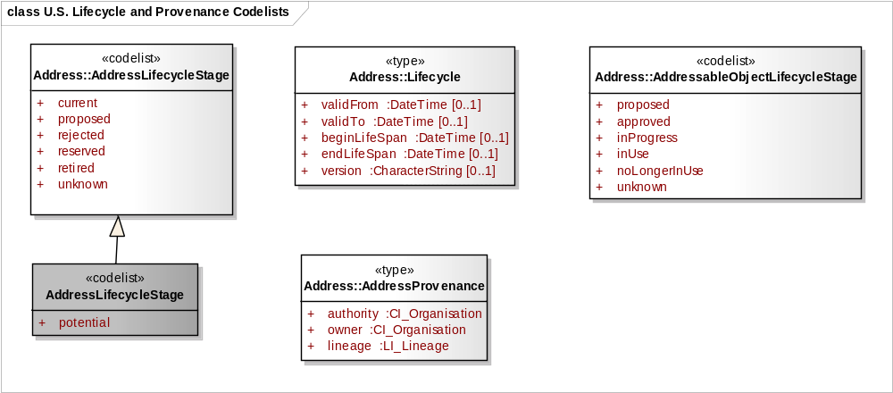
Figure B.11.5 US FGDC Profile: Lifecycle Class and Provenance Class Codelists

B.11.3 US FGDC Mapping Tables
Table B.11.1 Address mapping from US Profile of ISO 19160-1 to US Address Standard
US Profile of ISO 19160-1 Attribute: | Class | US Address Standard Attribute | Data Type | Mapping description
id | Address | AddressID | characterString | Map OID to US FGDC AddressID_type
class | Address | AddressClassification | characterString | Map from AddressClassCodelist to AddressClassification.
preferenceLevel | Address | no equivalent attribute
aliasType | Address | AddressRelationType | characterString | Map data from AddressAliasType to AddressRelationType.
status | Address | OfficialStatus | characterString | Map data from AddressStatus to OfficialStatus.
position
geometry | Address | AddressXCoordinate, AddressYCoordinate | Real
geometry | Address | AddressLongitude, AddressLatitude | Real
geometry | Address | USNationalGridCoordinate | characterString | Described in FGDC-STD-011-2001.
geometry | Address | AddressElevation
geometry | Address | AddressCoordinateReferenceSystem | characterString | Combine Address CRS Authority and ID.
geometry | Address | AddressCoordinateReferenceSystemAuthority | characterString
geometry | Address | AddressCoordinateReferenceSystemID | Integer
positionCode | Address | AddressFeatureType | characterString | Map data from AddressPositionCodeType to AddressFeatureType
lifecycle.stage | Address | AddressLifecycleStatus | characterString | Map data
lifecycle.version | Address | no equivalent attribute
lifecycle.beginLifeSpan | Address | no equivalent attribute | Date (YYYYMMDD) | Map data
lifecycle.endLifeSpan | Address | no equivalent attribute | Date (YYYYMMDD) | Map data
lifecycle.validFrom | Address | AddressStartDate
lifecycle.validTo | Address | AddressEndDate
provenance.authority | Address | AddressAuthority | characterString | Map data
provenance.owner | Address | no equivalent attribute
provenance.LI_Lineage | Address | AddressDirectSource | Text
locale.name | Address | no equivalent attribute
locale.language | Address | no equivalent attribute
locale.country | Address | CountryName | characterString | Map data
locale.characterEncoding | Address | no equivalent attribute
locale.citation | Address | no equivalent attribute
parent address relationship | Address | no equivalent attribute
address alias relationship | Address | RelatedAddressID | characterString | Map addressID of alias address to RelatedAddressID.
addressFeatureType | Address | AddressFeatureType | characterString | Transfer data
addressAnomolyStatus | Address | AddressAnomolyStatus |  | Transfer data
addressSideofStreet | Address | AddressSideofStreet |  | Transfer data
addressZLevel | Address | AddressZLevel |  | Transfer data
locationDescription | Address | LocationDescription |  | Transfer data
mailableAddress | Address | MailableAddress |  | Transfer data
dataSetID | Address | DataSetID |  | Transfer data
addressReferenceSystemID | Address | AddressReferenceSystemID |  | Transfer data
addressReferenceSystemAuthority | Address | AddressReferenceSystemAuthority |  | Transfer data

Table B.11.2 Component mapping from US Profile of ISO 19160-1 to US Address Standard
US Profile of ISO 19160-1 Attribute: | Class | US Address Standard Attribute | Data Type | Mapping description
id | Component | no equivalent attribute
type | Component | Element Name |  | See mapping of specific components in this table. See Table B.11.11 for component types and their associated address classes.
value | Component |  |  | Different attributes depending on the component types. See mapping of specific components in this table.
lifecycle.stage | Component | no equivalent attribute
lifecycle.version | Component | no equivalent attribute
lifecycle.beginLifeSpan | Component | no equivalent attribute
lifecycle.endLifeSpan | Component | no equivalent attribute
lifecycle.validFrom | Component | no equivalent attribute
lifecycle.validTo | Component | no equivalent attribute
provenance.authority | Component | no equivalent attribute
provenance.owner | Component | no equivalent attribute
provenance.LI_Lineage | Component | no equivalent attribute
locale.name | Component | no equivalent attribute
locale.language | Component | no equivalent attribute
locale.country | Component | no equivalent attribute
locale.characterEncoding | Component | no equivalent attribute
locale.citation | Component | no equivalent attribute
reference ReferenceObject | Component | AddressTransportationFeatureId | characterString | Key for relating feature component to transportation ReferenceObject
completeAddressNumber | Component | CompleteAddressNumber | Complex data type (see profile) | Transfer data.
completeStreetName | Component | CompleteStreetName | characterString | Transfer data.
completePlaceName | Component | CompletePlaceName | Complex data type (see profile) | CompletePlaceName is comprised of PlaceName, PlaceNameType, ElementSequenceNumber, and GnisFeatureId. Transfer data.
completePlaceName.placeName | Component | PlaceName | characterString | Part of CompletePlaceName. Transfer data.
completePlaceName.placeNameType | Component | PlaceNameType | characterString | Part of CompletePlaceName. This attribute indicates if place is postal, administrative, etc. Transfer data.
completePlaceName.gnisFeatureID | Component | GnisFeatureID | characterString | Transfer data
zipStateCountry.zipCode | Component | ZipCode | characterString | Transfer data
zipStateCountry.zipPlus4 |  | ZipPlus4 | characterString | Transfer data
zipStateCountry.countryName | Component | CountryName | characterString | Transfer data
zipStateCountry.stateName | Component | StateName | characterString | Transfer data
zipStateCountry.placeStateZip | Component | PlaceStateZip | Complex data type | PlaceStateZip is comprised of ZipCode, ZipPlus4, StateName, and optionally, CountryName. Transfer data.
landmarkName | Component | LandmarkName | characterString | Transfer data
completeSubaddress | Component | CompleteSubaddress | Complex data type (see profile) | Transfer data
intersection | Component | Intersection | characterString | Transfer data
deliveryAddress | Component | DeliveryAddress | characterString | Transfer data
uspsBox | Component | USPSBox | characterString | Transfer data
uspsRoute | Component | USPSRoute | characterString | Transfer data

Table B.11.3 Addressable Object mapping from US Profile of ISO 19160-1 to US Address Standard
US Profile of ISO 19160-1 Attribute: | Class | US Address Standard Attribute | Data Type | Mapping description
id | AddressableObject | ParcelIdentifier | characterString | Limited to parcelIdentifier. Transfer data.
type | AddressableObject | AddressFeatureType | characterString | Limited to 'parcel'. Set AddressFeatureType to ‘parcel’.
position | AddressableObject | no equivalent attribute
lifecycle.stage | AddressableObject | no equivalent attribute
lifecycle.version | AddressableObject | no equivalent attribute
lifecycle.beginLifeSpan | AddressableObject | no equivalent attribute
lifecycle.endLifeSpan | AddressableObject | no equivalent attribute
lifecycle.validFrom | AddressableObject | no equivalent attribute
lifecycle.validTo | AddressableObject | no equivalent attribute

Table B.11.4 Specification mapping from US Profile of ISO 19160-1 to US Address Standard
US Profile of ISO 19160-1 Attribute: | Class | US Address Standard Attribute | Data Type | Mapping description
citation | Specification |  | CL_Citation
addressClassesComponents | Specification | no equivalent attribute |  | Address Classification Matrix provides mandatory, conditional, optional, and forbidden elements for each address class.

Table B.11.5 Reference Object (Transportation Feature) mapping from US Profile of ISO 19160-1 to US Address Standard
US Profile of ISO 19160-1 Attribute: | Class | US Address Standard Attribute | Data Type | Mapping description
id | Reference Object | AddressTransportationSystemFeatureID | characterString | Transfer data
type | Reference Object | AddressTransportationSystemFeatureType |  | Transfer data
geometry | Reference Object | Geometry | GM_Object | Transfer data
addressTransportationSystemName | Reference Object | AddressTransportationSystemName |  | Transfer data
addressTransportationSystemAuthority | Reference Object | AddressTransportationSystemAuthority |  | Transfer data
relatedTransportationSystemName | Reference Object | RelatedTransportationSystemName |  | Transfer data
addressRangeType | Reference Object | AddressRangeType |  | Transfer data
addressRangeParity | Reference Object | AddressRangeParity |  | Transfer data
addressRangeDirectionality | Reference Object | AddressRangeDirectionality |  | Transfer data
addressRangeSpan | Reference Object | AddressRangeSpan |  | Transfer data

Table B.11.6 Address mapping from US Address Standard to US Profile of ISO 19160-1
US Profile of ISO 19160-1 Attribute: | Class | US Address Standard Attribute | Data Type | Mapping description
id | Address | AddressID | characterString | Map US FGDC AddressID to OID
class | Address | AddressClassification | characterString | Map from AddressClassification to AddressClassCodelist .
preferenceLevel | Address | no equivalent attribute
aliasType | Address | AddressRelationType | characterString | Map data from AddressRelationType to AddressAliasType.
status | Address | OfficialStatus | characterString | Map data from OfficialStatus to AddressStatus.
position
geometry | Address | AddressXCoordinate, AddressYCoordinate | Real
geometry | Address | AddressLongitude, AddressLatitude | Real
geometry | Address | USNationalGridCoordinate | characterString | Described in FGDC-STD-011-2001.
geometry | Address | AddressElevation
geometry | Address | AddressCoordinateReferenceSystem | characterString | Combine Address CRS Authority and ID.
geometry | Address | AddressCoordinateReferenceSystemAuthority | characterString
geometry | Address | AddressCoordinateReferenceSystemID | Integer
positionCode | Address | AddressFeatureType no equivalent attribute | characterString | Conditional: If AddressFeatureType is a position, map data from AddressFeatureType to AddressPositionCodeType. Else, do not map to AddressPositionCodeType.
addressFeatureType | Address | AddressFeatureType | characterString | Transfer data
lifecycle.stage | Address | AddressLifecycleStatus | characterString | Map data
lifecycle.version | Address | no equivalent attribute
lifecycle.beginLifeSpan | Address | no equivalent attribute | Date (YYYYMMDD) | Map data
lifecycle.endLifeSpan | Address | no equivalent attribute | Date (YYYYMMDD) | Map data
lifecycle.validFrom | Address | AddressStartDate
lifecycle.validTo | Address | AddressEndDate
provenance.authority | Address | AddressAuthority | characterString | Map data
provenance.owner | Address | no equivalent attribute
provenance.LI_Lineage | Address | AddressDirectSource | Text
locale.name | Address | no equivalent attribute
locale.language | Address | no equivalent attribute
locale.country | Address | CountryName | characterString | Map data
locale.characterEncoding | Address | no equivalent attribute
locale.citation | Address | no equivalent attribute
parent address relationship | Address | no equivalent attribute
address alias relationship | Address | RelatedAddressID | characterString | Provide RelatedAddressID when present.
addressAnomolyStatus | Address | AddressAnomolyStatus |  | Transfer data
addressSideofStreet | Address | AddressSideofStreet |  | Transfer data
addressZLevel | Address | AddressZLevel |  | Transfer data
locationDescription | Address | LocationDescription |  | Transfer data
mailableAddress | Address | MailableAddress |  | Transfer data
dataSetID | Address | DataSetID |  | Transfer data
addressReferenceSystemID | Address | AddressReferenceSystemID |  | Transfer data
addressReferenceSystemAuthority | Address | AddressReferenceSystemAuthority |  | Transfer data

Table B.11.7 Component mapping from US Profile of ISO 19160-1 to US Address Standard
US Profile of ISO 19160-1 Attribute: | Class | US Address Standard Attribute | Data Type | Mapping description
id | Component | no equivalent attribute
type | Component | Element Name |  | See mapping of specific components in this table. See Table B.11.11 for component types and their associated address classes.
value | Component |  |  | Different attributes depending on the component types. See mapping of specific components in this table.
lifecycle.stage | Component | no equivalent attribute
lifecycle.version | Component | no equivalent attribute
lifecycle.beginLifeSpan | Component | no equivalent attribute
lifecycle.endLifeSpan | Component | no equivalent attribute
lifecycle.validFrom | Component | no equivalent attribute
lifecycle.validTo | Component | no equivalent attribute
provenance.authority | Component | no equivalent attribute
provenance.owner | Component | no equivalent attribute
provenance.LI_Lineage | Component | no equivalent attribute
locale.name | Component | no equivalent attribute
locale.language | Component | no equivalent attribute
locale.country | Component | no equivalent attribute
locale.characterEncoding | Component | no equivalent attribute
locale.citation | Component | no equivalent attribute
reference ReferenceObject | Component | AddressTransportationFeatureId | characterString | Key for relating feature component to transportation ReferenceObject
completeAddressNumber | Component | CompleteAddressNumber | Complex data type (see profile) | Transfer data
completeStreetName | Component | CompleteStreetName | characterString | Transfer data
completePlaceName | Component | CompletePlaceName | Complex data type (see profile) | CompletePlaceName is comprised of PlaceName, PlaceNameType, ElementSequenceNumber, and GnisFeatureId. Transfer data.
completePlaceName.placeName | Component | PlaceName | characterString | Part of CompletePlaceName. Transfer data.
completePlaceName.placeNameType | Component | PlaceNameType | characterString | Part of CompletePlaceName. This attribute indicates if place is postal, administrative, etc. Transfer data.
completePlaceName.gnisFeatureID | Component | GnisFeatureID | characterString | Transfer data
zipStateCountry.zipCode | Component | ZipCode | characterString | Transfer data
zipStateCountry.zipPlus4 |  | ZipPlus4 | characterString | Transfer data
zipStateCountry.countryName | Component | CountryName | characterString | Transfer data
zipStateCountry.stateName | Component | StateName | characterString | Transfer data
zipStateCountry.placeStateZip | Component | PlaceStateZip | Complex data type | PlaceStateZip is comprised of ZipCode, ZipPlus4, StateName, and optionally, CountryName. Transfer data.
landmarkName | Component | LandmarkName | characterString | Transfer data
completeSubaddress | Component | CompleteSubaddress | Complex data type (see profile) | Transfer data
intersection | Component | Intersection | characterString | Transfer data
deliveryAddress | Component | DeliveryAddress | characterString | Transfer data
uspsBox | Component | USPSBox | characterString | Transfer data
uspsRoute | Component | USPSRoute | characterString | Transfer data

Table B.11.8 Addressable Object mapping from US Address Standard to US Profile of ISO 19160-1
US Profile of ISO 19160-1 Attribute: | Class | US Address Standard Attribute | Data Type | Mapping description
id | AddressableObject | ParcelIdentifier | characterString | Limited to parcelIdentifier. Transfer data.
type | AddressableObject | AddressFeatureType | characterString | Limited to 'parcel'. Set addressableObjectType to ‘parcel’.
position | AddressableObject | no equivalent attribute
lifecycle.stage | AddressableObject | no equivalent attribute
lifecycle.version | AddressableObject | no equivalent attribute
lifecycle.beginLifeSpan | AddressableObject | no equivalent attribute
lifecycle.endLifeSpan | AddressableObject | no equivalent attribute
lifecycle.validFrom | AddressableObject | no equivalent attribute
lifecycle.validTo | AddressableObject | no equivalent attribute

Table B.11.9 Specification mapping from US Address Standard to US Profile of ISO 19160-1
US Profile of ISO 19160-1 Attribute: | Class | US Address Standard Attribute | Data Type | Mapping description
citation | Specification |  | CL_Citation | Transfer data
addressClassComponents | Specification | no equivalent attribute

Table B.11.10 Reference Object (Transportation Feature) mapping from US Address Standard to US Profile of ISO 19160-1
US Profile of ISO 19160-1 Attribute: | Class | US Address Standard Attribute | Data Type | Mapping description
id | Reference Object | AddressTransportationSystemFeatureID | characterString | Transfer data
type | Reference Object | AddressTransportationSystemFeatureType |  | Transfer data
geometry | Reference Object | Geometry | GM_Object | Transfer data
addressTransportationSystemName | Reference Object | AddressTransportationSystemName |  | Transfer data
addressTransportationSystemAuthority | Reference Object | AddressTransportationSystemAuthority |  | Transfer data
relatedTransportationSystemName | Reference Object | RelatedTransportationSystemName |  | Transfer data
addressRangeType | Reference Object | AddressRangeType |  | Transfer data
addressRangeParity | Reference Object | AddressRangeParity |  | Transfer data
addressRangeDirectionality | Reference Object | AddressRangeDirectionality |  | Transfer data
addressRangeSpan | Reference Object | AddressRangeSpan |  | Transfer data

B.11.4 US FGDC Address Classification Tables
Table B.11.11 US Address Standard- Classification Matrix
Element | ISO 19160-1 Element | US Address Class
Element | ISO 19160-1 Element | Numbered Thoroughfare | Unnumberered Thoroughfare | Landmark | Community | USPS Postal Delivery Route | General | Intersection | USPS Postal Delivery Box |  | USPS Postal Delivery Office | Two Number Range | Four Number Range
GeneralAddress | DeliveryAddress | F | F | F | F | F | M | F | F |  | F | F | F
USPSBox | USPSBox | F | F | F | F | F | F | F | M |  | F | F | F
USPSGeneralDeliveryPoint | USPSRoute | F | F | F | F | F | C | F | F |  | M | F | F
USPSAddress | USPSRoute | F | F | F | F | M | F | F | F |  | F | F | F
DeliveryAddress | DeliveryAddress | F | F | F | F | F | C | F | F |  | F | F | F
CompleteLandmarkName | CompleteLandmarkName | O | O | M | C | F | F | O | F |  | F | O | O
CompletePlaceName | CompletePlaceName | O | O | F | C | F | F | O | F |  | F | O | O
CompleteAddressNumber | CompleteAddressNumber | M | F | F | M | F | F | F | F |  | F | M | M
SeparatorElement | Intersection | F | F | F | F | F | F | M | F |  | F | M | F
CornerOf | Intersection | F | F | F | F | F | F | O | F |  | F | F | F
CompleteStreetName | CompleteStreetName | M | M | F | F | F | F | M | F |  | F | M | M
CompleteSubAddress | CompleteSubAddress | O | O | O | O | O | C | F | F |  | F | F | F
CompletePlaceName | CompletePlaceName | C | C | C | C | C | C | C | C |  | C | C | C
StateName | ZipStateCountry | C | C | C | C | C | C | C | C |  | C | C | C
ZipCode | ZipStateCountry | C | C | C | C | C | C | C | C |  | C | C | C
ZipPlus4 | ZipStateCountry | C | C | C | C | C | C | C | C |  | C | C | C
CountryName | ZipStateCountry | C | C | C | C | C | C | C | C |  | C | C | C
PlaceStateZip | ZipStateCountry | C | C | C | C | C | C | C | C |  | C | C | C
AddressID | AddressID | M | M | M | M | M | M | M | M |  | M | M | M
ansiStateCountyCode | USAddress | O | O | O | O | O | O | O | O |  | O | O | O
AddressAuthority |  | O | O | O | O | O | O | O | O |  | O | O | O
RelatedAddressID |  | O | O | O | O | O | O | O | O |  | O | O | O
AddressXCoordinate |  | O | O | O | O | O | O | O | O |  | O | O | O
AddressYCoordinate |  | O | O | O | O | O | O | O | O |  | O | O | O
AddressLatitude |  | O | O | O | O | O | O | O | O |  | O | O | O
AddressLongitude |  | O | O | O | O | O | O | O | O |  | O | O | O
USNationalGridCoordinate |  | O | O | O | O | O | O | O | O |  | O | O | O
AddressElevation |  | O | O | O | O | O | O | O | O |  | O | O | O
AddressCoordinateReferenceSystem | USAddress | O | O | O | O | O | O | O | O |  | O | O | O
AddressParcelIdentifierSource | AddressParcel | O | O | O | O | O | O | O | O |  | O | O | O
AddressParcelIdentifier | AddressParcel | O | O | O | O | O | O | O | O |  | O | O | O
AddressTransportationSystemName | TransportationFeature | O | O | O | O | O | O | O | O |  | O | O | O
AddressTransportationSystemAuthority | TransportationFeature | O | O | O | O | O | O | O | O |  | O | O | O
AddressTransportationFeatureType | TransportationFeature | O | O | O | O | O | O | O | O |  | O | O | O
AddressTransportationFeatureID | TransportationFeature | O | O | O | O | O | O | O | O |  | O | O | O
relatedTransportationFeatureID | TransportationFeature | O | O | O | O | O | O | O | O |  | O | O | O
AddressRangeType | TransportationFeature | O | O | O | O | O | O | O | O |  | O | O | O
AddressRangeParity | TransportationFeature | O | O | O | O | O | O | O | O |  | O | O | O
AddressRangeSide | TransportationFeature | O | O | O | O | O | O | O | O |  | O | O | O
AddressRangeDirectionality | TransportationFeature | O | O | O | O | O | O | O | O |  | O | O | O
AddressRangeSpan | TransportationFeature | O | O | O | O | O | O | O | O |  | O | O | O
addressRangeClassification | TransportationFeature | O | O | O | O | O | O | O | O |  | O | O | O
AddressClassification |  | O | O | O | O | O | O | O | O |  | O | O | O
AddressFeatureType |  | O | O | O | O | O | O | O | O |  | O | O | O
AddressLifecycleStatus |  | O | O | O | O | O | O | O | O |  | O | O | O
OfficialStatus |  | O | O | O | O | O | O | O | O |  | O | O | O
AddressAnomalyStatus | USAddress | O | O | O | O | O | O | O | O |  | O | O | O
AddressSideOfStreet | USAddress | O | O | O | O | O | O | O | O |  | O | O | O
AddressZLevel | USAddress | O | O | O | O | O | O | O | O |  | O | O | O
LocationDescription | USAddress | O | O | O | O | O | O | O | O |  | O | O | O
MailableAddress | USAddress | O | O | O | O | O | O | O | O |  | O | O | O
AddressStartDate |  | O | O | O | O | O | O | O | O |  | O | O | O
AddressEndDate |  | O | O | O | O | O | O | O | O |  | O | O | O
DataSetID |  | O | O | O | O | O | O | O | O |  | O | O | O
AddressReferenceSystem | USAddress | O | O | O | O | O | O | O | O |  | O | O | O
AddressReferenceSystemId |  | O | O | O | O | O | O | O | O |  | O | O | O
AddressReferenceSystemAuthority |  | O | O | O | O | O | O | O | O |  | O | O | O
AddressDirectSource |  | O | O | O | O | O | O | O | O |  | O | O | O
 |  |  |  |  |  |  |  |  |  | Key
 |  |  |  |  |  |  |  |  |  | F: Forbidden
 |  |  |  |  |  |  |  |  |  | M: Mandatory
 |  |  |  |  |  |  |  |  |  | C: Conditional
 |  |  |  |  |  |  |  |  |  | O: Optional
 |  |  |  |  |  |  |  |  |  | Can not be mapped to ISO Profile elements

Table B.11.12 US Address Standard- Address Classes Syntax Table

Numbered Thoroughfare Address
Syntax: { Complete Landmark Name or Complete Place Name } + { Complete Address Number * } + { Complete Street Name * } + { Complete Subaddress } + { Complete Place Name * } + { State Name * } + { Zip Code } + { Zip Plus 4 } + { Country Name }

Intersection Address

Syntax: { Complete Landmark Name or Complete Place Name } + { Corner Of } + { Complete Street Name * { Separator Element * } } (2..n) + { Complete Place Name *} + { State Name *} + { Zip Code } + { Zip Plus 4 } + { Country Name }

Two Number Address Range

Syntax: { Complete Landmark Name or Complete Place Name } + { Complete Address Number (low) *} + { Separator Element *} + { Complete Address Number (high)*} +{ Complete Street Name * } + { Complete Place Name * } + { State Name * } + { Zip Code } + { Zip Plus 4 } + { Country Name }

Four Number Address Range

Syntax: { Complete Landmark Name or Complete Place Name } + { Complete Address Number *(left low) } + { Complete Address Number *(left high) } + { Complete Address Number * (right low) } + { Complete Address Number * (right high) }+{ Complete Street Name * } + { Complete Place Name * } + { State Name * } + { Zip Code } + { Zip Plus 4 } + { Country Name }

Unnumbered Thoroughfare Address

Syntax: { Complete Landmark Name or Complete Place Name } + { Complete Street Name * } + { Complete Subaddress } + { Complete Place Name * } + { State Name * } + { Zip Code } + { Zip Plus 4 } + { Country Name }

Landmark Address

Syntax: { Complete Landmark Name * } (1..n) + { Complete Subaddress } + { Complete Place Name * } + { State Name * } + { Zip Code } + { Zip Plus 4 } + { Country Name }

Community Address

Syntax: { Complete Address Number * } + { Complete Landmark Name or Complete Place Name * } + { Complete Subaddress } + { Complete Place Name * } + { State Name * } + { Zip Code } + { Zip Plus 4 } + { Country Name }

USPSPostal Delivery Box

Syntax: { Usps Box* } + { Complete Subaddress } + { Complete Place Name * } + { State Name * } + { Zip Code } + { Zip Plus 4 } + { Country Name }

Usps Box Format: Usps Box = "PO Box"* + { USPSBox ID * }

USPSPostal Delivery Route
Syntax: { Usps Address * } + { Complete Place Name * } + { State Name * } + { Zip Code } + { Zip Plus 4 } + { Country Name }
Type 1: Rural Route (RR) or Highway Contract Route (HC):
Usps Address = "RR" or "HC" + { USPSBox Group ID * } + "BOX" + { USPSBox ID * } + { Private Mail Box }
Type 2: Overseas Military or Diplomatic Delivery:
Usps Address = "PSC" or "CMR" or "UNIT" + { USPSBox Group ID * } + "BOX" + { USPSBox ID * }
NOTE 1: In this type, the Complete Place Name must be "APO" or "FPO" or "DPO"
NOTE 2: In this type, the State Name must be "AE" or "AP" or "AA"

USPSGeneral Delivery Office
Syntax: { USPSGeneral Delivery Point * } + { Complete Place Name * } + { State Name * } + { Zip Code } + { Zip Plus 4 } + { Country Name }
Type 1: General Delivery:
USPSGeneralDeliveryPoint = "GENERAL DELIVERY" *
Type 2: Overseas Military Address:
USPSGeneralDeliveryPoint = [A ship's name]
NOTE 1: In this type, the Complete Place Name must be "APO" or "FPO" or "DPO"
NOTE 2: In this type, the State Name must be "AE" or "AP" or "AA"

General Address Class
Syntax:
Type 1: The complete address as a single unparsed string of text.
Type 2: The complete address with place, state and zip code parsed out to a single field
{ Delivery Address *} + { Place State ZIP *}
Type 3: The complete address with place, state and zip code parsed out to separate fields
{ Delivery Address * } + { Complete Place Name * } + { State Name * } + { Zip Code } + { Zip Plus 4 } + { Country Name }

B.11.5 US FGDC Profile Instance Diagrams
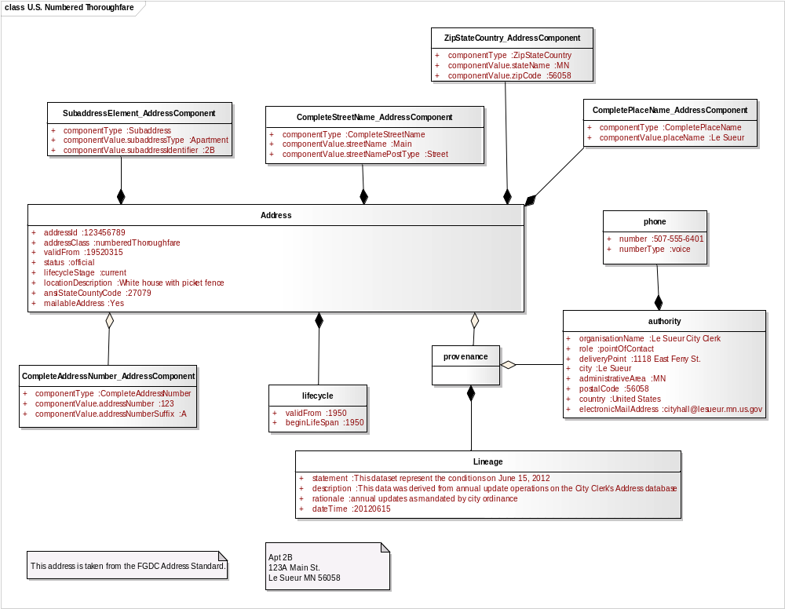
Figure B.11.6 US FGDC Profile Instance: US Numbered Thoroughfare Address
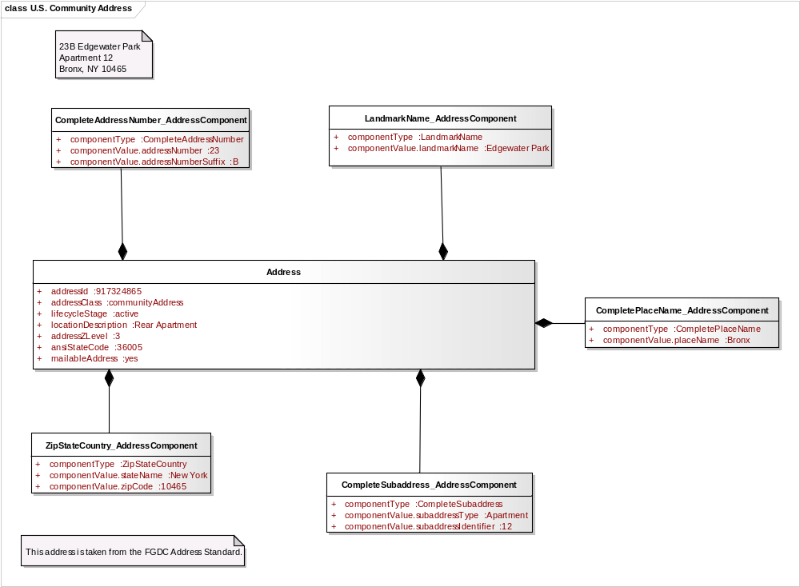
Figure B.11.7 US FGDC Profile Instance: US Community Address
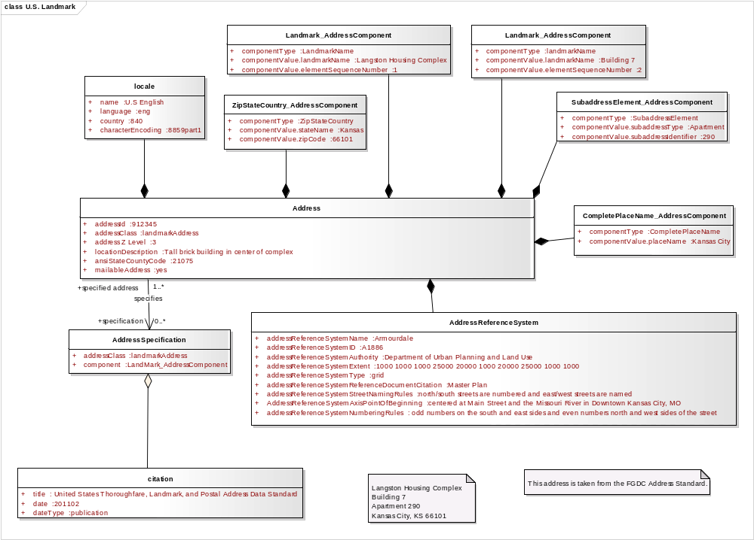
Figure B.11.8 US FGDC Profile Instance: US Landmark Address
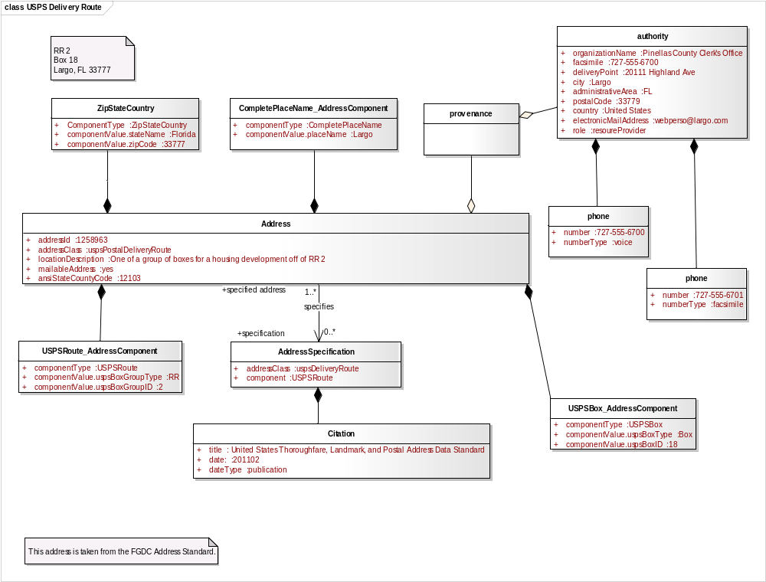
Figure B.11.9 US FGDC Profile Instance: USPS Delivery Route Address
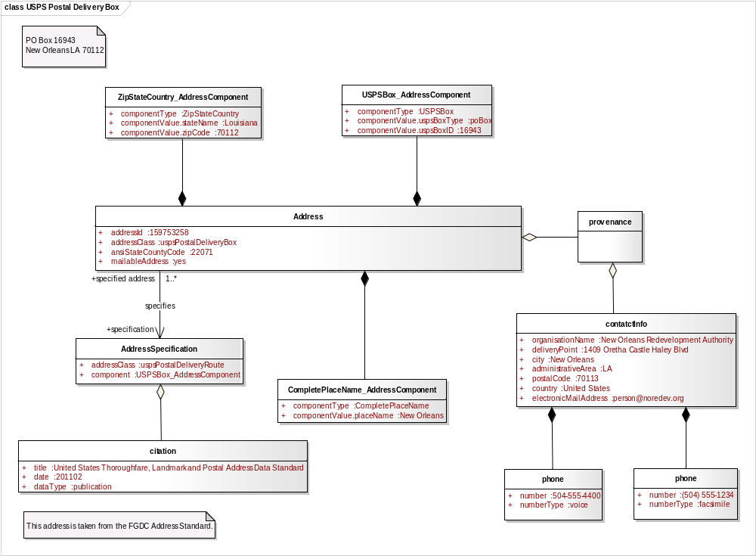
Figure B.11.10 US FGDC Profile Instance: USPS Postal Delivery Box
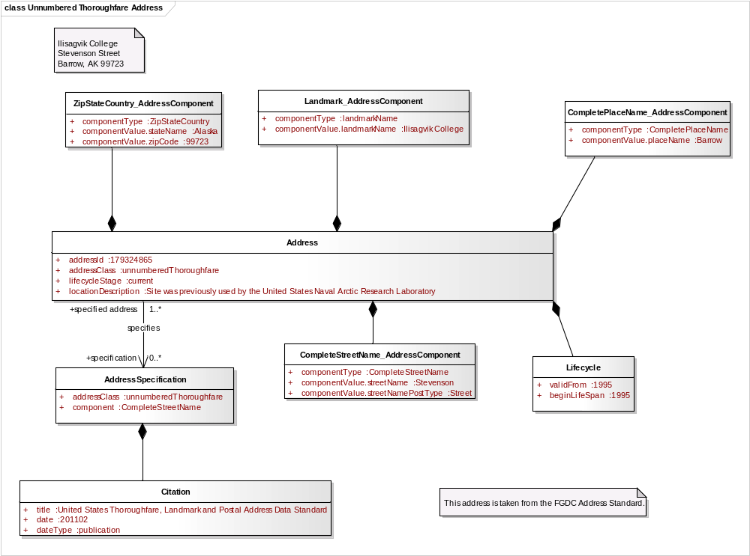
Figure B.11.11 US FGDC Profile Instance: US Unnumbered Thoroughfare Address
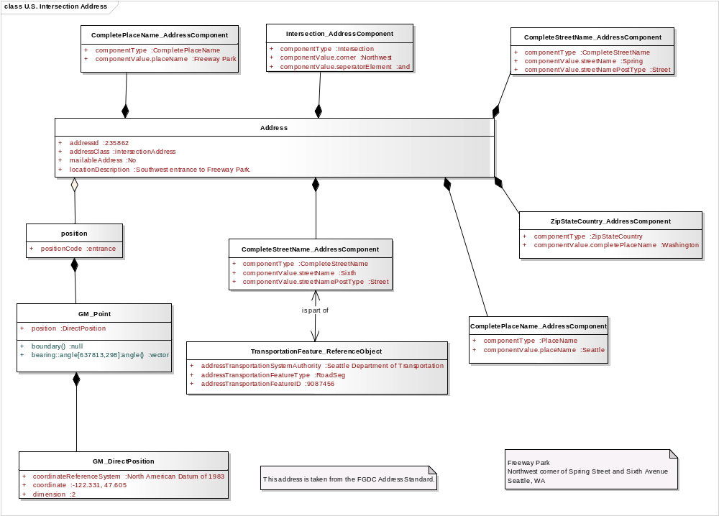
Figure B.11.12 US FGDC Profile Instance: US Intersection Address

