U.S. Census Bureau
Geography Division
National/State Geographic Partnerships Branch


Guide for Installing and Using the Census Address Software Suite Version 1
Version: Version 1 Draft
Date: Friday, October 05, 2012

Contents
1. Introduction 3
2: Download the Address Tool and Support Files 4
3. Download the Hyperlinked Standard 4
4. Modifying the Support Files (When Necessary) 4
1. mapaddress.csv 5
2. mapsubaddress.csv 5
3. mapplace.csv 6
4. common_abbr.csv 6
5. common_alias.csv 7
6. expert_parsing.csv 8
5. Checking the Quality of the Address Data 9
6. Modifying the Properties File 11
7A. Running the Program in UNIX 11
7B. Running the Program in the DOS/Windows XP 11
8. Interpreting any Error Messages 12
1. File Not Found (java.io.FileNotFoundException error) 12
2. SQL error in one of the QA Tests (Syntax Error in SQL statement). 13
3. Support File not saved as Tab Delimited (TABLEID Error) 15
9. Viewing the results 15

list of Figures
Figure 1: Sample SQL for the Record Count QA Test 10
Figure 2: Example of a file not found error. 12
Figure 3: Example of a support file missing 13
Figure 4: Example of a SQL error. 14
Figure 5: Example of an incorrectly saved support file. 15

List of Tables
Table 1: Quality Tests for each Thoroughfare Address Class 10

Introduction
The FGDC Address Quality Software Suite consists of two parts: the FGDC Address Quality and Exchange Tool and the hyperlinked standard. These parts work together to create an exchange file in the FGDC Address Format.

FGDC Address Quality and Exchange Tool (the Address Tool) is a command line interface that aids users in the preparation and publication of addresses in the Federal Geographic Data Committee’s (FGDC) United States Thoroughfare, Landmark, and Postal Address Data Standard (FGDC-STD-016-2011)(Address Standard) format. This tool works by looking for the predefined configuration file AddressTool.properties, which defines the location of the input address table and the quality tests that are to be run on the input address table, which is in the ESRI shapefile format. This address tool relies on several support files, listed in the C:\FGDC_Exchange_Tool\resources\sql folder, that provide the translation from data in the input file format to the correct Address Standard term. It also relies on the quality test SQL files located in the C:\FGDC_Exchange_Tool\resources\sql\qa folder to produce the quality tests that user wants to run.

When the address tool is run, it creates and populates the support tables needed to create the xml exchange file in the FGDC Address Standard format and run the quality tests. This program returns the aforementioned xml exchange file, the database files it created to transform data from the user’s input format to the FGDC address format and the AddressTest_rpt.txt file, which lists the results of any quality tests run on the address data.

The address tool will support the following Address Standard Thoroughfare Class Formats: Four Number Address Range, Two Number Address Range and Numbered Thoroughfare Address. These address formats all specify locations by referencing a linear transportation feature like a road, walkway or river. For more information on these address formats, see Part 3 of the Address Standard.

The steps needed to use the Address Quality Software Suite are described below.

2: Download the Address Tool and Support Files
- (if outside the Census Bureau) by clicking on: http://meadow.spatialfocus.com/twiki/pub/Capgrant/WebHome/addresstool_cli.zip
- (If inside the Census Bureau): This software is downloaded by clicking on advertised programs (next to the time) and downloading the FGDC Address Quality and Exchange Tool.

Download the Hyperlinked Standard
This is a lightweight and searchable version of the Address Standard designed to make finding information in the 600-page document easier. This application contains hyperlinks and a search capability to make getting around the standard easier. To use this application, do the following:
- Download the software:
  - (if outside the Census Bureau) by clicking on: http://www.spatialfocus.com/twiki/bin/view/SpatialFocus/SearchableFGDCAddressStandard
  - (If inside the Census Bureau): This software is downloaded by clicking on advertised programs (next to the time) and downloading the FGDC Hyperlinked Standard.
- Navigate to the directory containing the standard (C:\Program Files\Spatial Focus\Hyperlinked FGDC Address Standard if inside the Census Bureau) and click on the index file (index.html). For Census users, this application can also be found in the start menu as “Hyperlinked FGDC Address Standard”.
- Right click on the Yellow Bar on top of the web page that opens up and select “Allow Block Content” and “Yes” in the pop box that appears on the screen.
- Click on one of the grey bars for the sections of the Address Standard or the Appendices to the Address Standard.
- To search for a term in the Address Standard, enter a term in the search box in the upper right corner.

4. Modifying the Support Files (When Necessary)
Navigate to the C:\FGDC_Exchange_Tool\resources\sql folder. This folder contains the six tab-delimited comma-separated value (CSV) files that provide the translations the tool needs when it is creating the working tables and the final output xml file from the “raw” input file. Of these 6 files, 4 are mandatory and 2 are optional. These optional support files are only used in unique cases. The support files are described below:

- mapaddress.csv (mandatory): This is a tab delimited file of field names in the raw or input file and the corresponding nominal field in the intermediate working table. This file contains all the elements of an address: ADDRESSID, ADDRESSNUMBER, ADDRESSNUMBERSUFFIX, STREETNAMEPREDIRECTIONAL, STREETNAME, STREETNAMEPOSTTYPE, STREETNAMEPOSTDIRECTIONAL, ADDRESSPARCELIDENTIFIER, ADDRESSXCOORDINATE, ADDRESSYCOORDINATE and OFFICALSTATUS. To use this file, do the following:
  - Identify fields in the input shapefile that align with the Address Standard
  - Transform the data from tab delimited to an Excel format by selecting the column containing the data. Then select “Text to Columns” on the Data Tab. Then select “Delimited”, “Tab” and “Finish”.
  - Put the value of the input file column in the “Raw Column” and its corresponding Address Standard value in the “Map” Column.
  - The value of the “TABLEID” column must always be “1”.
  - An example of this would be mapping an input value of “STATUS” to an address standard value of “OFFICIALSTATUS” by putting “1” in the TABLEID column, “STATUS” in the RAW column and “OFFICIALSTATUS” in the MAP column.
  - Save the file the file as "Text (Tab delimited)". When closing Excel, the program will ask if you want to save any changes to the file. If any changes were made after converting the file to a tab delimited text, select save. Otherwise, select cancel.
  - Go to the C:\FGDC_Exchange_Tool\resources\sql directory and delete the mapaddress.csv file.
  - Right click the mapaddress.txt file and select Rename. Change the .txt extension to .csv
- mapsubaddress.csv (mandatory): This tab delimited file contains the field names in the input file that relate to sub-addresses (wings, apt, floors, buildings etc.) to the corresponding value “SUBADDRESID” in the intermediate working tables. To use this file, do the following:
  - Determine all the sub-address types in your file.
  - Transform the data from tab delimited to an Excel format by selecting the column containing the data. Then select “Text to Columns” on the Data Tab. Then select “Delimited”, “Tab” and “Finish”.
  - Enter a value of “1” for the TABLEID column, put the name of the sub address element from the input shapefile in the “RAW” column and “SUBADDRESSID” in the “MAP” column.
  - An example would be if some of your values use “UNIT” to designate apartments. This would be mapped by placing a “1” in the TABLEID column, “UNIT” in the RAW column and “SUBADDRESSID” in the MAP column.
  - Save the file the file as "Text (Tab delimited)". When closing Excel, the program will ask if you want to save any changes to the file. If any changes were made after converting the file to a tab delimited text, select save. Otherwise, select cancel.
  - Go to the C:\FGDC_Exchange_Tool\resources\sql directory and delete the mapsubaddress.csv file.
  - Right click the mapsubaddress.txt file and select Rename. Change the .txt extension to .csv
- mapplace.csv (mandatory): This tab delimited file of field names maps the raw address table to the corresponding Address Standard PlaceNameType, which is used to show what kind of place name is given for the address. According to the Address Standard, a place name is the name of an area, sector or development. Examples include cities, counties or neighborhoods. This file converts fields in the flat input address data table to the hierarchical place naming system in the Address System. To use this file, do the following:
  - Determine if any of the fields relating to place names in the raw address table need to be mapped into an Address Standard Value. If so, continue to step b. If not, no further modification is needed.
  - Transform the data from tab delimited to an Excel format by selecting the column containing the data. Then select “Text to Columns” on the Data Tab. Then select “Delimited”, “Tab” and “Finish”.
  - Enter a value of “1” for the TABLEID column, the name of the input data column in the RAW column and the Address Standard name in the MAP column
  - An example would if there was a field in the input database called “TOWN” which corresponds to an Address Standard value of “MunicipalJurisdiction”. This would be mapped by placing a “1” in the TABLEID column, “TOWN” in the RAW column and “MunicipalJurisdiction” in the MAP column.
  - Save the file the file as "Text (Tab delimited)". When closing Excel, the program will ask if you want to save any changes to the file. If any changes were made after converting the file to a tab delimited text, select save. Otherwise, select cancel.
  - Go to the C:\FGDC_Exchange_Tool\resources\sql directory and delete the mapplace.csv file.
  - Right click the mapplace.txt file and select Rename. Change the .txt extension to .csv
- common_abbr.csv (mandatory): This tab delimited file maps street types found in the input file to the list of official street abbreviations found in United States Postal Service Publication (USPS) 28. To use this file do the following:
  - Make a list of all abbreviation in your address file. If any of these are not an official U.S.P.S abbreviation, go to step b. Otherwise, this file needs no modification.
  - Transform the data from tab delimited to an Excel format by selecting the column containing the data. Then select “Text to Columns” on the Data Tab. Then select “Delimited”, “Tab” and “Finish”.
  - Add the non U.S.P.S abbreviations to the StreetType column and its corresponding USPS Pub 28 value in the Abbr column.
  - An example would be if your address file used “ALLY” for alleys. This would be mapped by putting “ALLY” in the StreetType column and “ALY” in the Abbr column.
  - Save the file the file as "Text (Tab delimited)". When closing Excel, the program will ask if you want to save any changes to the file. If any changes were made after converting the file to a tab delimited text, select save. Otherwise, select cancel.
  - Go to the C:\FGDC_Exchange_Tool\resources\sql directory and delete the common_abbr.csv file.
  - Right click the common_abbr.txt file and select Rename. Change the .txt extension to .csv

- common_alias.csv (Optional): This file contains the name of any aliases or alternate names that are used in the address data. An example would be “MLK BLVD” for “Martin Luther King Boulevard”. To use this file do the following:
  - Make a list of any aliases that occur in your address file. If there are aliases in your file, go on to step b. If not, you do not need to modify this file.
  - Transform the data from tab delimited to an Excel format by selecting the column containing the data. Then select “Text to Columns” on the Data Tab. Then select “Delimited”, “Tab” and “Finish”.
  - Put the real or official value in the appropriate “Match” columns and the alias values in the “Alias’ columns.
  - Fill in the Zone field with a unique identifier for the data. The Zone field is a ZIP code, City Name or some other indication of where the expert parsing should be applied.
  - An example of this would be a county where “MLK BLVD” is an alias for “Martin Luther King Boulevard”. This would be mapped by putting the ZIP Code or city name in the ZoneField, “Martin Luther King” in the “MatchStreet” column, and “Boulevard” in the “MatchStreetPostType” column, the ZIP Code or city name in the “MatchZone” field, “MLK” in the “AliasStreet” column and “BLVD” in the “AliasStreetPostType” column.
  - Save the file the file as "Text (Tab delimited)". When closing Excel, the program will ask if you want to save any changes to the file. If any changes were made after converting the file to a tab delimited text, select save. Otherwise, select cancel.
  - Go to the C:\FGDC_Exchange_Tool\resources\sql directory and delete the common_alias.csv file.
  - Right click the common_alias.txt file and select Rename. Change the .txt extension to .csv
- expert_parsing.csv File (Optional): This tab delimited file of field values contains the exact transformation to use when converting the address data into final form. An example of this would be if the value “North Point Street” should always be parsed with “North Point” in the in the Street Name field and not parsed as “North” in the StreetNamePreDirectional field. To use this file, do the following
  - Make a list of any special cases in your input address data. If there are none, you have finished with this step. Otherwise, proceed to step b.
  - Transform the data from tab delimited to an Excel format by selecting the column containing the data. Then select “Text to Columns” on the Data Tab. Then select “Delimited”, “Tab” and “Finish”.
  - Put the appropriate values for this exception in both the Match column and the Alias column.
  - Fill in the Zone field with a unique identifier for the data. The Zone field is a ZIP code, City Name or some other indication of where the expert parsing should be applied.
  - For the example above where “North Point Street” should always be parsed with “North Point” in the street name, enter the ZIP code or city name in the ZoneField column, “North Point” in the MatchStreet and AliasStreet columns, and “Street” in both the MatchStreetPostType and AliasStreetPostType columns.
  - Save the file the file as "Text (Tab delimited)". When closing Excel, the program will ask if you want to save any changes to the file. If any changes were made after converting the file to a tab delimited text, select save. Otherwise, select cancel.
  - Go to the C:\FGDC_Exchange_Tool\resources\sql directory and delete the ExpertParsingData.csv file.
  - Right click the ExperParsingData.txt file and select Rename. Change the .txt extension to .csv

5. Checking the Quality of the Address Data
The Address Standard contains quality tests to help the user assess the quality of their address data by testing its attribute accuracy, completeness, lineage, logical consistency, positional accuracy and temporal accuracy. These tests are in the form of Structured Query Language (SQL) files located in the C:\FGDC_Exchange_Tool\resources\sql\qa directory. These quality tests are described in Part 4 and Appendix G of the Address Standard.

These tests help users assess the quality of the addresses by running queries against the database and XML file created by the Address Tool. Eventually, the Address Tool will come preloaded with the following QC tests: Address ID Test, Conditional Component Test, Address Completeness Measure, Address Number Fishbones Measure, Address Number Parity Measure, Data Type Measure, Range Domain Measure, Related Element Uniqueness Measure, Related Element Value Measure, Tabular Domain Measure, Address Number, XY Coordinate Measure and Range Parity Consistency Measure. These were included because it was determined that these tests would be the most helpful in testing the quality of an address database. With the exception of the Conditional Component Test, the descriptions for all these tests can be found in Section 4 of the Address Standard. The Conditional Component test will check for all the required components for a specific address class. An example of this would be if the address class is supposed to be Numbered Thoroughfare, the test would check for address number, thoroughfare name and place name. This test is included in example 2 below.

Each quality test depends on certain views and tables in the database created by the address tool. A view is a stored virtual table created by a query that changes every time a table that it queries is changed. The tables needed for the QA tests are Elevation Polygon Collection, StreetsNodes and Nodes. The views needed for the QA tests are AddressPtCollection and StCenterlineCollection. More information on these views and tables can be found in Section 4 of the Address Standard.

The quality tests run will depend on the address classes present in the raw data file. The table below relates each address class to the quality tests that the Address Standard recommends should be run for it. Only members of the Thoroughfare Address Class are included because these are the only classes supported by the Address Tool.

Class/  Quality  Test (Measure) | Address Completeness Measure | Address Left Right Measure | Address Number Fishbones Measure | Address Number Range Completeness Measure | Address Number Range Parity Consistency Measure | Left Right Odd Even Parity Measure | Low High Address Sequence Measure | Overlapping Ranges Measure | Pattern Sequence Measure | Range Domain Measure | Spatial Domain Measure
Numbered Thoroughfare Address | X | x | x |  |  |  |  |  | x | x | x
Two Number Address Range |  |  | x | x | x |  | x | x | x | x | x
Four Number Address Range |  |  | x | x | x | x | x | x | x | x | x
Table 1: Quality Tests for each Thoroughfare Address Class

Each of the thirty-eight quality tests will have a separate SQL file in the C:\FGDC_Exchange_Tool\resources\sql\qa directory. These sequel tests are named using the name of the test in Camel case with a .sql extension. For example, the file for the DuplicateStreetNameMeasure QA test is DuplicateStreetNameMeasure.sql. The SQL code and description for each test is found in Part 4 of the Address Standard.

Here is an example of the SQL code that provides the number of address in the database.

SELECT 'The Number of entries or addresses is '||cnt
FROM
(SELECT COUNT(*) as cnt
FROM address_core
);

Figure 1: Sample SQL for the Record Count QA Test

The above SQL code queries the address xml exchange file by using the COUNT function to count all the entries in the database. The first select statement, which is highlighted in red, is what is sent to the on screen display and the AddressTest_rpt.txt text file. The second select statement, highlighted in blue, uses the COUNT function to count all the entries in the address_core table. Most of the queries will be against this table. The column values used in the test are also the XML tags present in the XML exchange file.

The creation and modification of SQL files can be done in notepad or MYSQL.

6. Modifying the Properties File
The properties file is a predefined configuration file that defines the name and location of the input address table and existing support tables described in Sections 5 and 6 above. It is used by the address to create an automated run that prepares and publishes the input address table into the Address Standard Format. It is located in the C:\FGDC_Exchange_Tool\resources directory. The steps needed to modify the file are described below:

- Indicate the name of the input address data to be transformed in the AddressData= line. This input data can be in the form of an ESRI shapefile or text delimited CSV file. The data must be in the data directory. If is not, the program will give the java.io.FileNotFound error message shown in figure 2 in part 1 of section 8.
- List the quality tests that are to be run on the input data file on the QATests= line. These tests are located in the C:\FGDC_Exchange_Tool\resources\sql\qa directory and have the same name as the file minus the .sql extension. These tests are separated by a space. At present, there seems to be a bug because the program seems to run the RecordCount regardless of whether it is listed in the properties file. If a test other than the RecordCount test needs to be run, rename the RecordCount test and name the test that is to be run RecordCount. This error should be fixed in future release of the Address Tool

7A. Running the Program in UNIX
- Ensure that you have the correct version of Java by typing java –version at the command line. You should be running JAVA SE Runtime Environment JRE1.6.0 or later.
- Navigate to the AddressTool directory by using the following Unix commands:
  - cd to change directories
  - ls: to list the contents of directories
- Type the following at the command line: java -jar AddressToolApp.jar.
- During execution of the Address Tool, the program will print out several warnings with the word “WARNING” or “SEVERE”. Ignore these warnings because they are part of the normal execution of the script and not an indication that anything is wrong.

7B. Running the Program in the DOS/Windows XP
- Open the Dos Window by pressing Start>Run and typing cmd in the textbox. The cmd.exe window will open.
- Ensure that you have the correct version of Java Running by typing java –version at the command line. You should be running JAVA SE Runtime Environment JRE1.6.0 or later.
- Navigate to the AddressTools directory (C:\FGDC_Exchange_Tool if inside the Census Bureau) by using the following DOS commands
  - c: to move to the C directory
  - cd : use to change directories
  - Dir: use to display a list of files and folders in the directory you are currently in
- Type the following at the command line: java -jar AddressToolApp.jar.
- During execution of the Address Tool, the program will print out several warnings with the word “WARNING” or “SEVERE”. Ignore these warnings because they are part of the normal execution of the script and not an indication that anything is wrong.

8. Interpreting any Error Messages
Unfortunately when running the program, you may get error messages. Below is a list of some of the error messages that you may receive.

File Not Found (java.io.FileNotFoundException error)
The following error message (java.io.FileNotFoundException) indicates that a file the programs needs to operate could not be found. If the missing file is not specified , as in figure 2 below, then the input shapefile could not be found in the directory specified in the properties file. To rectify this, make sure that the file is in the C:\FGDC_Exchange_Tool\data directory and that the AddressData line in the properties file is correct.

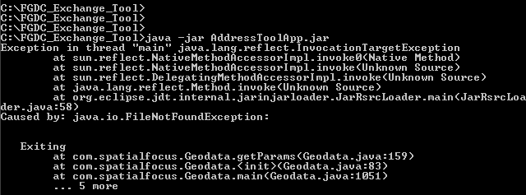
Figure 2: Example of a file not found error.

If the missing file is specified, then that indicates that one of the support files was not in the correct directory. Rectify this by ensuring that the support file is in the C:\FGDC_Exchange_Tool\resources\sql folder and that it has a .csv exstention.

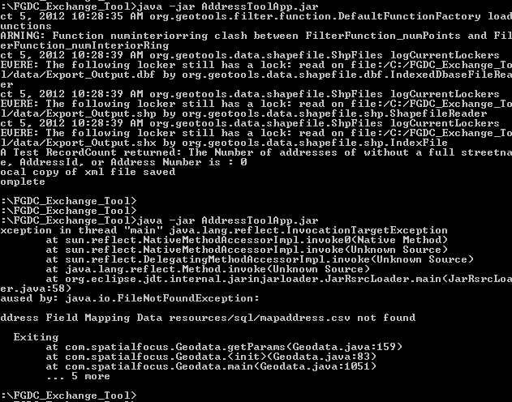
Figure 3: Example of a support file missing

SQL error in one of the QA Tests (Syntax Error in SQL statement).

The following verbose error message (Syntax error in SQL statement), with SQL code and references to the H2 database, indicates that there is a SQL error in one of the QA Tests. To fix this error, correct the SQL code in the offending QA test.

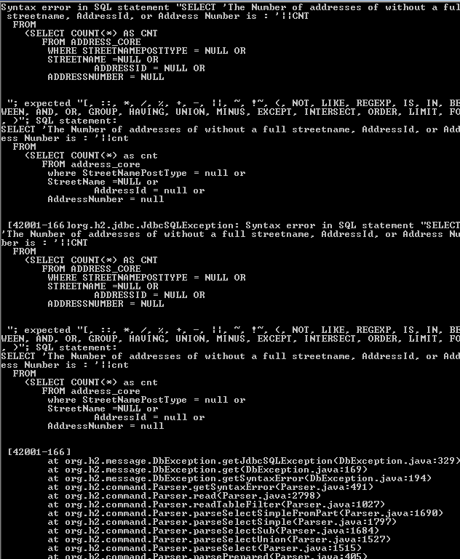
Figure 4: Example of a SQL error.

Support File not saved as Tab Delimited (TABLEID Error)
The following error indicates that a support file was not saved as tab delimited file. In the example in figure 4, the “TABLEID” column could not be found for the addressmap support file. To remedy this situation, save the problem support file as a text delimited tab file. Next, go to the C:\FGDC_Exchange_Tool\resources\sql directory and delete the support file’s csv file. Finally, rename the support file by changing the file extension to .csv
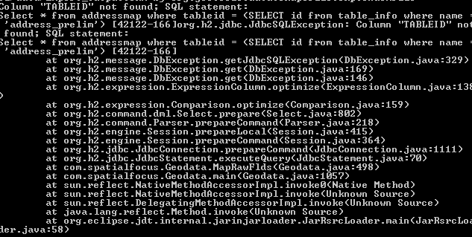
Figure 5: Example of an incorrectly saved support file.

9. Viewing the results
- Navigate to the AddressTool/projects directory. Here there are four files that have been created and/or updated by the tool:
  - AddressTest.h2.db
  - AddressTest_pkg.xml: This is the main xml file with all the addresses in FGDC Address Standard format. This file will be exchanged with other address partners.
  - AddressTest_rpt.txt: A text file showing the results of the quality test that were run.
  - AddressTest.trace.db

