Map Position Proposal for 2014 Revision of the United States Thoroughfare, Landmark, and Postal Address Data Standard
(FGDC-STD-016-2011)

Submitted by US Census Bureau
2/24/2014
Version 1.6

Contents
1. Introduction 2
2. Use Cases 2
2.1. Census 2
Example 1. Coordinates located at property access. 2
Example 2. Multi-unit apartment building with several points of collection. 3
2.2. Community Planning/Building Inspection 3
Example 3. One address representing multiple features. 4
2.3. Tax Assessment and Voting/School District Application 4
Example 4. Municipal boundary splits parcel. 4
2.4. E-911 4
3. Methods for Accomplishing Proposal 5
3.1. Address Position as Child Element to MapPosition 5
Figure 1: The Schema for the MapPosition element with AddressPosition as a child element. 5
Figure 2: Example of the MapPosition element with AddressPosition as a child element. 5
3.2. Address Position as an Attribute to MapPosition 6
Figure 3: The Schema for the MapPosition element with AddressPosition as an attribute. 6
Figure 4: Example of the MapPosition element with AddressPosition as an attribute. 6
4. Proposed Elements Definitions and Descriptions 6
4.1. MapPosition 6
4.2. The AddressPosition Element 7
5. Changes to the Schema 8
Figure 5: An example of an address class modified to include the MapPosition element. 9
6. Census Recommendations 9
List of Figures
Figure 1: The Schema for the MapPosition element with AddressPosition as a child element. 5
Figure 2: Example of the MapPosition element with AddressPosition as a child element. 5
Figure 3: The Schema for the MapPosition element with AddressPosition as an attribute. 6
Figure 4: Example of the MapPosition element with AddressPosition as an attribute 6
Figure 5: An example of an address class modified to include the MapPosition element. 9

Introduction
For the 2014 revision of the United States Thoroughfare, Landmark, and Postal Address Data Standard
(FGDC Address Standard), the following new element is proposed to allow multiple coordinate positions to be associated with an address:
- MapPosition- a repeatable element consisting of the coordinates of the map representation of an address with a description of the position. Such descriptions could be "Front Door", "Parcel Centroid", "Building Centroid", "Driveway" amongst others.
If implemented, the proposal would allow for a data producer to describe what a given set of address coordinates represent (e.g., position, point of collection, etc.) as well as the coordinates themselves. Benefits of this proposal include:
- Allowing the data receiver to make informed decisions on the appropriate use of the coordinates associated with an address.
- Mitigating the necessity to provide the same address multiple times in order to exchange multiple coordinates associated with that address.
The next section provides use cases to demonstrate the potential benefits of the proposal. Two options for accomplishing this proposal are provided in this document for discussion purposes. These options are found in Section 3, along with the XML schemas and examples for each. Section 4 provides descriptions of the proposed elements presented in the format found in the FGDC Address Standard.
Section 5 lays out the changes to the FGDC Address Standard’s schema that will be needed if the proposal is accepted, which is followed by Census recommendations.

Use Cases

Census
This proposal would enhance the Census Bureau’s operations, particularly in its partnership program aimed at acquiring addresses and address point data from states, counties, and tribal areas. Example 1 illustrates a one-to-one (address to coordinate set) situation where the coordinates represent the property access (driveway).
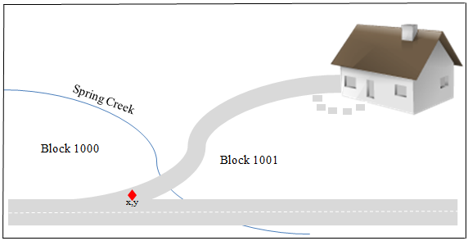

Example 1. Coordinates located at property access.

In this case, the address point cannot be used to tabulate a residence in its correct census geography. While this may be discerned through visual review, it would be more efficient to be aware of this during data ingest. This is particularly important when a dataset includes coordinates with different points of collection. In that case, this proposal would allow a data receiver to know which coordinates can be used for what purposes.
Example 2 illustrates a multi-unit apartment building that has coordinates for individual units within the structure, one set for the main entrance of the structure, and a set for each property access point.
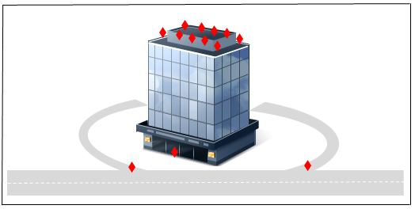

Example 2. Multi-unit apartment building with several points of collection.
Similar to example 1, there is obvious benefit to knowing what each coordinate set represents. In addition, this proposal would allow for a variety of data management schemes to unambiguously share addresses that have multiple coordinates associated with them. For example, each individual unit (with a unique address) might have a coordinate set indicating the location of the unit itself (including a height measurement), a coordinate pair identifying the building entrance (that it shares with all other units in the building), and coordinates for each entrance and exit to the property. Alternatively, the building may have its own address, separate from the individual units, along with coordinates for all building entrances and property access points. Either way, the data producer could clearly exchange the spatial information along with the addresses and the receiver would know if and how to use the information.
The Census Bureau’s business practice is to associate each unit with the structure. So in the case of example 2, the preferred coordinate set is the one at the building entrance being provided with each unit’s address. However, this proposal would allow the Census Bureau to better process the incoming data regardless of how it’s managed by the producer.

Community Planning/Building Inspection
The MapPosition proposal could prove beneficial to inter-departmental data sharing at the local level as well. Example 3 shows a situation where one address contains several features (i.e., house, parcel, utilities, etc.). This proposal would allow for data transfer of coordinate positions for each of these.
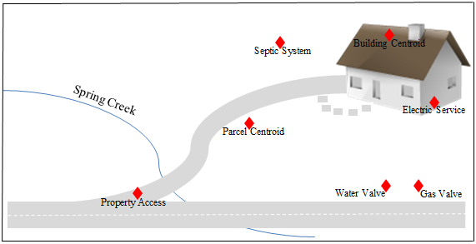

Example 3. One address representing multiple features.
We can imagine several data sharing scenarios where it would be critical to know what a set of coordinates represent. For example, if a city building department needs to share utility information with its counterpart at the county level; or perhaps a regional planning agency needs to know the location of septic systems and property access points.

Tax Assessment and Voting/School District Application
Example 4 has some obvious implications for district boundary and tax assessment applications. For example, school and voting districts need to know the house location for district planning while tax assessors need to know which part of the property falls within their municipality.
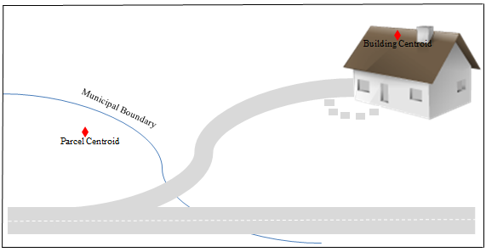

Example 4. Municipal boundary splits parcel.

E-911
Several of the examples above illustrate potential benefits of this proposal to emergency services, too. For instance, a fire department would benefit from knowing if the coordinates associated with a multi-unit building are for the property access, the building entrance, or a unit location. Similarly, being able to quickly locate the gas and water valves or electric service for a structure might be critical in an emergency situation. Again, if the information is available to share, the MapPosition element would allow for the transfer of multiple sets of coordinates along with their position descriptions.

Methods for Accomplishing Proposal
The MapPosition element being proposed here is a compound element consisting of a simple element that describes the position of a set of coordinates associated with an address (AddressPosition) along with a gml:Point element.
There are two proposed methods of linking the AddressPosition to the MapPosition. The first method is to have the AddressPosition element as a child element of the MapPosition element. The second method would be to use the AddressPosition as an attribute of the MapPosition element.
If either of these proposed methods were accepted, changes would have to be made to the schema. These changes are further explained in Section 5: Changes to the Schema.

Address Position as Child Element to MapPosition
In this method, the proposed MapPosition element would be a compound element that would contain the AddressPosition and gml:Point element, which is adopted from the Open GIS Consortium’s (OGC) Geographic Markup Language (GML). Both of these elements would be mandatory. The schema for the proposed element is shown in Figure 1. An XML example of the MapPosition element is shown in Figure 2.
<xsd:complexType name="MapPosition_type">
<xsd:sequence>
<xsd:element name="AddressPosition" type="MapPos:AddressPosition_type" minOccurs="1"/>
<xsd:group ref="MapPos:MapPositionGroup"/>
</xsd:sequence>
</xsd:complexType>

Figure 1: The Schema for the MapPosition element with AddressPosition as a child element.

<MapPosition>
<AddressPosition>Driveway Entrance</AddressPosition>
<gml:Point gml:id="p21" >
<gml:pos>49.27 -123.11 </gml:pos>
</gml:Point>
</MapPosition>

Figure 2: Example of the MapPosition element with AddressPosition as a child element.

Address Position as an Attribute to MapPosition
This method has AddressPosition as an attribute of the MapPosition element. The AddressPosition would be a compound element that would consist of the gml:Point element. It would also have the AddressPosition attribute, which describes the point of assignment of a set of coordinates associated with an address. The schema for this option is shown in Figure 3 with an example in Figure 4.
Figure 3: The Schema for the MapPosition element with AddressPosition as an attribute.
<xsd:complexType name="MapPosition_type">
<xsd:sequence>
<xsd:group ref="MapPos:MapPositionGroup"/>
</xsd:sequence>
<xsd:attribute name="AddressPosition" type="MapPos:AddressPosition_type"/>
</xsd:complexType>

<MapPosition AddressPosition="Driveway Entrance">
<gml:Point gml:id="p21" srsDimension="2" srsName="urn:ogc:def:crs:EPSG:6.6:4326"
axisLabels="x y">
<gml:pos>49.27 -123.11</gml:pos>
</gml:Point>
</MapPosition>

Figure 4: Example of the MapPosition element with AddressPosition as an attribute.

Proposed Elements Definitions and Descriptions
This section illustrates how the proposed elements would look in the format used in Part 1: Address Data Content of the FGDC Address Standard.

MapPosition
Element Name | MapPosition
Other common names for this element | None
Definition | A repeatable element consisting of the coordinates of the map representation of an address with a description of the position.
Syntax | { AddressPosition} + { gml.Point}
Definition Source | New
Data Type | CharacterString
Existing Standards for this element | Refer to Component Elements
Domain of Values for this element | Locally determined.
Source of Values | Locally determined.
How Defined | Locally determined.
Example
Notes/Comments | The MapPosition element is repeatable and therefore allows multiple coordinates associated with an address to be shared.  If using the MapPosition element, the address provider must provide coordinates associated with the address and the AddressPosition associated with those coordinates.
XML tag | <MapPosition>
XML Model | <xsd:complexType name="MapPosition_type">  <xsd:sequence>  <xsd:element name="AddressPosition" type="MapPos:AddressPosition_type" minOccurs="1"/>  <xsd:group ref="MapPos:MapPositionGroup"/>  </xsd:sequence>  </xsd:complexType>
XML Example | <MapPosition>  <AddressPosition>Driveway Entrance</AddressPosition>  <gml:Point gml:id="p21">  <gml:pos>49.27 -123.11 </gml:pos>  </gml:Point>  </MapPosition>
Quality Measures | None
Quality Notes | None

The AddressPosition Element
Element Name | AddressPosition
Other common names for this element | None
Definition | A description of the position of a set of coordinates associated with an address.
Definition Source | New
Data Type | characterString
Existing Standards for this element | ISO 19160-1
Domain of Values for this element | Locally determined
Source of Values | Locally determined
How Defined | Locally determined
Example | Driveway Entrance  Front Door
Notes/Comments | The Address position is locally determined by the address supplier and describes what the coordinate pair represents.
XML tag | <AddressPosition>
XML Model | <xsd:simpleType name="AddressPosition_type">  <xsd:restriction base="xsd:string">  <xsd:pattern value=".*"/>  </xsd:restriction>  </xsd:simpleType>  </xsd:schema>
XML Example | <MapPosition>  <AddressPosition>Driveway Entrance</AddressPosition>  </MapPosition>
Quality Measures | None
Quality Notes | None

Changes to the Schema
If either of these methods of linking the Address Position to the proposed MapPosition element is accepted, the following changes to the schema would have to be made:
- A new complex type would have to be created for the MapPosition element. MapPosition would include the AddressPosition element and the gml:Point element. The point element would include the gml namespace and would contain the following attributes:
- The gml:id attribute identifies the specific gml point. This attribute is mandatory.
- The srsDimension attribute identifies the number of entries in the list needed to describe the coordinate system. This element is optional.
- The srsName attribute specifies the object’s coordinate reference system (CRS). This element is optional but it is considered a best practice to provide one. The CRS provided is usually registered with the EPSG Geodetic Parameter Registry (http://www.epsg-registry.org/).
- The axisLabels attribute is an ordered list of labels for all the axes of this CRS. This element is optional.
- The uomLabels attribute is an ordered list of unit of measure (uom) labels for all the axes of this CRS. This element is optional.
- A new simple type would have to be created for the AddressPosition element. This element would be mandatory if the MapPosition element is to be used.
- The complex type for each address class would have to be modified to incorporate the new MapPosition element. This new element would be optional and would be allowed to have an unlimited number of occurrences. An example of this modification is shown in figure 5 for the Numbered Thoroughfare class. The additional line is highlighted in bold.

Figure 5: An example of an address class modified to include the MapPosition element.
<xsd:complexType name="NumberedThoroughfareAddress_type">
<xsd:annotation>
<xsd:documentation xml:lang="en">Defining Characteristics: 1. Addresses of this class must include a Complete Address Number and a Complete Street Name. 2. In addition, all thoroughfare, landmark, and postal addresses must include a Place Name and a State Name. A Zip Code is recommended but not mandatory. </xsd:documentation>
</xsd:annotation>
<xsd:sequence>
<xsd:choice>
<xsd:element name="CompleteLandmarkName" type="addr_type:CompleteLandmarkName_type"
minOccurs="0" maxOccurs="1"/>
<xsd:element name="CompletePlaceName" type="addr_type:CompletePlaceName_type"
minOccurs="0" maxOccurs="1"/>
</xsd:choice>
<xsd:element name="CompleteAddressNumber" type="addr_type:CompleteAddressNumber_type"
minOccurs="1" maxOccurs="1"/>
<xsd:element name="CompleteStreetName" type="addr_type:CompleteStreetName_type"
minOccurs="1" maxOccurs="1"/>
<xsd:element name="CompleteSubaddress" type="addr_type:CompleteSubaddress_type"
minOccurs="0" maxOccurs="1"/>
<xsd:group ref="addr_type:PlaceStateZip_group" minOccurs="0" maxOccurs="unbounded"/>
<xsd:group ref="addr_type:AddressAttributes_group" minOccurs="0" maxOccurs="1"/>
<xsd:element name="MapPosition" type="MapPos:MapPosition_type" minOccurs="0" maxOccurs="unbounded"/>
</xsd:sequence>
<xsd:attribute name="action" type="addr_type:Action_type" use="optional"/>
</xsd:complexType>

Census Recommendations
The Census Bureau recommends the creation of the new compound MapPosition element as a means to share coordinates associated with an address coupled with a description of the point of assignment for those coordinates. This element would allow multiple positions to be associated with a single address record. For example, an address may have coordinate positions for the driveway and the front door. The inclusion of this element will help data aggregators determine the appropriate use of coordinates associated with an address.
The creation of the MapPosition element depends on the creation of the AddressPosition element. This element provides a textual description of what the address coordinates represent.
The Census Bureau recommends pursuing the child element approach for several reasons. The child element option makes it easier for databases to produce address data and is easier for program code to manipulate. Child elements are also easier to read and maintain. This option is also consistent with other Address Standard elements, such as the CompleteAddressNumber found on page 40 of the standard. This compound element consists of the AddressNumberPrefix, the AddressNumber and the AddressNumber Suffix elements. Another example of the child element approach is the CompleteStreetName element, which contains the StreetNamePreModifier, StreetNamePreDirectional, StreetNamePreType, StreetName, StreetNamePostType, StreetPostDirectional and StreetNamePostModifier elements. This element is described on page 63 of the standard.

