U.S. Census Bureau
Geography Division



GSS Initiative
Linear Features Metadata Master Plan

November 27, 2013

Version 0.2.0

Revision History
Date | Version | Type of Review | Author(s)/Participants
11/27/2013 | 0.1.0 | Initial Draft | Fred Malkus
 |  | Updated Draft | Andrew Flora, JD Leach, Fred Malkus, Francia Torres
 |  | Review/Revision | Andrew Flora, Frederick Malkus, JD Leach, Francia Torres, Aaron Jensen, Andrew Coles, Carl Sanders, Dave Cackowski, Graham Baggett, James Pender, Joan Meiller, John Liadis, Joshua Quest, Laura La Kose, Lynda Liptrap, Mike Belgorodsky, Patrick Wilkinson, Peter Virgile, Rhonda Scaife, Ruth Johnson, Sharon Cochran, Stuart Irby, Tiernan Erickson, Tony Wilkinson, Valerie Beaudin
 |  | Review Revision
 | 1.0.0 | Baseline

Approval Log
Date | Version | Approving Party | Signature
 | 1.0 | Timothy F. Trainor  Chief, Geography Division
 | 1.0 | Curtis A. Dunson  Program Manager for Geographic Support System Initiative
 | 1.0 | Michael Ratcliffe  Features WG Mentor ADC  Assistant Division Chief for Geocartographic Products and Criteria
 | 1.0 | Joanne Aikman  Chief, Linear Features Branch
 | 1.0 | Andrew Flora  Metadata IPT Project Manager
 | 1.0 | Gerard Boudriault  Assistant Division Chief for Production and Control
 | 1.0 | Leslie S. Godwin  Assistant Division Chief for Geographic Program Management
 | 1.0 | Phani-Kumar Atri Kalluri  Assistant Division Chief for Spatial Data Systems and Database Management
 | 1.0 | Ama A. Danso  Assistant Division Chief for Address Software
 | 1.0 | Andrea G. Johnson  Assistant Division Chief for Geographic Operations
 | 1.0 | Gregory F. Hanks Jr.  Assistant Division Chief for Geographic Partnerships
 | 1.0 | Deirdre D. Bishop  Chief, Office of the Geographic Advisor

Change Control for this Document

This document is subject to review and update throughout the lifecycle of the project. The Revision History tracks changes to this document. For more details, see section 1.7 of this document.

Document File Name: MMP LF v0_2_0_2013_11_27.doc

Executive Summary
Metadata is a critical component within Census Bureau geographic operations. This perspective is consistent with the bureau directive of being a “data driven” organization and is supported by the GEO vision to capture as much metadata as possible with minimal operator action. Metadata provides the means to associate individual spatial features and addresses with specific sources and operations. Through this association, the reliability of data is established. This knowledge is critical to the improvement of the MAF/TIGER Database (MTDB) as it provides for the identification of areas where quality improvements are needed. Much of this information comes from our data exchange partners who are responsible for much of the information in the MTDB.
The concept of metadata is both broad and unfamiliar to many. It has been confused by a tangle of generally unfamiliar and inconsistently used terms. The purpose of this document is to be both instructive and prescriptive in presenting a definitive overview of metadata as it is used by the Geography Division (GEO).
As an instructive resource, this document explains the reasons why the GEO needs metadata and how it is used to support geographic operations and products. Specifically it: (a) provides an overview of metadata concepts as they apply to the MTDB; (b) defines metadata terminology as it relates to spatial data in the MTDB and Federal standards; (c) describes the organization of metadata in the MTDB and the relationships between metadata and the spatial feature and attribute information; and (d) provides an overview of the processes that maintain/use metadata in the MTDB. Anyone unfamiliar with metadata should be able to acquire a working understanding of metadata as it applies to the MTDB after studying this document.
As a prescriptive guide, this document identifies the high-level requirements for metadata in the MTDB and the geospatial products derived from it. It describes the business rules that regulate data content and relationships. As a master plan, this document functions as a compendium of metadata requirements that will inform the coordination and development of the GEO’s metadata system. All software development associated with the MTDB must build on the fundamental requirements and rules described here. As such, the master plan will be a dynamic document that contains current and relevant information useful to the development of applications and products.
Everyone who maintains and uses metadata within the GEO is a stakeholder in this document. All stakeholders are encouraged to contribute to this document by suggesting improvements, offering updates, correcting errors, adding references, and asking questions. The success of this document depends on the community of stakeholders and the contributions that they make.

1. Overview
A brief description of the purpose, scope, assumptions, and intended audience of the Linear Features MMP.
Any Assumptions, goals, and guidelines will be directed to the document as a whole, and not to linear features specifically.
LL comments: (a) Link this document back to the GSSI and the Metadata IPT, (b) Insert a “review by date” for the document, & (c) Expressed concern over keeping hyperlinks current over time within the document.
Lead Author: Fred Malkus
This master plan is the result of recommendations developed by the Metadata Subgroup, a member of the GSS 2011 Features Working Group. These recommendations are published in the document “Metadata Recommendations for the MTDB” version 0.11 [Ref_01], released on December 28, 2011. Within this document Recommendation 11: Participants from metadata stakeholder-branches need to compile a metadata master plan to inform current and future geographic operations; calls for the development of a metadata master plan.

1.1. Purpose
Define the purpose of the document. Should include a reference to section4: Master Plan (What is the mission of metadata in GEO to linear features).

1.2. Scope
This version of this document will concentrate of linear features. (Expound on this.)

In-Scope
???

1.2.2 Out-of-Scope
Areal features metadata / Point features metadata / Address metadata / Product metadata.

1.3. Assumptions
- Goal for version 1: address linear features. Use the experience from producing version to address the MAF
- Metadata will continue to be maintained and used by staff Census Bureau staff in nearly all branches of the Geography Division, as well as other divisions and data exchange partners.

1.4. Goals and Guidelines
- Develop a common language and understanding of (linear) feature metadata as it is used within the Geography Division of the U.S. Census Bureau.
- Identify/describe all Business Rules related to linear features currently in use within the GEO.
- Identify/describe all Processes related to linear features currently in use within the GEO.
- Identify/describe all databases within the GEO containing linear features metadata.
- Establish a community of practice with regular communication and interaction.

1.5. Intended Audience
The intended audience for this document is the Geography (GEO) Division’s Linear Features Branch (subject matter) and ANY other staff responsible for collecting, storing, mining, formatting, editing, or delivering linear features metadata. It is also an appropriate introduction to metadata for any staff member new to the division.

1.6. Participants
Table 1: Participants, Roles, and Responsibilities
Name | Org. | Phone | Role
Malkus, Fred | GEO / NSGPB | 301-763-9102 | Metadata Expert / Requirements Analyst / Principle Editor
Flora, Andrew H | GEO / LFB | 301-763-1119 | Subject Matter Expert
Leach, Jamison D | GEO / LFB | 301-763-9186 | Subject Matter Expert
Torres, Francia L | GEO / LFB | 301-763-8997 | Subject Matter Expert

1.7. Change Control Plan
This document is a configuration Item and is subject to review by stakeholders in the Geography Division. It may be updated by authorized stakeholders in accordance with GEO policy for submitting controlled documents to CM using procedures established by the GEO Configuration Manager and described in the Geography Division Configuration Management Plan and the Geography Division Program Management Plan. The Revision History tracks changes to this document. When changes are approved, the CM staff will post a new version of the document on the GEO Portal as a reference for all stakeholders.

1.7.1 Creating a Baseline
The Linear Feature Metadata Master Plan will be considered baselined when it is presented to the Steering Committee.

1.7.2 Changes to the Baseline
Changes to the baseline shall be in conformance with the GEO Configuration Management Plan.

1.8. Effective Date and Review Period
The Linear Features Metadata Master Plan is effective immediately and will remain in effect until modified or replaced pursuant to the procedure described in Section 1.7 of this document.
Linear features metadata and the processes associated with it are unlikely to be static. As such, the development of this master plan is not a one-time event, but rather one that must be revisited periodically. The (maintenance authority) will maintain the Linear Features Metadata Master Plan ensuring that the document is revisited after 5 years, or updating and revising it as necessary.
The Maint authority for this document is:

2. Metadata Concepts
An introduction to metadata not specific to the Geography division. This will be a very generic description. This section will not describe metadata as it is used within the Geography division. It will describe metadata in generic terms as it might be used beyond the Geography Division. This section should set the table for the balance of the document.
The description will include:
- What is metadata?
- What are the major types of metadata? (Include new graphic similar to Andy’s diagram – should show types of metadata w/examples that come from the world outside GEO. They should readily translate to Andy’s list: operations, data about update transactions, sources for updates, metadata about sources, metadata about the quality of the updates and sources, data confirmation)
- How are these types of metadata used,
- What assumptions are made regarding these types, and
- What are the limitations associated with these types, and
- What areas of geography require metadata.
LL comments: Give examples and put those examples in context. Emphasize where the metadata is used.
Lead Author: Fred Malkus

2.1. Sub-Section 1
???

3. Compliance
Using the terms described in the “Metadata Concepts” section, what must the Geography Division do to comply with federal requirements for metadata established beyond the Census Bureau? Requirement documents will be cited and specific requirements will be noted.
NOTE: This section will differentiate between metadata that is used within the GEO Division as compared to metadata that the Census Bureau is required to report. LL comment: Emphasize the difference between internal metadata and external metadata. Internal metadata: data used to support projects within the Census Bureau. External metadata: data describing public products that the Census Bureau is required to report.
Question: Should we develop a listing of ‘operations’, either general or specific, that must produce metadata in order to comply with these federal requirements? LL comment: Lynda agrees; TIGER/Line Shape files would be a good example.
Question: Are there any in-house requirements, from within the GEO that should be described here? LL comment: The Department of Commerce now has a policy on metadata. This document should note that the Census Bureau has acknowledged this policy.
Lead Author: Fred Malkus

3.1. Policy
Does the GEO have a policy?

3.2. Authority
Selected Processes & Business Rules will be a direct result of requirements established beyond the Census Bureau.
3.3.1. FGDC and ANSI Requirements: List what Federal Standards are relevant to Spatial Metadata.

3.3. Responsibilities
The document must list/describe what we are required to do to satisfy federal requirements established beyond the Census Bureau. For each requirement listed, the source of that requirement must be listed, for example Executive Order 12906 (EO-12906).

3.4. Implementation
How these standards impact the creation of data products?
ID examples process/products that are affected by the requirement.

4. Master Plan
Similar to the “Metadata Concepts” section; the difference being that this section will describe how metadata is used within the Geography Division. Should include a copy of the “TIGER Metadata Types” balloon diagram developed by Andy Flora (9/23/2013)
Any Assumptions, goals, and guidelines will be directed to the use of linear features within the Geography Division.
Lead Author: Andy Flora

5. Processes
This section will describe the major types of processes used within the Geography Division regarding linear features. There will be no exhaustive list of these processes; however, examples of each major type will be given and described in detail. For each example process, the following will be provided: (a) process name, (b) process description, (c) how the process is used within the GEO, & (d) metadata associated with that process. The following processes will be listed as examples:
- New op ID
- Interactive Update
- Batch Upload
- Source Acquisition and Testing
- Maintenance
- Confirmation
A standard ‘presentation form’ will be developed so that each process example will have the same look & feel.
Authors: Andrew H Flora, Jamison D Leach, Francia L Torres

6. Business Rules
This section will describe ALL Business Rules as they are applied within the Geography Division regarding linear features. The purpose and intent of each rule will be included in the description. These rules will be organized into groups based on the type of metadata; e.g. quality, source, transaction.
An added goal of this section is the removal of any ‘Old’ Business Rules that no longer apply to the processing of linear features and its associated metadata.
A standard ‘presentation form’ will be developed so that each Business Rule description will have the same look & feel.
Examples: (a) What are the rules for metadata content, (b) What are the rules covering the relationships between data elements, (c) What are the rules for recording and maintaining metadata for update transactions, etc.
Authors: Fred Malkus, Andrew H Flora, Jamison D Leach, Francia L Torres

7. Databases
A description of the databases. Include any database that contains or should contain metadata. This will parallel the description of the different types of metadata. The description should include text, diagrams, & links. The description should include:
- How metadata are organized
- The names of the databases that contain metadata.
- What data are stored in these databases
- The relationship between the databases and Census operations (what systems were set up for MTAIP what systems are operational for GSS-I)
- The interrelationships between metadata databases (What are the keys that link up the data)
- Common types of queries that a user may make.
A standard ‘presentation form’ will be developed so that each Database description will have the same look & feel.
Lead Author: Jamison D Leach

7.1 TMeta
The TMeta system provides a repository of metadata codes and their attributes for all sources and operations used to update the geospatial feature data in the MTDB. The metadata source codes in this system tie the data in the MTDB to external datasets that inventory sources, describe their acquisition and testing, and document the quality and intended use of the data. These external data sets include GSS-I GWCS/PFC, the imagery server, and the legacy MTAIP TED database. The TMeta system provides the functionality to create new metadata source codes, built on the information in these datasets, and new operation codes that document the census and geographic operations that update the MTDB. Apart from these operations, the new TMeta system maintains a list of applications, such as BFUS, GATRES, and the Conflation/Update processes, that in combination with sources, identify the means that generate spatial updates and the quality of these updates.
The TMeta system maintains information about the quality of data from the sources. The system describes quality in the form of standardized CQVs that enable comparisons across sources. The metadata system software performs a comparison of CQV values to prevent updates that would degrade the quality of the data. TMeta models quality as a function of both the observed quality of the source and the inaccuracies of the applications used to make the update. The MID in TMeta represents the unique combination of source and application that defines the CQV for the update in the MTDB.
The requirements for TMeta can be divided into the following subject areas:
- Basic system requirements – describing the basic data model and capabilities of the system;
- Data content requirements – describing the required data elements;
- Relationship Rules – describing the relationships between elements; and
- Update functionality – describing the data user requirements to update the system with new source and operation metadata.

7.1.1 Basic system requirements
Requirements that describes basic functionality and the basic data model:
Requirement 1: The TMeta system will maintain information for two types of metadata: Sources and Operations. Sources and operations will remain independent of each other and will not be associated.
Requirement 2: The TMeta system must support all previously identified sources and operations along with their attributes including CQVs. These include both current and completed operations.
Requirement x: The TMeta system must define unique identifiers for operation (OPID), source (SOURCEID), and means (MID) that are consistently used throughout the TMeta and MTDB databases. Note that there is no requirement that these IDs are permanent identifiers; the MIDs could be recalculated and assigned as needed.
Requirement 3: The TMeta system must maintain Source File metadata at the layer level.
Requirement 4: The TMeta system must maintain census quality values for only spatial accuracy and feature name quality. These are the only source attributes that are evaluated, have a quality score, and will be used in update permission checks or other applications. The list could expand in the future.
Requirement 5: Each source will be associated to one or more update applications, such as GATRES and 1Spatial batch conflation, so that we can correct the CQVs to reflect the inherent inaccuracies of each update application.
Requirement 6: The TMeta system will represent each unique combination of source and update application with a MID that will be associated to spatial feature updates in the MTDB. The MID represents a unique combination of a source and application.
Requirement 7: The TMeta system will calculate a corrected CQV for each MID by multiplying the correction factor for each application and attribute to the corresponding attribute CQV for the source. One source can be used by multiple applications and the CQV will be adjusted for each combination according to the correction factor.
Requirement 8: The TMeta system must support an application-specific quality correction factor used to determine the final CQV of the data in the MTDB after update.
Requirement 9: The TMeta system must provide full access to metadata from the GWCS/Partner File Catalog, TIGER Enhancement Database (TED), and imagery source metadata.
Requirement 10: The spatial CQV for the MID will be set based on the calculated CE95 of the GIS source or the imagery CE95, and the application quality correction factor.

7.1.2 Data content requirements
The following requirements describe the attributes that the TMeta system will record for the metadata elements:
Operation
Requirement 1: The TMeta system will maintain an inventory of all Census update operations used to update the MTDB.
Requirement 2: The TMeta system will assign a unique ID number to each operation. This ID is mandatory (see annex).
Requirement 3: The TMeta system will record a descriptive name for each operation consisting of a text string of up to 1000 characters. This information is mandatory.
Requirement 5: The TMeta system will record a unique descriptive abbreviation for each operation consisting of a text string of up to 8 characters. This information is mandatory.
Requirement 6: The TMeta system will record the date that each operation ID is created. This information is mandatory.
Requirement 7: The TMeta system will record the active/inactive status of each operation. An active status operation is current and available for updates. An inactive operation has been completed and should not be available to GATRES users as a valid operation.
Requirement 8: The TMeta system will maintain an optional comments field for each operation consisting of a text string of up to 500 characters. The comments field will record the number of the change requests that authorize the creation or modification of the operation.
Requirement 9: The TMeta system will maintain a mandatory field for each operation to identify whether it is available for interactive, batch, or both interactive and batch updates. Active operations designated as interactive may be available in GATRES. Those that are reserved for Batch processing may not.
Source:
Requirement 1: The TMeta system will maintain an inventory of all sources that are associated with updates in the MTDB.
Requirement 2: The TMeta system will assign a unique ID to each source. This ID is mandatory.
Requirement 3: The TMeta system will record a descriptive name for each source consisting of a text string of up to 10000 characters. This information is mandatory.
Requirement 4: The TMeta system will record the source creation date for each source. This information is mandatory.
Requirement 5: The TMeta system must display/provide the vintage date of the source identifying the last update date.
Requirement 6: The TMeta system will record the TED_ID “Legacy MTAIP TIGE Enhancement Database ID” consisting of a text of up to 8 characters.
Requirement 7: The TMeta system will record the Partner File Catalog Layer ID for each source consisting of a text of up to 20 characters.
Requirement 8: The TMeta system will record the Imagery Source ID used to update the MTDB consisting of a text of up to 30 characters.
Requirement 9: The TMeta system will record the geometric accuracy (CE95) of Imagery used to update the MTDB. Note that this information is for internal GEO use on an as needed basis and should be suppressed from reports and the interactive user interface.
Requirement 10: The TMeta system will maintain an optional comments field for each source consisting of a text string of up to 500 characters. The comments field will record any particular and specific details of a source.
Requirement 11: The TMeta system will record the Feature Type with a one-character code representing the type of a feature in the data layer.
Requirement 12: The TMeta system will calculate the Feature name Census Quality Value of the source. Note that the method of calculation is pending.
Application:
Requirement 1: The TMeta system will maintain an inventory of all software applications that are associated with updates in the MTDB. The inventory will not include applications that do not record metadata, such as feature deletes.
Requirement 2: The TMeta system will assign a unique ID number to each application. This ID is mandatory.
Requirement 3: The TMeta system will record a descriptive name for each application consisting of a text string of up to 100 characters. This information is mandatory.
Requirement 4: The TMeta system will record text describing each operation consisting of a text string of up to 1000 characters. This information is mandatory.
Requirement 5: The TMeta system will record a unique descriptive abbreviation for each application consisting of a text string of up to 8 characters. This information is mandatory.
Requirement 6: The TMeta system will record the active/inactive status of each application. An active status application is current and available for updates. An inactive operation has been completed and should not be associated with any new sources.
Requirement 7: The TMeta system will record the date that each application ID is created. This information is mandatory.
Requirement 8: The TMeta system will maintain an optional comments field for each application consisting of a text string of up to 500 characters.
Means:
Requirement 1: The TMeta system will maintain an inventory of all valid combinations of source and application that define the metadata means used to update the MTDB.
Requirement 2: The TMeta system will assign a unique ID number to each valid combination of source and application. This ID is mandatory. The MTDB will apply the MID to the edge as a SMID or to update transactions (In MDHISTORY) as the source ID.
Requirement 3: The TMeta system will record the source associated with each Means. This ID is mandatory
Requirement 4: The TMeta system will record the application associated with each Means. This ID is mandatory
Requirement 5: The TMeta system will maintain the adjusted spatial CQV for the Means. Note: Metadata system software permission checks should use this value for geometric updates.
Requirement 6: The TMeta system will maintain the adjusted NameCQV for the Means. Note: Metadata system software permission checks should use this value for names.
Requirement 7: The TMeta system will maintain an optional comments field for each application consisting of a text string of up to 500 characters.

7.1.3 Relationship Rules

7.1.4 Update functionality
General System and System Interface Requirements
SR-01-47810-13 - The Metadata Update System must be capable of creating a unique Operation ID.
SR-02-47810-13 - Operation ID values must be traceable to a MAF/TIGER Change Request that gives authorization for current and future projects. The Change Request number (e.g., MT.CR.10840) is an attribute of the Operation ID.
SR-03-47810-13 - The TMeta System must be capable of either automatically creating a MID, when notified by the GWCS/PFC database that a Community TIGER or other source file has been accepted for update to the MTDB or on an as-needed basis.
SR-04-47810-13 - After the TMeta system has assigned a MID, it must communicate the MID Code back to the GWCS/PFC.
SR-05-47810-13 - The TMeta system must be capable of displaying to the user, the specific entity name for the source layer for each MID in the update screens and reports. The GWCS/PFC creates and stores the entity ID and entity name data. The entity code is embedded in the source layer ID. For example, layer ID 123456.CO06037.01, the entity is Los Angeles County, California.
SR-06-47810-13 - The TMeta system must be capable of accessing and displaying in update screens and reports, the specific source file’s Entity Name, CE95, and CQV value from the GWCS/PFC. However, the imagery CE95 must be suppressed from all such reports.
SR-44-47810-13 - The source MID will be independent of operation.
SR-45-47810-13 - The source MID will be associated to an application
- The application will be flagged as batch and/or Interactive; and
- The application will have a CQV correction factor assigned to it.
- The default CQV correction factor is 1.0
SR-46-47810-13 - The Metadata system will have the capability to calculate the Spatial CQV using the following formula and parameters where M is the CE95 value:
$$CQV=A-BM+$$$${C\left(M-13.2639\right)}^{2}-{D\left(M-13.2639\right)}^{3}+{E\left(M-13.2639\right)}^{4}-{F(M-13.2639)}^{5}$$
Where:
A = 101
B = 5.5
C = 0.3178065
D = 0.007968
E = 0.0004752
F = 0.0000218
Example: For a Value of M = 3.79 the resulting CQV = 121
SR-47-47810-13 - The metadata system will have the capability to export the CQV to the GWCS/PFC.
To automate the creation of the MID codes it is necessary to know the default set of applications that we will use with the source files to update the MTDB. There is no requirement to use the MID or make any updates using any of the default applications. The default of applications are:
- Upload Software for MTAIP
- Upload Software after MTAIP
- Batch Conflation Software
- Batch Confirmation Software
General recommendations:
The system should create MIDs on an as needed basis to avoid creating large numbers of unused MIDs.
MIDs that remain unused (not associated to any MTDB data or transactions) long after the completion of the project that acquired the sources for update, may be purged from TMeta.
Accessing Legacy Data Requirements
SR-07-47810-13 - The TMeta system must be capable of retrieving specific data such as operations, and MIDs, CE95, and CQVs previously used to update the MTDB.

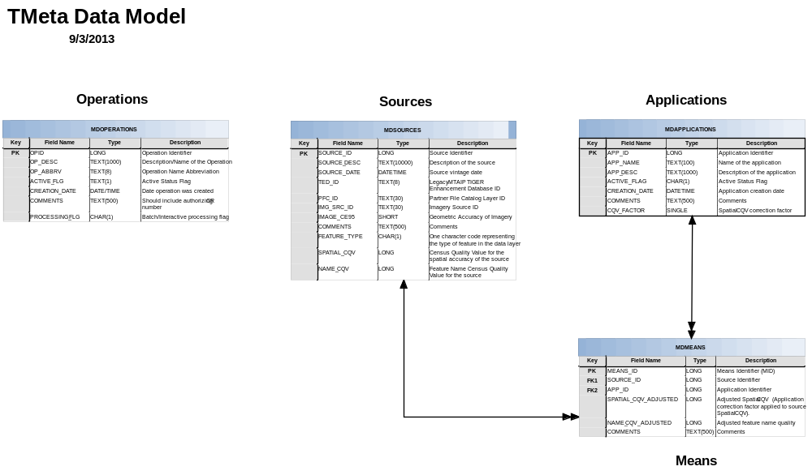
The TMeta database design has four tables for: operations, sources, applications and MID. The operations table is separated from/not linked to sources, applications, and means.

7.1.5 Relationship and Data Content Rules
This section covers the rules that specify the data content of the TMeta Data Tables.
MDOPERATIONS table
Rule 1: All historical and current Operations must be represented in the Operations table
Rule 2: All Operation records must have an Operation Description (OP_DESC).
Rule 3: All Operation records must have an Operation Abbreviation (OP_ABBRV).
Rule 4: All Operation records must have an Active Status Flag (ACTIVE_FLG) set.
MDSOURCES Table
Rule 1: All Records must have a source description (SOURCE_ID).
Rule 2: All Records must have a source creation date (SOURCE_DATE).
Rule 3: All Records must have a non-null Feature Type (FEA_TYPE).
Rule 4: All Records must have one valid source ID (either a TED_ID, IMG_SRC_ID, or PFC_ID).
Rule 5: All sources in the current TMeta must be represented in the SOURCES table.
Rule 6: All source records must link to at least one Means record.
Rule 7: If a source record links to more than one Means Record, each of the matching Means records must link to a different application in the APPLICATIONS Table.
Rule 8: All Imagery Sources must be associated to a MID linked to an interactive GATRES application.
Rule 9: All Imagery sources must have a name CQV of zero or null (NAME_CQV = null or zero).
Rule 10: All imagery sources will have a default physical-feature Feature Type (If IMG_SRC_ID ≠ null then FEATURE_TYPE = 'E').
Rule 11: The geometric accuracy of imagery must be null for all non-imagery sources (If IMG_SRC_ID = null then IMAGE_CE95 = null)
MDAPPLICATIONS
Rule 1: All applications must have an application name (APP_NAME).
Rule 2: All applications must have an application description (APP_DESC).
Rule 3: All applications must have a spatial CQV correction factor (CQV_FACTOR) ≤ 1.00.
Rule 4: All applications must have an active-flag value set (ACTIVE_FLAG).

figure XX - PFC to TMEta Data Flow Model
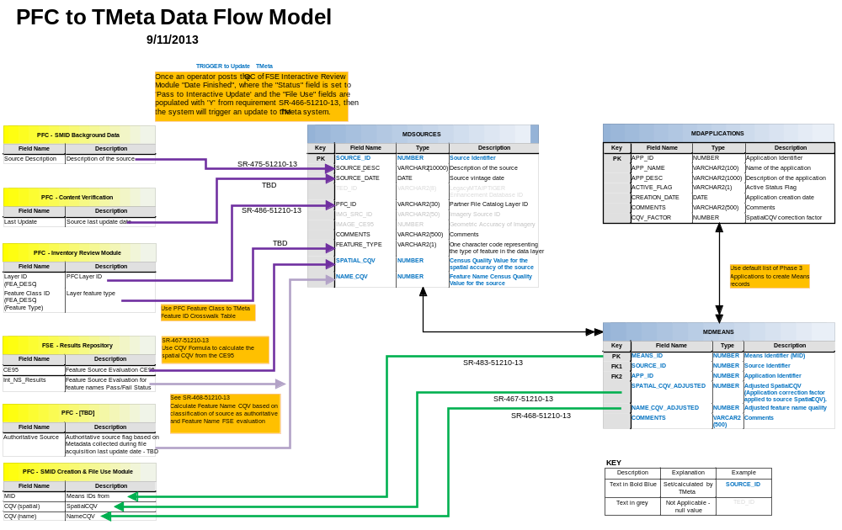
Partner File Catalog/GSS-I Workflow Control (PFC/GWCS) Data Relationship Rules
Rule 1: The PFC SMID Background Data must have a Source Description linked to the MDSources table.
Rule 2: The PFC - Content Verification must have the Source vintage date linked to the MDSOURCES report.
Rule 3: The PFC - Inventory Review Module Verification must have a PFC Layer (FEA_DESC) and layer Feature type (FEA_DESC) and both must link to the MDSOURCES table using the TMeta Feature ID Crosswalk Table. See below.
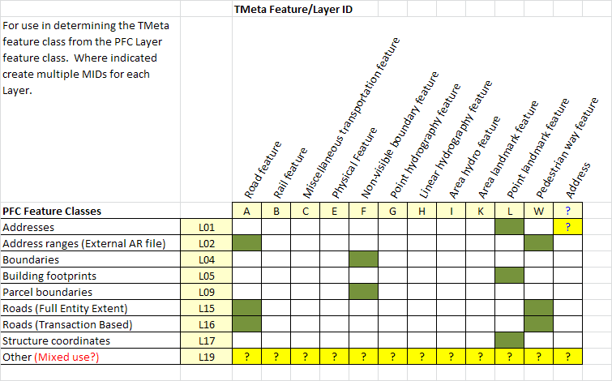
Rule 4: The FSE - Results Repository must have the CE95 and TMeta must use it to calculate the spatial CQV (described in the SR-467-51210-13) and record the results in the MDSOURCES table.
Rule 5: The FSE - Results Repository must have the Feature Source Evaluation for feature names Pass/Fail Status (Int_NS_Results) and TMeta must use it to calculate the Name_CQV (see SR-468-51210-13) and display the results in the MDSOURCES table.
Rule 6: The PFC must have the Authoritative source flag based on Metadata collected during file acquisition last update date, this field must support the Feature Name CQV calculation based on classification of the source as authoritative and Feature Name FSE evaluation (See SR-468-51210-13)
Rule 7: The MIDs, Spatial CQV, and Name CQV from must be linked to the PFC – SMID creation and file use Module.

8. References & Related Documents
A listing of the documents used to compile the Linear Features Metadata Master Plan. The ‘true’ citation for each document will be found in this section. Any reference to that document throughout the balance of the document will link back to here.
This section should list:
- The documents used to compile the information in the Master Plan.
- Other relevant documents to refer to for more information about metadata.
- References as to the location of these documents.
A standard ‘presentation form’ will be developed so that each reference will have the same look & feel.
Lead Editor: Fred Malkus

8.1. References
The following references are cited in the Linear Features Metadata Master Plan:
[Ref_01] U.S. Census Bureau, “Metadata Recommendations for the MTDB”, December, 2011, link
[REF_02] U.S. Census Bureau. “Project Charter for the Metadata Integrated Project Team”, March 2013, link
[REF_03] U.S. Census Bureau. “Project Plan for the Metadata Integrated Project Team (IPT)”, March 2013, link
[REF_04] International Organization for Standardization. “ISO 19115-2:2009 Geographic information -- Metadata -- Part 2: Extensions for imagery and gridded data”, January 2012
[REF_05] U.S. Census Bureau. “Census Bureau Geospatial Product Metadata Standard”, January 2010, link

8.2. Related Documents
This is likely the first of a series of documents describing how metadata is used within the division.

Attachments
A listing of defined concepts, terms, and acronyms used within this document. This section could reference a FAQ somewhere on the GEO site.
LL comments: This document will start the process of building a metadata lexicon within the Geography Division. Use the term lexicon.
Authors: Fred Malkus, Andrew H Flora, Jamison D Leach, Francia L Torres

Metadata Lexicon
PROBLEM: Within the Geography Division, the term Metadata is commonly used as the default term for all metadata maintained or produced within the division. As there are a number of different categories of metadata within the division, this results in substantial confusion and wasted time.
Solution: Develop a lexicon of standard terms to be used in describing metadata as it is used within the division.

A.1 Concepts
Geographic Metadata: ???
Source Metadata: ???
Process Metadata: ???
Product Metadata: ???

A.2 Terms
Confirmation
Metadata data about data; "a library catalog is metadata because it describes publications."
Partnership program
Transaction

A.3 Acronyms
CQV Census Quality Value
GATRES Geographic Acquis-Based Topological Real-time Editing System
GEO U.S. Census Bureau Geography Division
GIS Geographic Information System
GSS-I Geographic Support System Initiative
ISO International Organization for Standardization
IPT Integrated Project Team
MAF Master Address File
MTDB MAF/TIGER Database
TIGER Topologically Integrated Geographic Encoding and Referencing System

