U.S. Census Bureau
Geography Division



GSS Initiative
Linear Features Metadata Master Plan

March 12 2014

Version 0.4.2

Revision History
Date | Version | Type of Review | Author(s)/Participants
11/27/2013 | 0.1.0 | Initial Draft | Fred Malkus
 |  | Updated Draft | Andrew Flora, JD Leach, Fred Malkus, Francia Torres
 |  | Review/Revision | Andrew Flora, Frederick Malkus, JD Leach, Francia Torres, Aaron Jensen, Andrew Coles, Carl Sanders, Dave Cackowski, Graham Baggett, James Pender, Joan Meiller, John Liadis, Joshua Quest, Laura La Kose, Lynda Liptrap, Mike Belgorodsky, Patrick Wilkinson, Peter Virgile, Rhonda Scaife, Ruth Johnson, Sharon Cochran, Stuart Irby, Tiernan Erickson, Tony Wilkinson, Valerie Beaudin
 |  | Review Revision
 | 1.0.0 | Baseline

Approval Log
Date | Version | Approving Party | Signature
 | 1.0 | Timothy F. Trainor  Chief, Geography Division
 | 1.0 | Curtis A. Dunson  Program Manager for Geographic Support System Initiative
 | 1.0 | Michael Ratcliffe  Features WG Mentor ADC  Assistant Division Chief for Geocartographic Products and Criteria
 | 1.0 | Joanne Aikman  Chief, Linear Features Branch
 | 1.0 | Andrew Flora  Metadata IPT Project Manager
 | 1.0 | Gerard Boudriault  Assistant Division Chief for Production and Control
 | 1.0 | Leslie S. Godwin  Assistant Division Chief for Geographic Program Management
 | 1.0 | Phani-Kumar Atri Kalluri  Assistant Division Chief for Spatial Data Systems and Database Management
 | 1.0 | Ama A. Danso  Assistant Division Chief for Address Software
 | 1.0 | Andrea G. Johnson  Assistant Division Chief for Geographic Operations
 | 1.0 | Gregory F. Hanks Jr.  Assistant Division Chief for Geographic Partnerships
 | 1.0 | Deirdre D. Bishop  Chief, Office of the Geographic Advisor

Change Control for this Document

This document is subject to review and update throughout the lifecycle of the project. The Revision History tracks changes to this document. For more details, see section 1.7 of this document.

Document File Name: MMP LF v0_4_1_2014_02_28.doc

Executive Summary
Metadata is a critical component within Census Bureau geographic operations. This perspective is consistent with the bureau directive of being a “data driven” organization and is supported by the GEO vision to capture as much metadata as possible with minimal operator action. Metadata provides the means to associate individual spatial features and addresses with specific sources and operations. Through this association, the reliability of data is established. This knowledge is critical to the improvement of the MAF/TIGER Database (MTDB) as it provides for the identification of areas where quality improvements are needed. Much of this information comes from our data exchange partners who are responsible for much of the information in the MTDB.
The concept of metadata is relevant to nearly all aspects of spatial data yet it is unfamiliar to many. It has been confused by a tangle of generally unfamiliar and inconsistently used terms. The purpose of this document is to be both instructive and prescriptive in presenting a definitive overview of metadata as it is used by the Geography Division (GEO).
As an instructive resource, this document explains the reasons why the GEO needs metadata and how it is used to support geographic operations and products. Specifically it: (a) provides an overview of metadata concepts as they apply to the MTDB; (b) defines metadata terminology as it relates to spatial data in the MTDB and Federal standards; (c) describes the organization of metadata in the MTDB and the relationships between metadata and the spatial feature and attribute information; and (d) provides an overview of the processes that maintain/use metadata in the MTDB. Anyone unfamiliar with metadata should be able to acquire a working understanding of metadata as it applies to the MTDB after studying this document.
As a prescriptive guide, this document identifies the high-level requirements for metadata in the MTDB and the geospatial products derived from it. It describes the business rules that regulate data content and relationships. As a master plan, this document functions as a compendium of metadata requirements that will inform the coordination and development of the GEO’s metadata system. All software development associated with the MTDB must build on the fundamental requirements and rules described here. As such, the master plan will be a dynamic document that contains current and relevant information useful to the development of applications and products.
Everyone who maintains and uses metadata within the GEO is a stakeholder in this document. All stakeholders are encouraged to contribute to this document by suggesting improvements, offering updates, correcting errors, adding references, and asking questions. The success of this document depends on the community of stakeholders and the contributions that they make.

1. Introduction
A brief description of the purpose, scope, assumptions, and intended audience of the Linear Features MMP.
Any Assumptions, goals, and guidelines will be directed to the document as a whole, and not to linear features specifically.
LL comments: (a) Link this document back to the GSSI and the Metadata IPT, (b) Insert a “review by date” for the document, & (c) Expressed concern over keeping hyperlinks current over time within the document.
Lead Author: Fred Malkus
This master plan is the result of recommendations developed by the Metadata Subgroup, a member of the GSS 2011 Features Working Group. These recommendations are published in the document “Metadata Recommendations for the MTDB” version 0.11 [Ref_01], released on December 28, 2011 and have the official GSS-I designation REC-2011-022. Within this document “Recommendation 11: Participants from metadata stakeholder-branches need to compile a metadata master plan to inform current and future geographic operations”; calls for the development of a metadata master plan.
The assumptions, goals, and guidelines listed in this section are directed to the document as a whole, and not to linear features specifically.

1.1. Purpose
The use and maintenance of metadata is shared across nearly every branch in the GEO. However, there is no central repository for information about metadata. This linear feature metadata master plan will represent a compendium of this body of knowledge as it relates to linear features. It will also define current and future metadata collection needs and establish requirements for update operations in general.

1.2. Scope
This metadata master plan will focus on linear features and their attributes including characteristics of the component edges, feature names, and any address ranges associated to these edges.

In-Scope Activities
This document will consider the following activities and topics to be in-scope:
- Describe metadata concepts for linear features in the MTDB;
- Describe requirements for applications and products that require metadata;
- Describe procedures and processes for obtaining, maintaining, and extracting metadata;
- Describe metadata databases;
- Establish new MDHISTORY Business Rules;
- Eliminating existing MDHISTORY Business Rules that are out of date; and
- Establish guidelines for the collection and maintenance of external IDs to link MTDB data to external data sets.

1.2.2 Out-of-Scope Activities
This document will consider the following activities and topics to be out-of-scope:
- The development or maintenance of software;
- The development or maintenance of metadata databases;
- The collection or maintenance of metadata content;
- The creation, update, maintenance, or validation of metadata;
- The evaluation of specific sources;
- The collection of metadata for partner files;
- The identification and extraction of linear feature metadata for public products;
- Metadata for point features and landmarks;
- Metadata for MAF structure points (MSPs);
- Metadata for Area landmark features including hydrographic features;
- Metadata for Legal and statistical areas; and
- Metadata for addresses.

1.3. Assumptions
- This document focused on metadata for linear features. Metadata for products, addresses, and non-linear features will be addressed in another document.
- Metadata will continue to be maintained and used by staff in nearly all branches of the GEO, as well as other divisions and data exchange partners.
- The GEO will continue to collect geo-spatial information from a wide range of sources and data exchange partners.
- Data customers have an interest in the source and vintage of the geo-spatial data in the MTDB and will want this metadata available in geographic products.
- Metadata provides a dependable indicator of data reliability and quality. It will continue to inform update decisions through quality indicators used to target areas for further updates.
- The GEO will support the formation of a permanent metadata working group that will serve as the maintenance authority. This group will include representatives from all branches with a stake in metadata issues. The group will provide a forum to discuss all future metadata issues and will serve as a clearing house for master plan and policy changes.

1.4. Goals and Guidelines
- Develop centralized metadata documentation that provides a standard set of terms, provides concise definitions, and explains data relationships and update processes for use across all GEO applications related to linear features.
- Provide the policy for collecting, maintaining, and archiving linear feature metadata within the GEO.
- Develop a common language and understanding of linear feature metadata as it is used within the GEO.
- Describe what Federal Standards are relevant to linear feature metadata.
- Describe what GEO must do to be compliant with these Federal Standards.
- Identify/describe all Business Rules related to linear features currently in use within the GEO.
- Identify/describe all databases within the GEO containing linear features metadata.
- Identify/describe all Processes related to linear features currently in use within the GEO.
- Establish a community of practice with regular communication and interaction.

1.5. Intended Audience
The intended audience for this document is the Geography (GEO) Division’s Linear Features Branch (subject matter) and ANY other staff responsible for collecting, storing, mining, formatting, editing, or delivering linear features metadata. It is also an appropriate introduction to metadata for any staff member new to the division.

1.6. Participants
Table 1: Participants, Roles, and Responsibilities
Name | Org. | Phone | Role
Malkus, Fred | GEO / NSGPB | 301-763-9102 | Metadata Expert / Requirements Analyst / Principle Editor
Flora, Andrew H | GEO / LFB | 301-763-1119 | Subject Matter Expert
Leach, Jamison D | GEO / LFB | 301-763-9186 | Subject Matter Expert
Torres, Francia L | GEO / LFB | 301-763-8997 | Subject Matter Expert

1.7. Change Control Plan
This document is a configuration Item and is subject to review by stakeholders in the Geography Division (GEO). It may be updated by authorized stakeholders in accordance with GEO policy for submitting controlled documents to Configuration Management (CM) using procedures established by the GEO Configuration Manager and described in the Geography Division Configuration Management Plan and the Geography Division Program Management Plan. The Revision History tracks changes to this document. When changes are approved, the CM staff will post a new version of the document on the intranet as a reference for all stakeholders.

1.7.1 Creating a Baseline
The Linear Feature Metadata Master Plan will be considered baselined when the Change Request (CR) requesting Baseline approval is approved by the GEO Change Control Board.

1.7.2 Changes to the Baseline
Changes to the baseline shall be in conformance with the GEO Configuration Management Plan.

1.8. Effective Date and Review Period
The Linear Features Metadata Master Plan is effective immediately following baseline approval and will remain in effect until modified or replaced pursuant to the procedure described in Section 1.7 of this document.
Linear features metadata and the processes associated with it are unlikely to be static. As such, the development of this master plan is not a one-time event, but rather one that must be revisited periodically. The maintenance authority will maintain the Linear Features Metadata Master Plan ensuring that the document is revisited after 5 years, or updating and revising it as necessary.
:

2. Compliance
Using the terms described in the “Metadata Concepts” section, what must the Geography Division do to comply with federal requirements for metadata established beyond the Census Bureau? Requirement documents will be cited and specific requirements will be noted.
NOTE: This section will differentiate between metadata that is used within the GEO Division as compared to metadata that the Census Bureau is required to report. LL comment: Emphasize the difference between internal metadata and external metadata. Internal metadata: data used to support projects within the Census Bureau. External metadata: data describing public products that the Census Bureau is required to report.
Question: Should we develop a listing of ‘operations’, either general or specific, that must produce metadata in order to comply with these federal requirements? LL comment: Lynda agrees; TIGER/Line Shape files would be a good example.
Question: Are there any in-house requirements, from within the GEO that should be described here? LL comment: The Department of Commerce now has a policy on metadata. This document should note that the Census Bureau has acknowledged this policy.
Lead Author: Fred Malkus
“What must the Geography Division do to comply with federal requirements for metadata established beyond the Census Bureau?”
- What are the federal requirements for (product) metadata?
- For each requirement:
  - Who is the authority?
  - What is the source?
  - What must the Geography Division do to comply?
What is the Department of Commerce’s policy on metadata?
- The Department of Commerce now has a policy on metadata. The Census Bureau has acknowledged this policy.
- What are the requirements of this policy?
In accordance with the OMB Circular A-16 Revised, the agencies shall:
  - Document all geospatial data that is collected, produced, acquired, maintained, distributed, used, or preserved by the agency using a/the metadata standard designated by the Federal Geographic Data Committee (FGDC).
  - Ensure metadata meets all requirements of the designated standard for both content and format.
  - Include information to meet minimal requirements of the standard.
  - Include additional information whenever appropriate to provide the maximum information available through the standard.
  - Review metadata periodically for accuracy and update appropriately.
  - Submit all geospatial metadata for publication to the FGDC designated Clearinghouse.
  - Ensure metadata meets requirements of the privacy act.
  - Information in the metadata must not release proprietary or classified information.
Are there any in-house requirements, from within the GEO Division?
- Geospatial Product Metadata Standard (Jan. 28, 2010): This standard provides guidance for the collection of metadata for all geospatial products offered by the U.S. Census Bureau. The objective of the standard is to provide a common set of elements and definitions for the documentation of geospatial products that will enable users to obtain consistent information concerning the availability and fitness of use of the product.
“This section will differentiate between metadata that is used within the GEO Division as compared to metadata that the Census Bureau is required to report”
- Emphasize the difference between internal metadata and external metadata.
  - Internal metadata: data used to support projects and operations within the Census Bureau (GEO Division).
  - External metadata: data describing public products that the Census Bureau is required to report.
  - By internal, what do we mean? GEO Division or Census Bureau?
  - Federal requirements are satisfied thru using external metadata.
“Should we develop a listing of ‘operations’, either general or specific, that must produce metadata in order to comply with these federal requirements?”
- TIGER/Line Shape files
- TIGERweb???

2.1. Background

2.2. Policy
Does the GEO have a policy?

2.2.1. Federal
List what Federal Standards are relevant to Spatial Metadata.

2.2.2. Department of Commerce

2.2.3. Geography Division

2.3. Definitions

2.4. Implementation
How these standards impact the creation of data products?
ID examples process/products that are affected by the requirement.

2.5. Responsibilities
The document must list/describe what we are required to do to satisfy federal requirements established beyond the Census Bureau. For each requirement listed, the source of that requirement must be listed, for example Executive Order 12906 (EO-12906).

3. Metadata Concepts
An introduction to metadata not specific to the Geography division. This will be a very generic description. This section will not describe metadata as it is used within the Geography division. It will describe metadata in generic terms as it might be used beyond the Geography Division. This section should set the table for the balance of the document.
The description will include:
- What is metadata?
- What are the major types of metadata? (Include new graphic similar to Andy’s diagram – should show types of metadata w/examples that come from the world outside GEO. They should readily translate to Andy’s list: operations, data about update transactions, sources for updates, metadata about sources, metadata about the quality of the updates and sources, data confirmation)
- How are these types of metadata used,
- What assumptions are made regarding these types, and
- What are the limitations associated with these types, and
- What areas of geography require metadata.
LL comments: Give examples and put those examples in context. Emphasize where the metadata is used.
Lead Author: Fred Malkus

3.1. Sub-Section 1
???

4. Linear Feature Master Plan
Similar to the “Metadata Concepts” section; the difference being that this section will describe how metadata is used within the Geography Division. Should include a copy of the “TIGER Metadata Types” balloon diagram developed by Andy Flora (9/23/2013)
Any Assumptions, goals, and guidelines will be directed to the use of linear features within the Geography Division.
Lead Author: Andy Flora

4.1 Purpose
The purpose of the master plan section is four-fold:
- Identify general principles that apply to the management of Spatial Feature Metadata;
- Provide specific policies and guidelines that should be applied to all new operations to make them compliant with general principles;
- Describe how the GEO applies general metadata concepts to spatial features in the MAF/TIGER database; and
- Inventory the uses of spatial metadata.

4.2 Introduction
The Census Bureau and specifically the Geography Division created the MAF/TIGER System to “automate the mapping and related geographic activities required to support the decennial census and sample survey programs of the U.S. Census Bureau starting with the 1990 decennial census. … The building of the MAF/TIGER database involved a variety of encoding techniques such as automated map scanning, manual map digitizing, standard data keying, and sophisticated computer file matching. The goal was to provide automated access to, and retrieval of, relevant geographic information about the United States and its territories.”
From its creation, the TIGER System has included metadata to document updates from diverse update operations. Internally, GEO staff used metadata to evaluate the results of different update operations, as well as to investigate the update history of features and their attributes. In one major operation, metadata were critical to the integration of the 1990 census address ranges with newly created address ranges created from the 1990 Address Control File.
The variety of metadata in the TIGER System greatly expanded with the MAF/TIGER Accuracy Improvement Program (MTAIP) in the years leading up to the 2010 Census. The program added new metadata describing update sources and the quality of the information acquired. The purpose of these enhancements was to promote ever greater improvements to data quality and more accountability to data exchange partners by tracking the specific sources of updates.
In the time following MTAIP, the GEO has worked to streamline and improve the systems and processes pioneered during MTAIP and extend these systems to new technologies namely updates derived from imagery. The GSS-I program would also expand the use of metadata in 2013 to support the calculation of Quality Indicators that would help identify areas for update in advance of a targeted address canvassing operation.
The GSS-I Feature Coverage & sources Workgroup-Metadata Subgroup revisited the metadata requirements, and made 14 specific recommendations to improve the spatial metadata. These recommendations identify specific needs to simplify and correct existing systems as well as create new metadata systems for imagery and data confirmation. The confirmation process adds confidence to existing features by using current sources to validate them and their attributes and has the potential to improve the quality indicators.
Although not specifically stated, the GSS-I recommendations are founded on a core set of principles that provide the foundation for future metadata work. Other efforts, outside the scope of this document will address the creation of metadata for boundaries, geographic areas, and addresses.

4.3 General Principles
The following metadata principles reflect the underlying philosophy and primary guidelines used in the collection and maintenance of metadata. As such, they document the business case or customer requirements for spatial feature metadata.
Principle 1: Spatial feature metadata will identify the geographic operation responsible for the update. The purposes of this information are 1) to relate specific updates to an operation for quality assurance testing; 2) to identify the source of problem data; and 3) to identify information from a specific operation where a specific source file or data provider cannot or has not been named.
Principle 2: Spatial feature metadata will identify the name of the source and its provider for spatial features and their attributes derived from a specific reference file or document. To the extent possible, it should be possible to trace a feature or attribute to a specific source. The origins of these data are relevant as they reflect data quality and the contributions of data partners.
Principle 3: The source file is the basic unit for describing data quality Metadata. It has been long standing policy and practice to evaluate the quality of spatial features based on a sample evaluation of features from that entity. This practice is supported by an assumption that the source provider has applied the same standards and update and maintenance procedures across the area covered by the source. For imagery, the basic unit is a group of image tiles with a unique combination of dataset ID and CE95.
Principle 4: The quality of spatial feature data is a function of the vintage and accuracy of the data across the source and the application used to update the MTDB. First, the quality of a feature is only valid so long as the information it describes is current. With the passage of time, changes will occur to the attributes, location and even the existence of spatial features. These changes degrade the quality of the data. Second, the quality metadata for a source is a statistical average of all observed features. Third, the manipulation of the source data by the update application process may degrade the accuracy of the data. Batch processes have long been considered to have minimal impact on data quality, while interactive processes are believed to have more.
The quality of any specific feature or attribute may be higher or lower than the average. Update systems must have the capability to override existing metadata for specific features when operators determine that the quality metadata does not apply to the specific feature or the information is no longer valid.
Principle 5: All spatial feature update operations must ensure that each feature update represents a net improvement in data quality. More current and accurate information should replace less accurate or older information. The metadata system must provide for the calculation of Census Quality Values that enable an objective comparison of updates based on data quality/reliability.
However, If there is evidence that a feature from a high quality source has been significantly modified and is not currently correct, the quality metadata for that feature is no longer valid. The feature (or its attributes) can be replaced by information from a source even if its metadata indicates it has a lower quality than the original feature.
Principle 6: All spatial feature update operations must maintain metadata about the update transactions about existing spatial features and their attributes derived from data sources. As indicated earlier, the GEO has used transactional metadata to trace the origins of features, troubleshoot data problems, and test the functionality of new processes. As a general practice, these transactions are limited to add, modify, and split transactions.
Principle 7: All spatial feature update operations must maintain the integrity and reliability of new and preexisting metadata. The reliability of the metadata to provide an accurate statement of the source, means, and quality, depends on effective maintenance. Failure to correctly maintain the data could result in the loss of metadata for a feature or the incorrect association of metadata to that feature.
Principle 8: Feature update operations should include measures to capture all required metadata with the minimum of human operator intervention. 1) Applications should minimize human error in the recording of metadata that would compromise the reliability of the data. 2) Applications should minimize the cost (time and effort) needed to interactively record metadata.

4.4 Guidelines and Policies for New Operations and Applications
The following policies and guidelines are intended to support the development of new spatial update processes by promoting sound practices for the update and maintenance of metadata. They relate back to the principles outlined earlier and provide more specific guidelines for implementation. The developers of new operations and applications should review the policies below to ensure that their procedures and applications are compliant with these requirements.
Policy 1: All spatial feature update operations that add or modify spatial features must have a unique metadata Operation ID that uniquely identifies any updates from this operation.
Policy 2: Spatial feature update operations must make provisions to collect metadata about the content and structure of potential data sources that relate to the quality and usability of the data. These data should also include information about the authoritative and trusted status of the data as it also relates to data quality.
Policy 3: Spatial feature update operations must make provisions to inventory data sources through the use of the Partner File Catalog, to quality evaluate these sources, and to document all findings that relate to the quality and usability of the data.
Policy 4: All spatial feature update operations must identify all applications that are expected to record metadata for spatial feature updates and to the extent possible, identify any quality factors characteristic of these applications or their use that may lessen the quality of the final updates.
Policy 5: The metadata system must provide for the creation of new means IDs that identify each unique combination of source and application required for update operations. The metadata system must also provide for the calculation of Census Quality Values that indicate the relative quality of updates from different means (sources and applications).
Policy 6: All update applications must include provisions to record the relevant metadata to the extent possible and should be tested to ensure that the information is recorded correctly. Update processes should use the core API software to ensure that the metadata codes and transactions are recorded correctly.
Policy 7: A sponsoring branch may choose the option not to create a means ID for each source and application for an operation if the sources are too numerous to effectively manage and a CQV is not critical for the feature. For instance, GAB has opted not to create MIDs for each BAS participant but will record the quality of the boundary edges using the boundary edge SMIDTYPE flags and the yearly BAS operation ID. APMB has also opted to not create a MID for each source of MSP locations but will use other means to ID the quality of these features.
Policy 8: All measures of data quality for a specific data attribute or characteristic must be consistently standardized to a simple linear scale that enables a direct comparison to determine the higher quality information.
Policy 9: All data quality comparisons are limited to the same data attribute or characteristic. The quality of one attribute is not dependent on the quality of other attributes. When making updates, it is appropriate to compare the spatial accuracy of an edge from one source and application to the spatial accuracy from another. The spatial accuracy of the feature name does not enhance or degrade the spatial accuracy of feature.
Policy 10: All spatial feature update operations must maintain the integrity of existing metadata by 1) recording new metadata for feature updates; 2) removing preexisting metadata for features or attributes modified by the process; and 3) perpetuation preexisting metadata for features untouched by the process. Update operations should use the core API to standardize updates.
Policy 11: Software developers should develop applications to minimize operator intervention to record metadata by using: 1) processes that collect metadata from the update system environment such as time, date, operator ID, and the displayed imagery; 2) Provide restricted pick lists that provide only relevant options such as current Operation IDs; and 3) provide fully automated tools to generate/validate appropriate metadata IDs as they are needed.

4.5 Inventory the uses of spatial metadata
There are two aspects of metadata for the GEO: 1) A need for internal/business process metadata to inform feature editing and update decisions; and 2) A mandate by the Federal government to produce metadata for our public products.
Operations Metadata  TMeta database - Operations Table  OPID – Operations Identifier  OP DESC – Description/Name of the Operation  OP_ABBRV – Operation Name Abbreviation  ACTIVE_FLG – Active Status Flag  CREATION_DATE  COMMENTS – Identifies authorizing CR when known.  PROCESSING_FLG – Batch/Interactive processing flag | Serves as Recorder:  What operation changed the data?  Specific processes may associate a general quality level to updates associated with specific update operations. For example, the calculation of Quality Indicators associates a higher level of quality for updates with a specific operation because these are known to have been made from imagery.  Other operations may exclude features and attributes based on their update operation. For example, the Address Range Build process excludes address ranges from update when they have a OPID from the last two BAS update cycles or MTAG.

Source Metadata  TMeta database  MID – Means ID  SOURCE_ID – Link to the Source Table  APP_ID – Link to the Application Table  SPATIAL_CQV_ADJUSTED - Adjusted Spatial CQV (Application correction factor applied to source Spatial CQV)  NAME_CQV_ADJUSTED - Adjusted feature name quality  TMeta database – Source Table  SOURCE_ID – Unique TMeta Source ID  SOURCE_DESC – Source description – ad descriptive name for the source  SOURCE_DATE – Source date  TED_ID – ID that links source to TED database primarily when the source was acquired for MTAIP.\  PFC_ID – The ID that links the source to the Partner File Catalog Initially used for GSS-I partner file processing.  IMG_SRC_ID - Imagery Source ID used to link the source to the imagery server metadata database.  COMMENTS  FEATURE_TYPE – One character code representing the type of feature in the data layer.  SPATIAL_CQV – Census Quality Value for the spatial accuracy of the source  NAME_CQV – Census Quality Value for the feature name  SRC_GRP_ID - Reference to the Imagery source group ID in the Imagery-Server metadata table that is unique for a source data set ID (SRC_DATASET_ID) and CE95.  TMeta database – Applications Table  APP_ID – Application Identifier  APP_NAME – Name of the update application  APP_DESC – Description of the update application  ACTIVE_FLAG – Active status flag – is the application actively in use or not.  CREATION_DATE  CQV_FACTOR  COMMENTS  CQV_FACTOR – Spatial CQV correction factor | Serves as Validator:  Who Provided data?  What is the quality of the data?  MID Code links to a unique combination of source and application.  The resulting CQVs for the means reflect the quality of the source adjusted by the error factor inherent in the application/update process. Update permission checks must use these CQVs and not the source CQV.  The TIGER/Line data product metadata provides these source descriptions.  A source will have either a TED_ID, PFC_ID, or IMG_SRC_ID. These external data sets contain additional information about the sources, their providers, and the processing that the sources went through.  Each source and MID represents a single data layer, except for imagery, which represents all visible feature types. There is an expectation that the MTDB feature type will be consistent with the feature type(s) in the source layer.  The TMeta system derives the spatial CQV from the CE95. However, GPS based updates from 2010 Address Canvassing received a generic, CQV = 1.  The TMeta system has the potential to record a feature name CQV. There is a proposal to base this value on the demonstrated quality of the names and authoritative status of the provider.  The SRC_GRP_ID supports the creation of MIDs for imagery.  Applications figure into the quality of the resulting update in the MTDB because each update process has the potential to introduce data error. It is generally held that updates based on interactive updates have the potential to add greater update errors than purely batch processes.  Applications are distinct from operations in that they represent specific software tools that perform specific update tasks. An operation may employ different update strategies and data sources to meet specific project goals. Operations may use a mix of different software applications to meet these goals.

Transaction Metadata  Metadata that records information about updates to specific spatial features and their attributes.  MDHISTORY Table:  OIDMT1 – OID of the record being tracked  OIDMT2 – 2nd OID where metadata is assigned to a feature/topo primitive relationship.  COLUMNID – Indicates which column has been modified.  ACTIONCODE – type of update action  OPID – Operation ID  METADATAID – References a source in the metadata database (TMeta).  MTUPDATE – Date MAF/TIGER Updated.  JBID – James Bond ID of digitizer.  EDGE Table  SMID – Spatial Metadata ID  SMIDTYPE – Spatial type associated with the SMID. | Metadata enables internal and external data users to isolate updates from specific sources and update operations. This information is useful in process quality control and testing. It can be used to provide feedback to data exchange partners indicating which and how many features were derived from specific data partners.  The metadata supports research and process improvement. The information can help determine the sequence of feature updates that contributed to data errors.  Metadata on update operators supports personal accountability for the quality of feature updates.  The SMID supports permission checks that protect high quality data from being overwritten or modified by lower quality information. The SMIDs enforce a degree of spatial stability in the database.  Includes boundary type flags that protect the boundaries of legal entity boundaries.

Feature Identifier Metadata  The MTDB includes metadata about the permanent IDs for spatial data.  External ID metadata records IDs (foreign keys) to external datasets.  EXTERNALID Table  OIDMT – OID of the MTDB record associated with the external ID.  EXIDTYP – External ID Type.  EXTID – External ID number.  TRACKER Table – Permanent ID Tracking  IDNEW – New permanent ID after update.  IDOLD – Old permanent ID before update.  IDTYP – Permanent ID type.  ACTION – Update action type.  DATETIME – Date and time of the update action. | External ID numbers provide a direct means for relating spatial data in one data set with those in another. Data exchange partners can use these IDs to correlate MTDB permanent feature IDs with their own. The external IDs may also support the linkage or transfer of attributes between datasets.  These IDs can be linked to other metadata about the source of the of these ID numbers.  The TRACKER table provides the means to correlate permanent IDs that changed over time due to split and merge update actions. When information is associated to a permanent ID number that is no longer on a feature in the MTDB, the tracker table may be able to relate that ID number to descendants that were created from the original feature. The data supports correlation of data sets from slightly different times.

5. Business Rules
This section will describe ALL Business Rules as they are applied within the Geography Division regarding linear features. The purpose and intent of each rule will be included in the description. These rules will be organized into groups based on the type of metadata; e.g. quality, source, transaction.
An added goal of this section is the removal of any ‘Old’ Business Rules that no longer apply to the processing of linear features and its associated metadata.
A standard ‘presentation form’ will be developed so that each Business Rule description will have the same look & feel.
Examples: (a) What are the rules for metadata content, (b) What are the rules covering the relationships between data elements, (c) What are the rules for recording and maintaining metadata for update transactions, etc.
Authors: Fred Malkus, Andrew H Flora, Jamison D Leach, Francia L Torres

6. Databases
A description of the databases. Include any database that contains or should contain metadata. This will parallel the description of the different types of metadata. The description should include text, diagrams, & links. The description should include:
- How metadata are organized
- The names of the databases that contain metadata.
- What data are stored in these databases
- The relationship between the databases and Census operations (what systems were set up for MTAIP what systems are operational for GSS-I)
- The interrelationships between metadata databases (What are the keys that link up the data)
- Common types of queries that a user may make.
A standard ‘presentation form’ will be developed so that each Database description will have the same look & feel.
Lead Author: Jamison D Leach

6.1 Overview
The purpose of this section is to describe to organization and storage of metadata in the MAF/TIGER system. This section will:
- Describe how metadata are organized into tables and database.
- Describe the databases that contain metadata including the names of the databases and the data that they store.
- Identify the interrelationships between metadata data sets and identify the keys that link together the data.
- Describe the relationships between the databases and the census operations that led to their creation.
- Identify the common types of queries that a user may make.
The MAF/TIGER System is capable of managing a wide range of different feature metadata. The metadata balloon diagram below illustrates the variety and organization of this information.
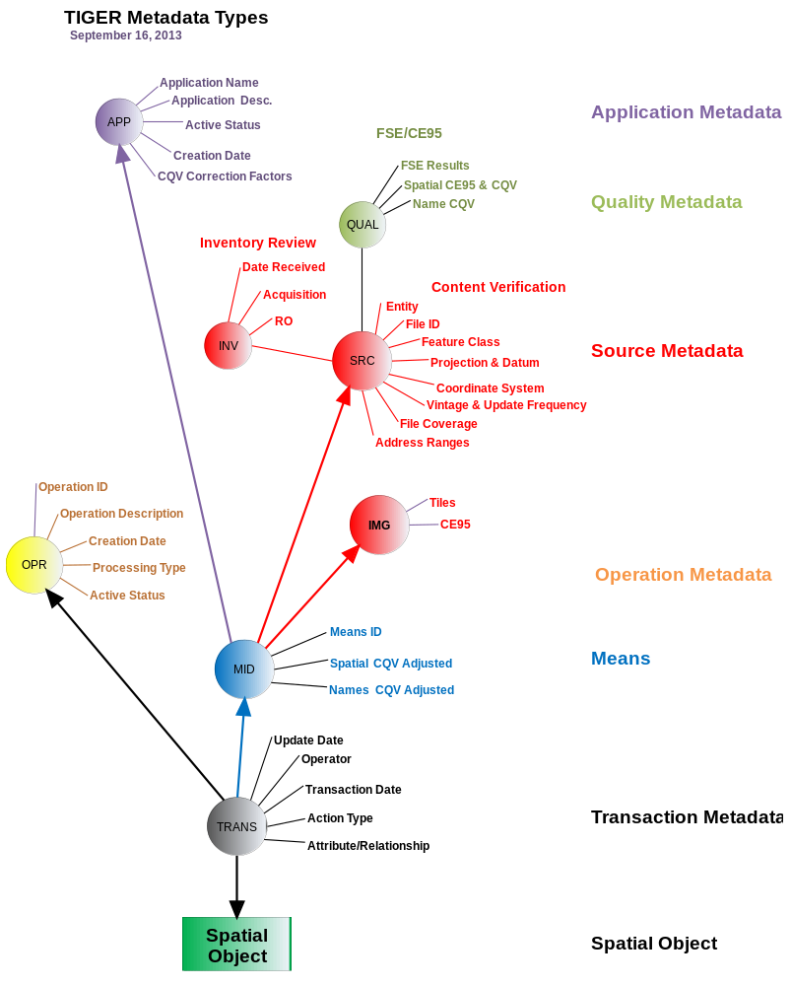
Feature metadata for the MAF/TIGER System are distributed over an integrated set of internal and external data sets:
- Internal metadata reside in the tables of the MAFTIGER database and include information about specific spatial objects or features. These data may include information about permanent ID numbers (MTDB TRACKER table), external ID numbers (MTDB EXTERNALID table), and update transactions (MTDB MDHISTORY table). The update transactions identify the operation responsible for the update and the source that provides the basis for the update when this operation is known. The Means ID (MID) provides the essential link to the external source metadata.
- External metadata provide information about the sources used to update the MTDB. For the most part, these sources are digit data sets and imagery used to directly update the MTDB. The metadata for these sources describe the characteristics of these data sets and the operational history of how the Census Bureau processed them. Some of the information includes the name of the source, the source provider, the geographic entity covered by the source, the vintage of the data, and the evaluated spatial and attribute quality of the information. The collection of these data was the direct outgrowth of specific geographic operations that have defined their organization to this day. The essential data element required for all sources is a unique source identifier.
The TMeta system is essential to integrating the various metadata together. It maintains the inventory of all sources and operations, and provides the linkages between the internal metadata IDs and external data sets. The diagram below illustrates this relationship.
On the MTDB side, update operations tag feature updates with source and operation metadata in the form of operation IDs (OPIDs) and means IDs (MIDs). The MTDB maintains this information in the MDHISTORY table with the exception of the spatial MID (SMID) which appears on the edge for easy access.
The TMeta system generates a MID as the unique combination of source and application (see section on TMeta below). A MID translates back to a single source.
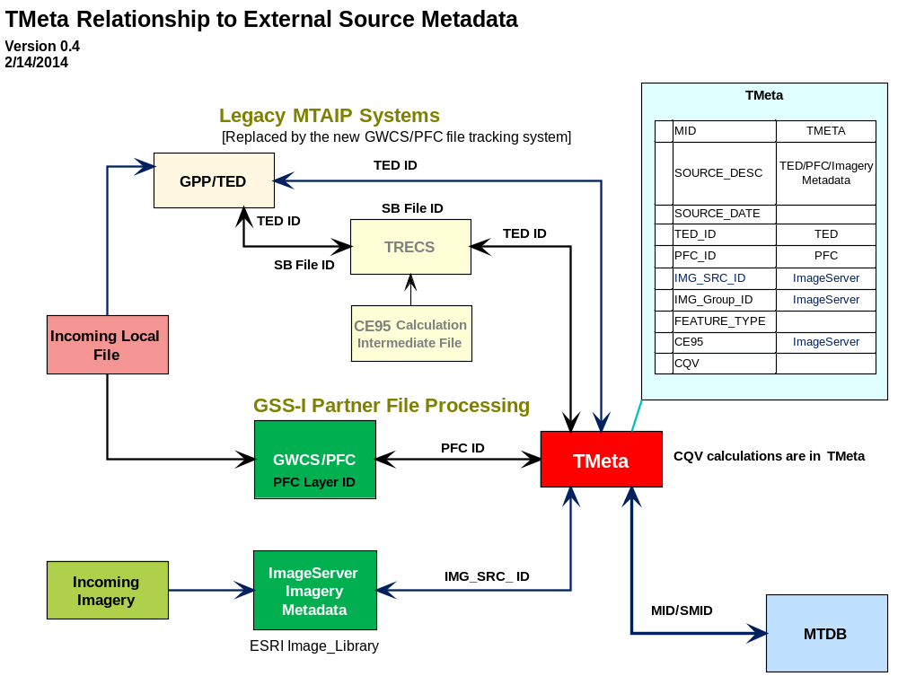

6.2 GPP TED
The TIGER Enhancement Database (TED) is a component of the Geographic Program Participants (GPP) database intended to manage information about geospatial data sources for MAF/TIGER updates. The GPP itself is a system to track contacts between Census Bureau staff and Census Bureau program participants. These participants include contacts from various tribal. State, county and local (TSC&L) agencies as well as commercial sources that may potentially provide reference material. The following is the conceptual diagram for GPP system from the TED SRS.
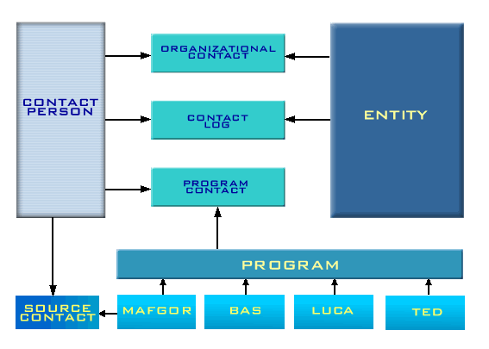
The GEO developed the TED to support the MAF/TIGER Accuracy Improvement Project (MTAIP) that was in production in the years leading up to the 2010 Census. The primary purpose of MTAIP was to improve the coverage and spatial accuracy of geographic features for the 2010 census, which would enable the use of GPS technology in the field. To accomplish this goal, GEO and regional office staff carried out research to find sources potentially available from TSC&L agencies. Research involved online searches and later contacting agency staff. The resulting information became the core of the TED database. Once acquired, these sources would feed the main update track for MTAIP.
The TED database would “house geospatial data for local, state, tribal, and commercial provider files. This inventory information would be used to evaluate potential sources for coordinate enhancement of the TIGER database to include GIS, GPS, Imagery and Paper Maps for MAF/TIGER modernization. In addition the TED will be used to inventory Homeland Security information to include responsible center and other GIS companies tasked by GEO to collect metadata on digital files.”
The TED database would include
The full inventory of TED attributes and legal values is available online.
The T/LGPB is the subject matter branch responsible for the TED system. Technical documentation for the GPP TED system is available on line (Caution: This documentation may not reflect the latest changes to the database):
http://app.geo.census.gov/gppsystem/doc/Documentation.html

6.3 Common types of Queries
The TMeta system maintains information about the quality of data from the sources. The system describes quality in the form of standardized CQVs that enable comparisons across sources. The metadata system software performs a comparison of CQV values to prevent updates that would degrade the quality of the data. TMeta models quality as a function of both the observed quality of the source and the inaccuracies of the applications used to make the update. The MID in TMeta represents the unique combination of source and application that defines the CQV for the update in the MTDB.
There are a number of common queries that must traverse the system of interconnected metadata. These queries involve the acquisition of some metadata data element for display or analysis purposes.
Permission Checks
A common query supports update permission checks to determine whether a new update has a higher spatial accuracy than an existing feature. The query in this case must retrieve the spatial CQV in TMeta for both the source MID and the SMID of the existing edge. The Metadata System Software performs this query as part of the core API.
In theory, permission checks could be extended to any MTDB attribute that has been quality evaluated. Originally, TMeta had the capability to maintain CQV for more than 40 attributes. However, the current TMeta system only supports spatial and feature name values.
Product Metadata

6.4 TMeta
The TMeta system provides a repository of metadata codes and their attributes for all sources and operations used to update the geospatial feature data in the MTDB. The metadata source codes in this system tie the data in the MTDB to external datasets that inventory sources, describe their acquisition and testing, and document the quality and intended use of the data. These external data sets include GSS-I Workflow control System/Partner File Catalog (GWCS/PFC), the imagery server, and the legacy MAF/TIGER Accuracy Improvement Project (MTAIP) TIGER Enhancement Database (TED). The TMeta system provides the functionality to create new metadata source codes, built on the information in these datasets, and new operation codes that document the census and geographic operations that update the MTDB. Apart from these operations, the TMeta system maintains a list of applications, such as BFUS, GATRES, and the Conflation/Update processes, that in combination with sources, identify the means that generate spatial updates and the quality of these updates.
The TMeta system maintains information about the quality of data from the sources. The system describes quality in the form of standardized CQVs that enable comparisons across sources. The metadata system software performs a comparison of CQV values to prevent updates that would degrade the quality of the data. TMeta models quality as a function of both the observed quality of the source and the inaccuracies of the applications used to make the update. The MID in TMeta represents the unique combination of source and application that defines the CQV for the update in the MTDB.
The requirements for TMeta can be divided into the following subject areas:
- Basic system requirements – describing the basic data model and capabilities of the system;
- Data content requirements – describing the required data elements;
- Relationship and Data Content Rules– describing the relationships between elements; and
- Update functionality – describing the data user requirements to update the system with new source and operation metadata.

6.1.1 Basic system requirements
Requirements that describes basic functionality and the basic data model:
Requirement 1: The TMeta system will maintain information for two types of metadata: Sources and Operations. Sources and operations will remain independent of each other and will not be associated.
Requirement 2: The TMeta system must support all previously identified sources and operations along with their attributes including CQVs. These include both current and completed operations.
Requirement x: The TMeta system must define unique identifiers for operation (OPID), source (SOURCEID), and means (MID) that are consistently used throughout the TMeta and MTDB databases. Note that there is no requirement that these IDs are permanent identifiers; the MIDs could be recalculated and assigned as needed.
Requirement 3: The TMeta system must maintain Source File metadata at the layer level.
Requirement 4: The TMeta system must maintain census quality values for only spatial accuracy and feature name quality. These are the only source attributes that are evaluated, have a quality score, and will be used in update permission checks or other applications. The list could expand in the future.
Requirement 5: Each source will be associated to one or more update applications, such as GATRES and 1Spatial batch conflation, so that we can correct the CQVs to reflect the inherent inaccuracies of each update application.
Requirement 6: The TMeta system will represent each unique combination of source and update application with a MID that will be associated to spatial feature updates in the MTDB. The MID represents a unique combination of a source and application.
Requirement 7: The TMeta system will calculate a corrected CQV for each MID by multiplying the correction factor for each application and attribute to the corresponding attribute CQV for the source. One source can be used by multiple applications and the CQV will be adjusted for each combination according to the correction factor.
Requirement 8: The TMeta system must support an application-specific quality correction factor used to determine the final CQV of the data in the MTDB after update.
Requirement 9: The TMeta system must provide full access to metadata from the GWCS/Partner File Catalog, TIGER Enhancement Database (TED), and imagery source metadata.
Requirement 10: The spatial CQV for the MID will be set based on the calculated CE95 of the GIS source or the imagery CE95, and the application quality correction factor. The formula for the calculation the spatial CQV from the CE95 appears below in SR-46-47810-13.

6.1.2 Data content requirements
The following requirements describe the attributes that the TMeta system will record for the metadata elements:
Operation
Requirement 1: The TMeta system will maintain an inventory of all Census update operations used to update the MTDB.
Requirement 2: The TMeta system will assign a unique ID number to each operation. This ID is mandatory (see annex).
Requirement 3: The TMeta system will record a descriptive name for each operation consisting of a text string of up to 1000 characters. This information is mandatory.
Requirement 5: The TMeta system will record a unique descriptive abbreviation for each operation consisting of a text string of up to 8 characters. This information is mandatory.
Requirement 6: The TMeta system will record the date that each operation ID is created. This information is mandatory.
Requirement 7: The TMeta system will record the active/inactive status of each operation. An active status operation is current and available for updates. An inactive operation has been completed and should not be available to GATRES users as a valid operation.
Requirement 8: The TMeta system will maintain an optional comments field for each operation consisting of a text string of up to 500 characters. The comments field will record the number of the change requests that authorize the creation or modification of the operation.
Requirement 9: The TMeta system will maintain a mandatory field for each operation to identify whether it is available for interactive, batch, or both interactive and batch updates. Active operations designated as interactive may be available in GATRES. Those that are reserved for Batch processing may not.
Source:
Requirement 1: The TMeta system will maintain an inventory of all sources that are associated with updates in the MTDB.
Requirement 2: The TMeta system will assign a unique ID to each source. This ID is mandatory.
Requirement 3: The TMeta system will record a descriptive name for each source consisting of a text string of up to 10000 characters. This information is mandatory.
Requirement 4: The TMeta system will record the source creation date for each source. This information is mandatory.
Requirement 5: The TMeta system must display/provide the vintage date of the source identifying the last update date.
Requirement 6: The TMeta system will record the TED_ID “Legacy MTAIP TIGE Enhancement Database ID” consisting of a text of up to 8 characters.
Requirement 7: The TMeta system will record the Partner File Catalog Layer ID for each source consisting of a text of up to 20 characters.
Requirement 8: The TMeta system will record the Imagery Source ID used to update the MTDB consisting of a text of up to 30 characters.
Requirement 9: The TMeta system will record the geometric accuracy (CE95) of Imagery used to update the MTDB. Note that this information is for internal GEO use on an as needed basis and should be suppressed from reports and the interactive user interface.
Requirement 10: The TMeta system will maintain an optional comments field for each source consisting of a text string of up to 500 characters. The comments field will record any particular and specific details of a source.
Requirement 11: The TMeta system will record the Feature Type with a one-character code representing the type of a feature in the data layer.
Requirement 12: The TMeta system will calculate the Feature name Census Quality Value of the source. Note that the method of calculation is pending.
Application:
Requirement 1: The TMeta system will maintain an inventory of all software applications that are associated with updates in the MTDB. The inventory will not include applications that do not record metadata, such as feature deletes.
Requirement 2: The TMeta system will assign a unique ID number to each application. This ID is mandatory.
Requirement 3: The TMeta system will record a descriptive name for each application consisting of a text string of up to 100 characters. This information is mandatory.
Requirement 4: The TMeta system will record text describing each operation consisting of a text string of up to 1000 characters. This information is mandatory.
Requirement 5: The TMeta system will record a unique descriptive abbreviation for each application consisting of a text string of up to 8 characters. This information is mandatory.
Requirement 6: The TMeta system will record the active/inactive status of each application. An active status application is current and available for updates. An inactive operation has been completed and should not be associated with any new sources.
Requirement 7: The TMeta system will record the date that each application ID is created. This information is mandatory.
Requirement 8: The TMeta system will maintain an optional comments field for each application consisting of a text string of up to 500 characters.
Means:
Requirement 1: The TMeta system will maintain an inventory of all valid combinations of source and application that define the metadata means used to update the MTDB.
Requirement 2: The TMeta system will assign a unique ID number to each valid combination of source and application. This ID is mandatory. The MTDB will apply the MID to the edge as a SMID or to update transactions (In MDHISTORY) as the source ID.
Requirement 3: The TMeta system will record the source associated with each Means. This ID is mandatory
Requirement 4: The TMeta system will record the application associated with each Means. This ID is mandatory
Requirement 5: The TMeta system will maintain the adjusted spatial CQV for the Means. Note: Metadata system software permission checks should use this value for geometric updates.
Requirement 6: The TMeta system will maintain the adjusted NameCQV for the Means. Note: Metadata system software permission checks should use this value for names.
Requirement 7: The TMeta system will maintain an optional comments field for each application consisting of a text string of up to 500 characters.

6.1.3 Relationship and Data Content Rules
This section covers the rules that specify the data content of the TMeta Data Tables.
MDOPERATIONS table
Rule 1: All historical and current Operations must be represented in the Operations table
Rule 2: All Operation records must have an Operation Description (OP_DESC).
Rule 3: All Operation records must have an Operation Abbreviation (OP_ABBRV).
Rule 4: All Operation records must have an Active Status Flag (ACTIVE_FLG) set.
MDSOURCES Table
Rule 1: All Records must have a source description (SOURCE_ID).
Rule 2: All Records must have a source creation date (SOURCE_DATE).
Rule 3: All Records must have a non-null Feature Type (FEA_TYPE).
Rule 4: All Records must have one valid source ID (either a TED_ID, IMG_SRC_ID, or PFC_ID).
Rule 5: All sources in the current TMeta must be represented in the SOURCES table.
Rule 6: All source records must link to at least one Means record.
Rule 7: If a source record links to more than one Means Record, each of the matching Means records must link to a different application in the APPLICATIONS Table.
Rule 8: All Imagery Sources must be associated to a MID linked to an interactive GATRES application.
Rule 9: All Imagery sources must have a name CQV of zero or null (NAME_CQV = null or zero).
Rule 10: All imagery sources will have a default physical-feature Feature Type (If IMG_SRC_ID ≠ null then FEATURE_TYPE = 'E').
Rule 11: The geometric accuracy of imagery must be null for all non-imagery sources (If IMG_SRC_ID = null then IMAGE_CE95 = null)
MDAPPLICATIONS
Rule 1: All applications must have an application name (APP_NAME).
Rule 2: All applications must have an application description (APP_DESC).
Rule 3: All applications must have a spatial CQV correction factor (CQV_FACTOR) ≤ 1.00.
Rule 4: All applications must have an active-flag value set (ACTIVE_FLAG).

figure XX - PFC to TMEta Data Flow Model
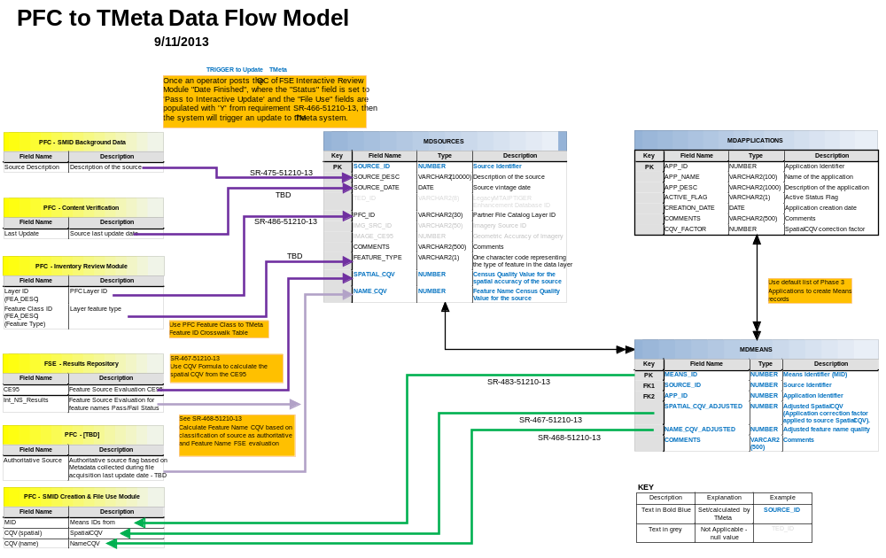
Partner File Catalog/GSS-I Workflow Control (PFC/GWCS) Data Relationship Rules
Rule 1: The PFC SMID Background Data must have a Source Description linked to the MDSources table.
Rule 2: The PFC - Content Verification must have the Source vintage date linked to the MDSOURCES report.
Rule 3: The PFC - Inventory Review Module Verification must have a PFC Layer (FEA_DESC) and layer Feature type (FEA_DESC) and both must link to the MDSOURCES table using the TMeta Feature ID Crosswalk Table. See below.
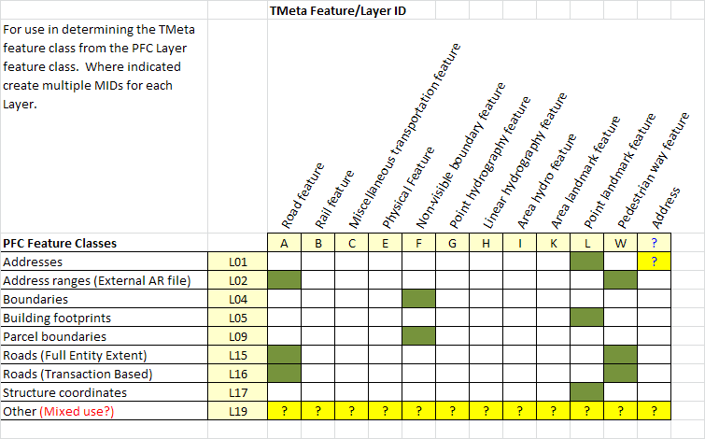
Rule 4: The FSE - Results Repository must have the CE95 and TMeta must use it to calculate the spatial CQV (described in the SR-467-51210-13) and record the results in the MDSOURCES table.
Rule 5: The FSE - Results Repository must have the Feature Source Evaluation for feature names Pass/Fail Status (Int_NS_Results) and TMeta must use it to calculate the Name_CQV (see SR-468-51210-13) and display the results in the MDSOURCES table.
Rule 6: The PFC must have the Authoritative source flag based on Metadata collected during file acquisition last update date, this field must support the Feature Name CQV calculation based on classification of the source as authoritative and Feature Name FSE evaluation (See SR-468-51210-13)
Rule 7: The MIDs, Spatial CQV, and Name CQV from must be linked to the PFC – SMID creation and file use Module.

6.1.4 Update functionality
General System and System Interface Requirements
SR-01-47810-13 - The Metadata Update System must be capable of creating a unique Operation ID.
SR-02-47810-13 - Operation ID values must be traceable to a MAF/TIGER Change Request that gives authorization for current and future projects. The Change Request number (e.g., MT.CR.10840) is an attribute of the Operation ID.
SR-03-47810-13 - The TMeta System must be capable of either automatically creating a MID, when notified by the GWCS/PFC database that a Community TIGER or other source file has been accepted for update to the MTDB or on an as-needed basis.
SR-04-47810-13 - After the TMeta system has assigned a MID, it must communicate the MID Code back to the GWCS/PFC.
SR-05-47810-13 - The TMeta system must be capable of displaying to the user, the specific entity name for the source layer for each MID in the update screens and reports. The GWCS/PFC creates and stores the entity ID and entity name data. The entity code is embedded in the source layer ID. For example, layer ID 123456.CO06037.01, the entity is Los Angeles County, California.
SR-06-47810-13 - The TMeta system must be capable of accessing and displaying in update screens and reports, the specific source file’s Entity Name, CE95, and CQV value from the GWCS/PFC. However, the imagery CE95 must be suppressed from all such reports.
SR-44-47810-13 - The source MID will be independent of operation.
SR-45-47810-13 - The source MID will be associated to an application
- The application will be flagged as batch and/or Interactive; and
- The application will have a CQV correction factor assigned to it.
- The default CQV correction factor is 1.0
SR-46-47810-13 - The Metadata system will have the capability to calculate the Spatial CQV using the following formula and parameters where M is the CE95 value:
$$CQV=A-BM+{C\left(M-13.2639\right)}^{2}-{D\left(M-13.2639\right)}^{3}+{E\left(M-13.2639\right)}^{4}-{F(M-13.2639)}^{5}$$
Where:
A = 101
B = 5.5
C = 0.3178065
D = 0.007968
E = 0.0004752
F = 0.0000218
Example: For a Value of M = 3.79 the resulting CQV = 121
SR-47-47810-13 - The metadata system will have the capability to export the CQV to the GWCS/PFC.
To automate the creation of the MID codes it is necessary to know the default set of applications that we will use with the source files to update the MTDB. There is no requirement to use the MID or make any updates using any of the default applications. The default of applications are:
- Upload Software for MTAIP
- Upload Software after MTAIP
- Batch Conflation Software
- Batch Confirmation Software
General recommendations:
The system should create MIDs on an as needed basis to avoid creating large numbers of unused MIDs.
MIDs that remain unused (not associated to any MTDB data or transactions) long after the completion of the project that acquired the sources for update, may be purged from TMeta.
Accessing Legacy Data Requirements
SR-07-47810-13 - The TMeta system must be capable of retrieving specific data such as operations, and MIDs, CE95, and CQVs previously used to update the MTDB.

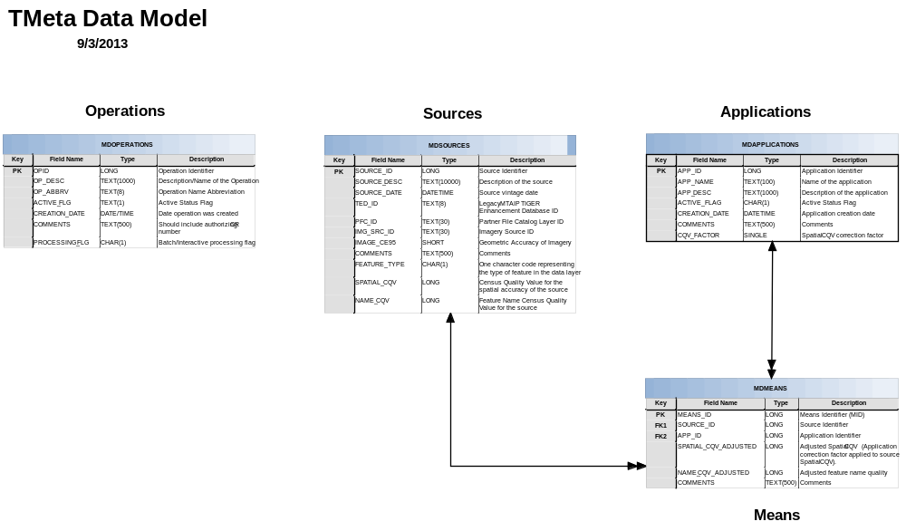
The TMeta database design has four tables for: operations, sources, applications and MID. The operations table is separated from/not linked to sources, applications, and means.

7. Processes
This section will describe the major types of processes used within the Geography Division regarding linear features. There will be no exhaustive list of these processes; however, examples of each major type will be given and described in detail. For each example process, the following will be provided: (a) process name, (b) process description, (c) how the process is used within the GEO, & (d) metadata associated with that process. The following processes will be listed as examples:
- New op ID
- Interactive Update
- Batch Upload
- Source Acquisition and Testing
- Maintenance
- Confirmation
A standard ‘presentation form’ will be developed so that each process example will have the same look & feel.
Authors: Andrew H Flora, Jamison D Leach, Francia L Torres

8. References & Related Documents
A listing of the documents used to compile the Linear Features Metadata Master Plan. The ‘true’ citation for each document will be found in this section. Any reference to that document throughout the balance of the document will link back to here.
This section should list:
- The documents used to compile the information in the Master Plan.
- Other relevant documents to refer to for more information about metadata.
- References as to the location of these documents.
A standard ‘presentation form’ will be developed so that each reference will have the same look & feel.
Lead Editor: Fred Malkus

8.1. References
The following references are cited in the Linear Features Metadata Master Plan:
[Ref_01] U.S. Census Bureau, “Metadata Recommendations for the MTDB”, December, 2011, link
[REF_02] U.S. Census Bureau. “Project Charter for the Metadata Integrated Project Team”, March 2013, link
[REF_03] U.S. Census Bureau. “Project Plan for the Metadata Integrated Project Team (IPT)”, March 2013, link
[REF_04] International Organization for Standardization. “ISO 19115-2:2009 Geographic information -- Metadata -- Part 2: Extensions for imagery and gridded data”, January 2012
[REF_05] U.S. Census Bureau. “Census Bureau Geospatial Product Metadata Standard”, January 2010, link

8.2. Related Documents
This is likely the first of a series of documents describing how metadata is used within the division.

Attachments
A listing of defined concepts, terms, and acronyms used within this document. This section could reference a FAQ somewhere on the GEO site.
LL comments: This document will start the process of building a metadata lexicon within the Geography Division. Use the term lexicon.
Authors: Fred Malkus, Andrew H Flora, Jamison D Leach, Francia L Torres

Metadata Lexicon
PROBLEM: Within the Geography Division, the term Metadata is commonly used as the default term for all metadata maintained or produced within the division. As there are a number of different categories of metadata within the division, this results in substantial confusion and wasted time.
Solution: Develop a lexicon of standard terms to be used in describing metadata as it is used within the division.

A.1 Concepts
Geographic Metadata: ???
Source Metadata: ???
Process Metadata: ???
Product Metadata: ???

A.2 Terms
Authoritative – [see Peggy Sweeney’s documents]
Community of practice
Confirmation – [See Aarons document]
Census Quality Value – A standardized value indicating the quality of a specific data characteristic. It is a function of the quality of the source and the reliability of the update operation that makes the update. It supports the comparison of competing updates to help ensure that higher quality updates are not degraded by those of lower quality.
External ID – A unique geospatial feature identifier from a data provider that serves to link the geospatial feature back to the corresponding feature in the provider file.
Means Represents a unique combination of source and application used for a geospatial update to the MTDB. The means is identified by a MID. The quality of the update is a function of both the source of the information and the reliability of the application that was used to perform the update. Each MID associated to the same source may have a different CQV.
Metadata data about data; "a library catalog is metadata because it describes publications." In the context of geographic features, metadata may describe the source, vintage, provider, and the assessed quality of geospatial data as well as the operations, applications, operator, update transactions responsible for the update. Metadata may also include external IDs and references that serve to uniquely identify geographic features and relate them to other datasets.
Partnership program
Provider – The organization responsible for compiling geospatial data and submitting a geospatial dataset to the Census Bureau for the purpose of updating the MTDB. The provider may have compiled the data from other sources.
Source – A specific data file or document used to update geospatial data in the MTDB. It is characterized as having a defined coverage area, a specific vintage, and a known provider. Note that data sets covering the same area but having either or both a different provider or vintage constitute separate sources.
Transaction – Data describing a specific update action that may include the means operations, applications, date, operator, type of update transaction describing the update. The MTDB records information about update transaction in the MDHISTORY table. The MTDB will maintain transaction information for only those geospatial features that currently exist in the MTDB.
Transaction date/time – The date/time when an update is posted to the MTDB. The MTDB records information in the MDHISTORY table as the MTUPDATE.
Transaction file – A geospatial source file consisting of only new update transactions recorded from the creation of the last transaction file.
Trusted – [see Peggy Sweeney’s documents]
Update Action – one of series of standardized update types. The codes for spatial features include;
AD – Add for spatial features
MD – Modify for spatial features
SP – Split for spatial features
The MTDB records information in the MDHISTORY table as the ACTIONCODE.
Vintage – A date indicating how current a source is. It may represent the last update date or the last date that a source dataset was reviewed and verified to be current.

A.3 Acronyms
CM Configuration Management
CQV Census Quality Value
CR Change Request
GATRES Geographic Acquis-Based Topological Real-time Editing System
GEO U.S. Census Bureau Geography Division
GIS Geographic Information System
GSS-I Geographic Support System Initiative
ISO International Organization for Standardization
IPT Integrated Project Team
MAF Master Address File
MTDB MAF/TIGER Database
TIGER Topologically Integrated Geographic Encoding and Referencing System

From TIGER/Line Technical Documentation, 2008, Chapter 1 p1-1 [Will work to find a better opening description of the TIGER System]
See GSS-I Recommendation REC-2011-022 described in the documents REC-2011-022.pdf and REC-2011-022 v11 Addendum.docx.
Note that this section first appeared as a handout for discussion at the xxxx Planning Priority meeting with the title: Justification for Spatial Metadata in the MAF/TIGER Database.
See the MAF/TIGER Legal Values Physical View link: http://app.geo.census.gov/LegalValues/MTLVPReport?action=treetable
Traditional paper and documentary resources have not been listed as sources most likely because they are used in combination with other sources, and there have been no operational mechanisms for cataloging these sources and tagging the updates with this information.
From page 2 of the Software Requirement Specification: TIGER Enhancement Database (TED), prepared by the Geographic Reference Software Branch (GRSB) dated April 30, 2003.
From page 1 of the Software Requirement Specification: TIGER Enhancement Database (TED), prepared by the Geographic Reference Software Branch (GRSB) dated April 30, 2003.
See URL: http://app.geo.census.gov/gppsystem/doc/GPP_TED_datadict.pdf

