TMeta REQUIREMENTS

Description

The TMeta system provides a repository of metadata codes and their attributes for all sources and operations used to update the geospatial feature data in the MTDB. The metadata source codes in this system tie the data in the MTDB to external datasets that inventory sources, describe their acquisition and testing, and document the quality and intended use of the data. These external data sets include GSS-I GWCS/PFC, the imagery server, and the legacy MTAIP TED database. The TMeta system provides the functionality to create new metadata source codes, built on the information in these datasets, and new operation codes that document the census and geographic operations that update the MTDB. Apart from these operations, the new TMeta system maintains a list of applications, such as BFUS, GATRES, and the Conflation/Update processes, that in combination with sources, identify the means that generate spatial updates and the quality of these updates.
The TMeta system maintains information about the quality of data from the sources. The system describes quality in the form of standardized CQVs that enable comparisons across sources. The metadata system software performs a comparison of CQV values to prevent updates that would degrade the quality of the data. TMeta models quality as a function of both the observed quality of the source and the inaccuracies of the applications used to make the update. The MID in TMeta represents the unique combination of source and application that defines the CQV for the update in the MTDB.
The requirements for TMeta can be divided into the following subject areas:
- Basic system requirements – describing the basic data model and capabilities of the system;
- Data content requirements – describing the required data elements;
- Relationship Rules – describing the relationships between elements; and
- Update functionality – describing the data user requirements to update the system with new source and operation metadata.

Basic System Requirements
Requirements that describes basic functionality and the basic data model:
Requirement 1: The TMeta system will maintain information for two types of metadata: Sources and Operations. Sources and operations will remain independent of each other and will not be associated.
Requirement 2: The TMeta system must support all previously identified sources and operations along with their attributes including CQVs. These include both current and completed operations.

Requirement x: The TMeta system must define unique identifiers for operation (OPID), source (SOURCEID), and means (MID) that are consistently used throughout the TMeta and MTDB databases. Note that there is no requirement that these IDs are permanent identifiers; the MIDs could be recalculated and assigned as needed.
Requirement 3: The TMeta system must maintain Source File metadata at the layer level.
Requirement 4: The TMeta system must maintain census quality values for only spatial accuracy and feature name quality. These are the only source attributes that are evaluated, have a quality score, and will be used in update permission checks or other applications. The list could expand in the future.
Requirement 5: Each source will be associated to one or more update applications, such as GATRES and 1Spatial batch conflation, so that we can correct the CQVs to reflect the inherent inaccuracies of each update application.
Requirement 6: The TMeta system will represent each unique combination of source and update application with a MID that will be associated to spatial feature updates in the MTDB. The MID represents a unique combination of a source and application.
Requirement 7: The TMeta system will calculate a corrected CQV for each MID by multiplying the correction factor for each application and attribute to the corresponding attribute CQV for the source. One source can be used by multiple applications and the CQV will be adjusted for each combination according to the correction factor.
Requirement 8: The TMeta system must support an application-specific quality correction factor used to determine the final CQV of the data in the MTDB after update.
Requirement 9: The TMeta system must provide full access to metadata from the GWCS/Partner File Catalog, TIGER Enhancement Database (TED), and imagery source metadata.
Requirement 10: The spatial CQV for the MID will be set based on the calculated CE95 of the GIS source or the imagery CE95, and the application quality correction factor.

Data Content Requirements
The following requirements describe the attributes that the TMeta system will record for the metadata elements:
Operation
Requirement 1: The TMeta system will maintain an inventory of all Census update operations used to update the MTDB.
Requirement 2: The TMeta system will assign a unique ID number to each operation. This ID is mandatory (see annex).
Requirement 3: The TMeta system will record a descriptive name for each operation consisting of a text string of up to 1000 characters. This information is mandatory.
Requirement 5: The TMeta system will record a unique descriptive abbreviation for each operation consisting of a text string of up to 8 characters. This information is mandatory.
Requirement 6: The TMeta system will record the date that each operation ID is created. This information is mandatory.
Requirement 7: The TMeta system will record the active/inactive status of each operation. An active status operation is current and available for updates. An inactive operation has been completed and should not be available to GATRES users as a valid operation.
Requirement 8: The TMeta system will maintain an optional comments field for each operation consisting of a text string of up to 500 characters. The comments field will record the number of the change requests that authorize the creation or modification of the operation.
Requirement 9: The TMeta system will maintain a mandatory field for each operation to identify whether it is available for interactive, batch, or both interactive and batch updates. Active operations designated as interactive may be available in GATRES. Those that are reserved for Batch processing may not.
Source:
Requirement 1: The TMeta system will maintain an inventory of all sources that are associated with updates in the MTDB.
Requirement 2: The TMeta system will assign a unique ID to each source. This ID is mandatory.
Requirement 3: The TMeta system will record a descriptive name for each source consisting of a text string of up to 10000 characters. This information is mandatory.
Requirement 4: The TMeta system will record the source creation date for each source. This information is mandatory.
Requirement 5: The TMeta system must display/provide the vintage date of the source identifying the last update date.
Requirement 6: The TMeta system will record the TED_ID “Legacy MTAIP TIGE Enhancement Database ID” consisting of a text of up to 8 characters.
Requirement 7: The TMeta system will record the Partner File Catalog Layer ID for each source consisting of a text of up to 20 characters.
Requirement 8: The TMeta system will record the Imagery Source ID used to update the MTDB consisting of a text of up to 30 characters.
Requirement 9: The TMeta system will record the geometric accuracy (CE95) of Imagery used to update the MTDB. Note that this information is for internal GEO use on an as needed basis and should be suppressed from reports and the interactive user interface.
Requirement 10: The TMeta system will maintain an optional comments field for each source consisting of a text string of up to 500 characters. The comments field will record any particular and specific details of a source.
Requirement 11: The TMeta system will record the Feature Type with a one-character code representing the type of a feature in the data layer.
Requirement 12: The TMeta system will calculate the Feature name Census Quality Value of the source. Note that the method of calculation is pending.
Application:
Requirement 1: The TMeta system will maintain an inventory of all software applications that are associated with updates in the MTDB. The inventory will not include applications that do not record metadata, such as feature deletes.
Requirement 2: The TMeta system will assign a unique ID number to each application. This ID is mandatory.
Requirement 3: The TMeta system will record a descriptive name for each application consisting of a text string of up to 100 characters. This information is mandatory.
Requirement 4: The TMeta system will record text describing each operation consisting of a text string of up to 1000 characters. This information is mandatory.
Requirement 5: The TMeta system will record a unique descriptive abbreviation for each application consisting of a text string of up to 8 characters. This information is mandatory.
Requirement 6: The TMeta system will record the active/inactive status of each application. An active status application is current and available for updates. An inactive operation has been completed and should not be associated with any new sources.
Requirement 7: The TMeta system will record the date that each application ID is created. This information is mandatory.
Requirement 8: The TMeta system will maintain an optional comments field for each application consisting of a text string of up to 500 characters.
Means:
Requirement 1: The TMeta system will maintain an inventory of all valid combinations of source and application that define the metadata means used to update the MTDB.
Requirement 2: The TMeta system will assign a unique ID number to each valid combination of source and application. This ID is mandatory. The MTDB will apply the MID to the edge as a SMID or to update transactions (In MDHISTORY) as the source ID.
Requirement 3: The TMeta system will record the source associated with each Means. This ID is mandatory
Requirement 4: The TMeta system will record the application associated with each Means. This ID is mandatory
Requirement 5: The TMeta system will maintain the adjusted spatial CQV for the Means. Note: Metadata system software permission checks should use this value for geometric updates.
Requirement 6: The TMeta system will maintain the adjusted NameCQV for the Means. Note: Metadata system software permission checks should use this value for names.
Requirement 7: The TMeta system will maintain an optional comments field for each application consisting of a text string of up to 500 characters.

Update Functionality

General System and System Interface Requirements

- SR-01-47810-13-The Metadata Update System must be capable of creating a unique Operation ID.

- SR-02-47810-13- Operation ID values must be traceable to a MAF/TIGER Change Request that gives authorization for current and future projects. The Change Request number (e.g., MT.CR.10840) is an attribute of the Operation ID.

- SR-03-47810-13- The TMeta System must be capable of either automatically creating a MID, when notified by the GWCS/PFC database that a Community TIGER or other source file has been accepted for update to the MTDB or on an as-needed basis.

- SR-04-47810-13- After the TMeta system has assigned a MID, it must communicate the MID Code back to the GWCS/PFC.

- SR-05-47810-13- The TMeta system must be capable of displaying to the user, the specific entity name for the source layer for each MID in the update screens and reports. The GWCS/PFC creates and stores the entity ID and entity name data. The entity code is embedded in the source layer ID. For example, layer ID 123456.CO06037.01, the entity is Los Angeles County, California.

- SR-06-47810-13- The TMeta system must be capable of accessing and displaying in update screens and reports, the specific source file’s Entity Name, CE95, and CQV value from the GWCS/PFC. However, the imagery CE95 must be suppressed from all such reports.

- SR-44-47810-13- The source MID will be independent of operation.

- SR-45-47810-13- The source MID will be associated to an application
- The application will be flagged as batch and/or Interactive; and
- The application will have a CQV correction factor assigned to it.
- The default CQV correction factor is 1.0

- SR-46-47810-13 - The Metadata system will have the capability to calculate the Spatial CQV using the following formula and parameters where M is the CE95 value:
CQV = A - BM + C(M - 13.2639)² - D(M - 13.2639)³ + E(M - 13.2639)⁴ -
F(M - 13.2639)⁵

Where:
A = 101
B = 5.5
C = 0.3178065
D = 0.007968
E = 0.0004752
F = 0.0000218
Example: For a Value of M = 3.79 the resulting CQV = 121

- SR-47-47810-13 -The metadata system will have the capability to export the CQV to the GWCS/PFC.

- To automate the creation of the MID codes it is necessary to know the default set of applications that we will use with the source files to update the MTDB. There is no requirement to use the MID or make any updates using any of the default applications. The default of applications are:
Upload Software for MTAIP
Upload Software after MTAIP
Batch Conflation Software
Batch Confirmation Software

General recommendations:

The system should create MIDs on an as needed basis to avoid creating large numbers of unused MIDs.

MIDs that remain unused (not associated to any MTDB data or transactions) long after the completion of the project that acquired the sources for update, may be purged from TMeta.

Accessing Legacy Data Requirements

SR-07-47810-13 - The TMeta system must be capable of retrieving specific data such as operations, and MIDs, CE95, and CQVs previously used to update the MTDB.

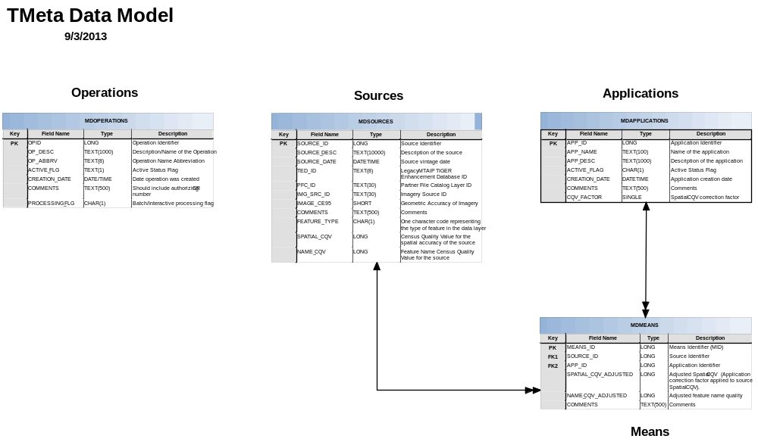

The TMeta database design has four tables for: operations, sources, applications and MID. The operations table is separated from/not linked to sources, applications, and means.

Relationship and Data Content Rules
This section covers the rules that specify the data content of the TMeta Data Tables.

MDOPERATIONS table

Rule 1: All historical and current Operations must be represented in the Operations table

Rule 2: All Operation records must have an Operation Description (OP_DESC).

Rule 3: All Operation records must have an Operation Abbreviation (OP_ABBRV).

Rule 4: All Operation records must have an Active Status Flag (ACTIVE_FLG) set.

MDSOURCES Table

Rule 1: All Records must have a source description (SOURCE_ID).

Rule 2: All Records must have a source creation date (SOURCE_DATE).

Rule 3: All Records must have a non-null Feature Type (FEA_TYPE).

Rule 4: All Records must have one valid source ID (either a TED_ID, IMG_SRC_ID, or PFC_ID).

Rule 5: All sources in the current TMeta must be represented in the SOURCES table.

Rule 6: All source records must link to at least one Means record.

Rule 7: If a source record links to more than one Means Record, each of the matching Means records must link to a different application in the APPLICATIONS Table.

Rule 8: All Imagery Sources must be associated to a MID linked to an interactive GATRES application.

Rule 9: All Imagery sources must have a name CQV of zero or null (NAME_CQV = null or zero).

Rule 10: All imagery sources will have a default physical-feature Feature Type (If IMG_SRC_ID ≠ null then FEATURE_TYPE = 'E').

Rule 11: The geometric accuracy of imagery must be null for all non-imagery sources (If IMG_SRC_ID = null then IMAGE_CE95 = null)

MDAPPLICATIONS

Rule 1: All applications must have an application name (APP_NAME).

Rule 2: All applications must have an application description (APP_DESC).

Rule 3: All applications must have a spatial CQV correction factor (CQV_FACTOR) ≤ 1.00.

Rule 4: All applications must have an active-flag value set (ACTIVE_FLAG).

PFC to TMEta Data Flow Model
See figure XX.
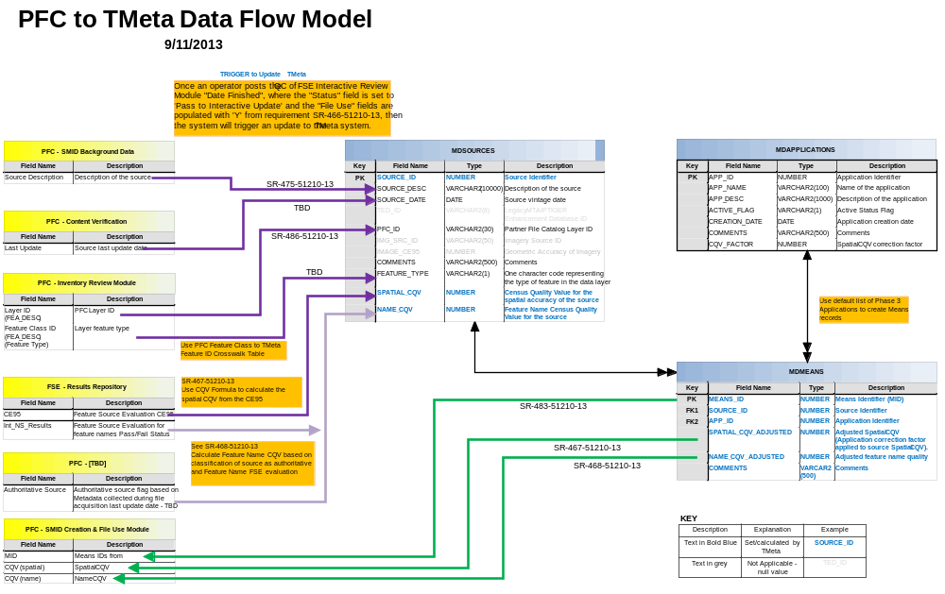
Partner File Catalog/GSS-I Workflow Control (PFC/GWCS) Data Relationship Rules
Rule 1: The PFC SMID Background Data must have a Source Description linked to the MDSources table.
Rule 2: The PFC - Content Verification must have the Source vintage date linked to the MDSOURCES report.
Rule 3: The PFC - Inventory Review Module Verification must have a PFC Layer (FEA_DESC) and layer Feature type (FEA_DESC) and both must link to the MDSOURCES table using the TMeta Feature ID Crosswalk Table. See below.

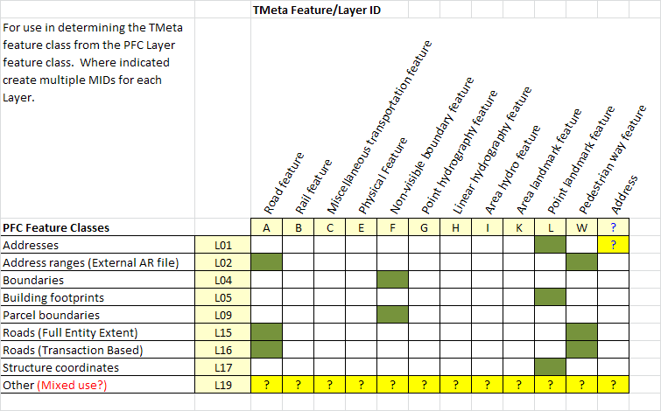

Rule 4: The FSE - Results Repository must have the CE95 and TMeta must use it to calculate the spatial CQV (described in the SR-467-51210-13) and record the results in the MDSOURCES table.

Rule 5: The FSE - Results Repository must have the Feature Source Evaluation for feature names Pass/Fail Status (Int_NS_Results) and TMeta must use it to calculate the Name_CQV (see SR-468-51210-13) and display the results in the MDSOURCES table.

Rule 6: The PFC must have the Authoritative source flag based on Metadata collected during file acquisition last update date, this field must support the Feature Name CQV calculation based on classification of the source as authoritative and Feature Name FSE evaluation (See SR-468-51210-13)

Rule 7: The MIDs, Spatial CQV, and Name CQV from must be linked to the PFC – SMID creation and file use Module.

